What role does social awareness and responsibility play in the education of children?

When teachers provide opportunities within our classrooms and community to develop social awareness and responsibility, students gain the skills they need to become compassionate citizens. Building relationships, contributing to society, caring for the environment, resolving problems, and valuing diversity are facets of social emotional learning that exemplify a thriving child. Embedded within the social awareness and responsibility competency is the First Peoples’ belief that we have commonalities with all people in our community, and a strong connection and responsibility to the land. When students advocate for themselves, others, and the environment, they develop a strong sense of self.

For more information about the curriculum, visit https://www.sd42.ca/new-curriculum/

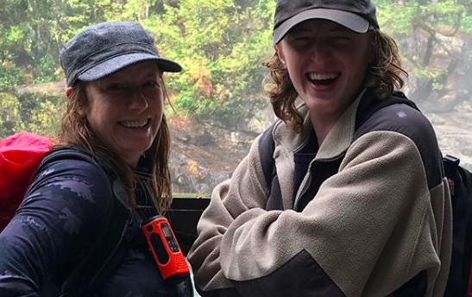
Coming in December – Formative Assessment.
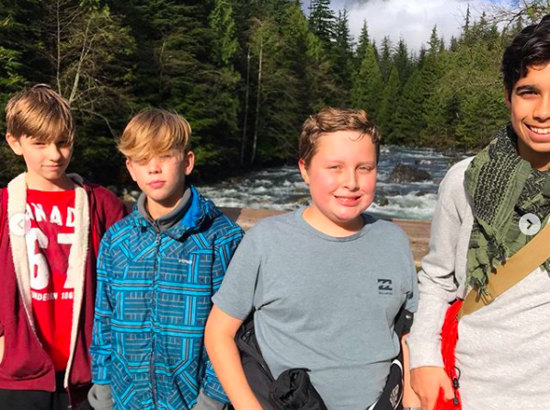
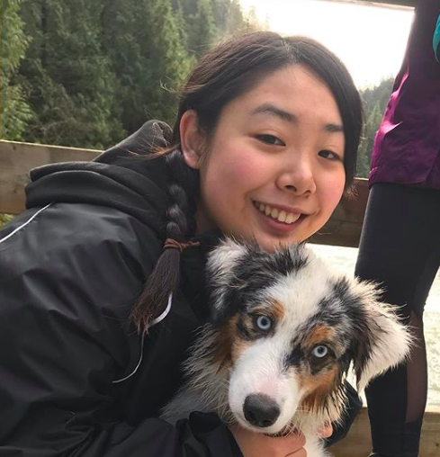
The SRT Outdoors Club spends a lot of time in our local environment, experiencing nature in a responsible and interactive way! From local hikes to camping trips, rock climbing and more—this is just one way that students at SRT are navigating personal and social responsibility.

