Personal Awareness and Responsibility

W
hy is personal awareness and responsibility so important to a child’s education?
Personal awareness and responsibility is a core competency integrated into all areas of learning in the curriculum.
When a student is personally aware and responsible, their sense of self-worth and confidence grow as they develop skills to ensure their well-being. Students learn how to set goals, regulate their emotions and stress, express their needs, and seek help when needed.
When students understand how their choices affect their educational, emotional, and social well-being, they recognize that they have a personal responsibility for their future.

For more information about the curriculum, visit https://www.sd42.ca/new-curriculum/

Coming in November – Compassion.

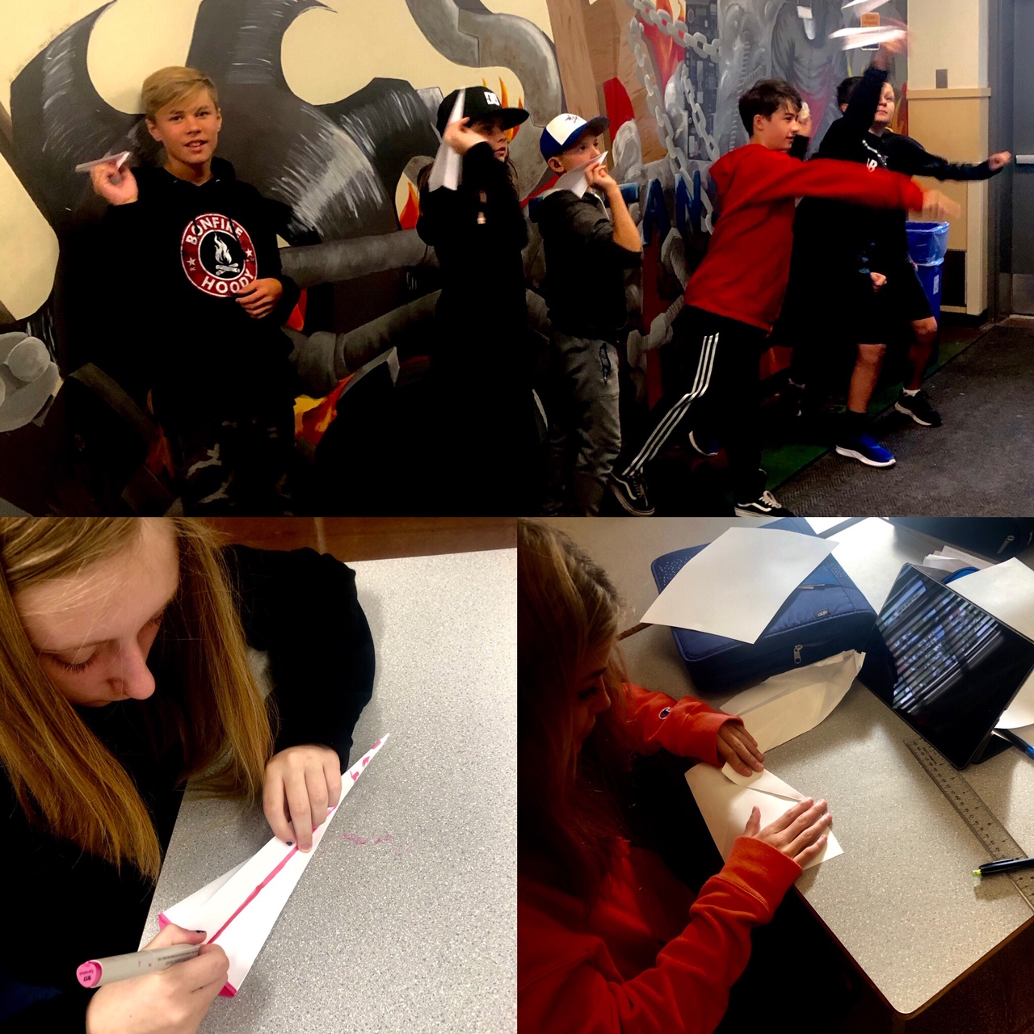

Grade 8 students learn about working together and overcoming failure: paper airplanes help them understand trial and error, and recalculating design to do better.

