How are teachers engaging students with Creative Thinking?

Creative Thinking is a core competency that is woven throughout our curriculum and is becoming more essential in daily life and the workplace. When students engage in creative thinking, they solve problems from a fresh or new perspective, and create solutions that are unconventional and require “thinking outside the box.” Creative thinking can be developed and improved by cultivating key techniques. Curiosity and open-mindedness are encouraged to provide the space for creative thinking to occur. New ideas and inspiration are developed through individual and collaborative brainstorming, play and periods of reflection. Although novel ideas are encouraged, they must also have value for their intended purpose. Students learn to evaluate their ideas by determining whether they support the well-being of self, community and the land.

For more information about the curriculum, visit https://www.sd42.ca/new-curriculum/

Coming in April: Place-Based Learning.

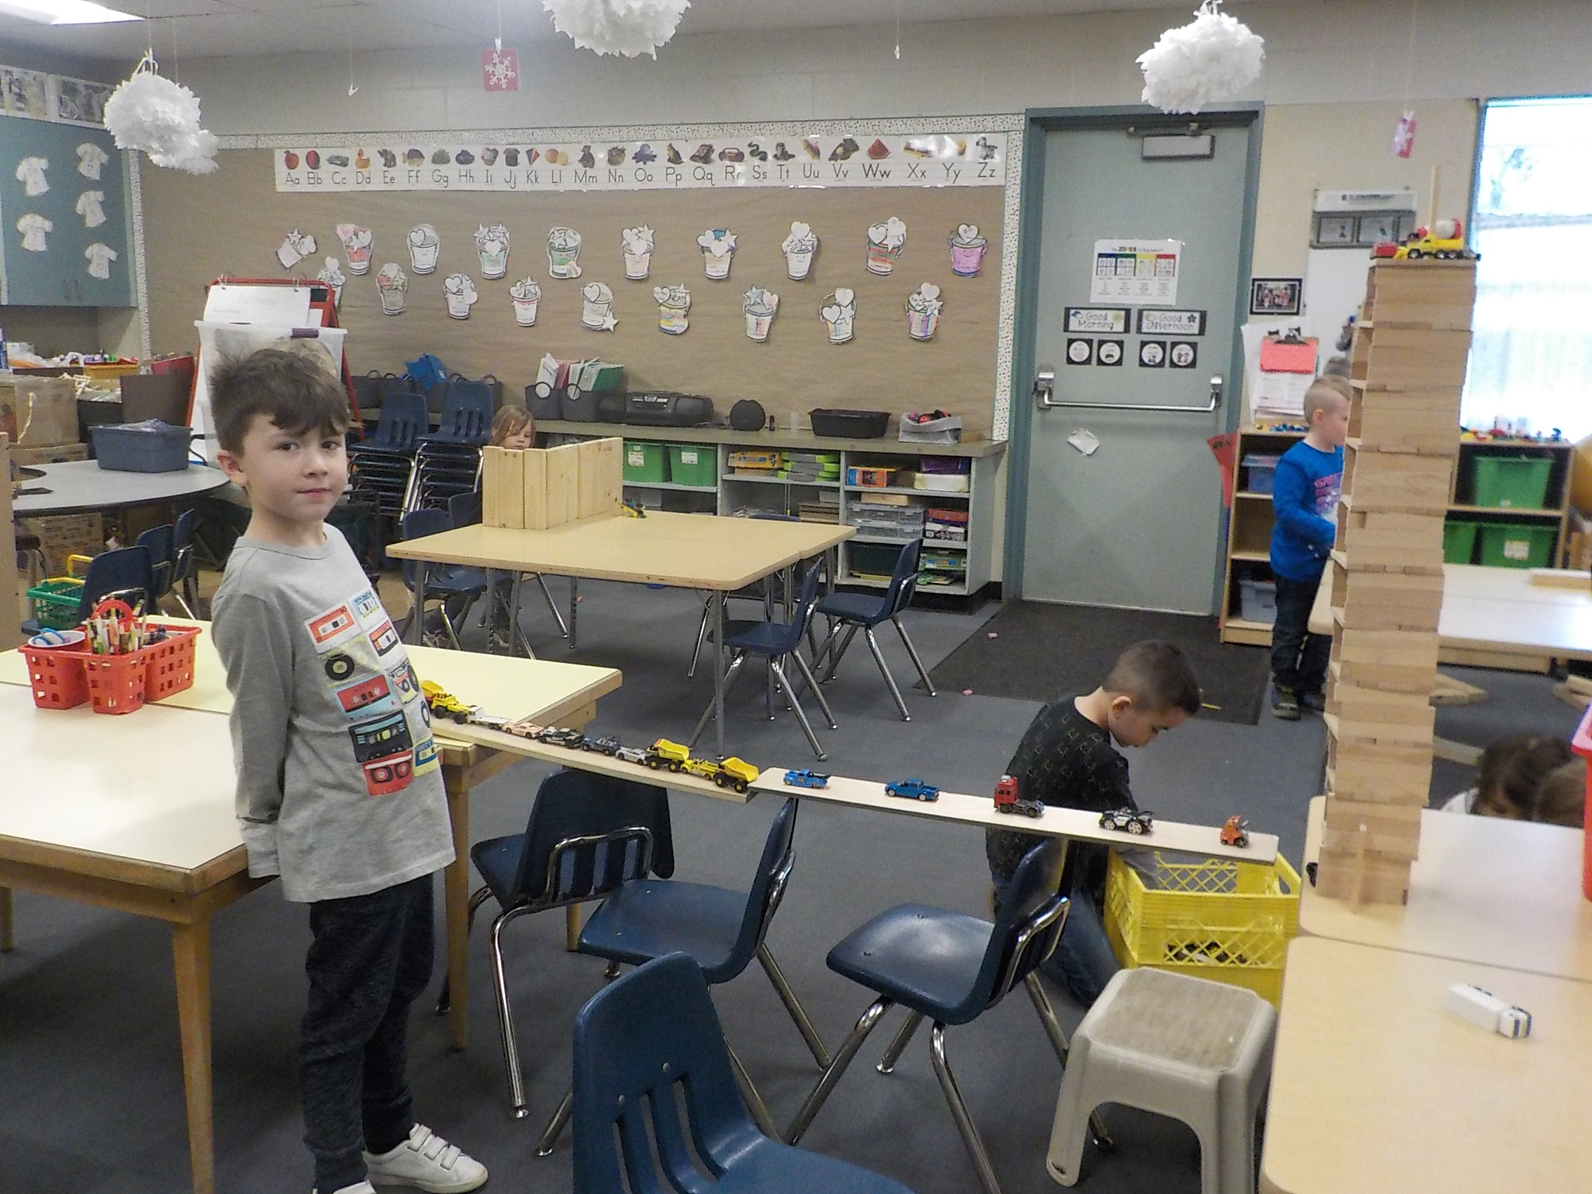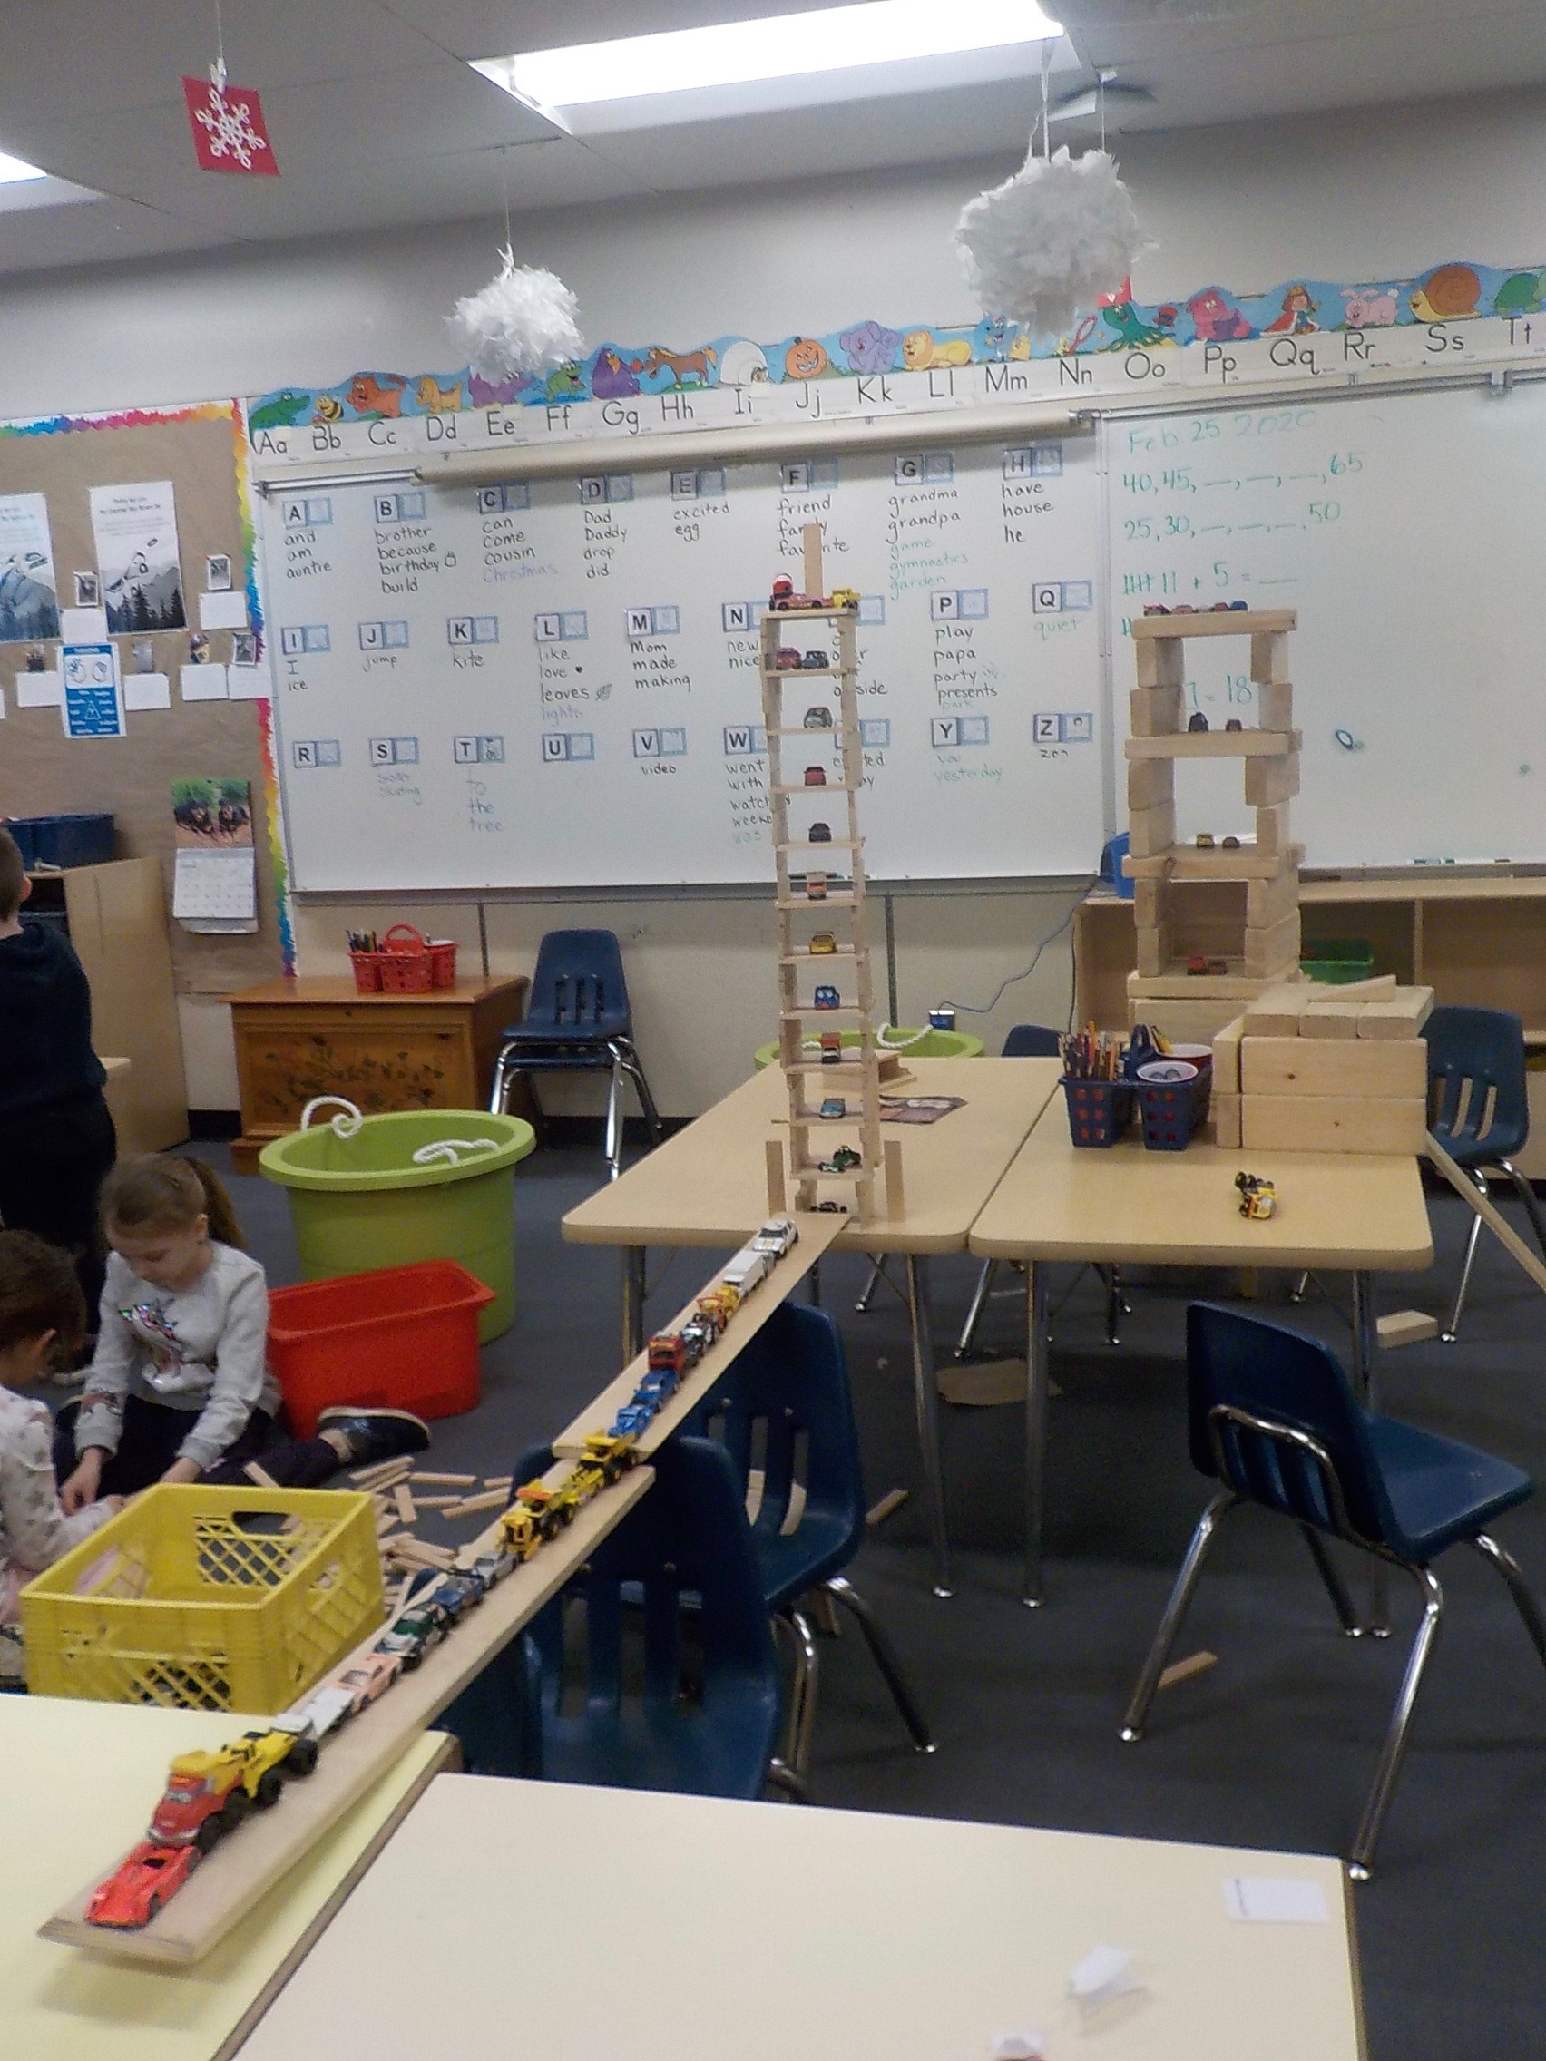

Surprising things happen when students use traditional materials in novel ways. Construction of this “high-rise parkade” took creativity and a great deal of perseverance.

