What is the importance of Personal Awareness and Responsibility to the development of healthy, resilient children and youth?

Students who develop personal awareness and responsibility make healthy connections between individual and social behaviour. Within our new curriculum, students are taught how to self-advocate so that they can express what supports they need to be successful in school. The ability to self-advocate develops confidence and self-worth so that children and youth have the courage to convey how they feel in constructive ways, ask questions, admit mistakes and commit to learning in all facets of life. An essential First Peoples’ Principle of Learning states that learning takes patience and time. Helping students understand this principle leads to perseverance in challenging times and encourages resiliency. Teaching our students to be personally aware and responsible leads to the development of healthy, whole children and youth.

For more information about the curriculum, visit https://www.sd42.ca/new-curriculum/

Coming in March: Creative Thinking.

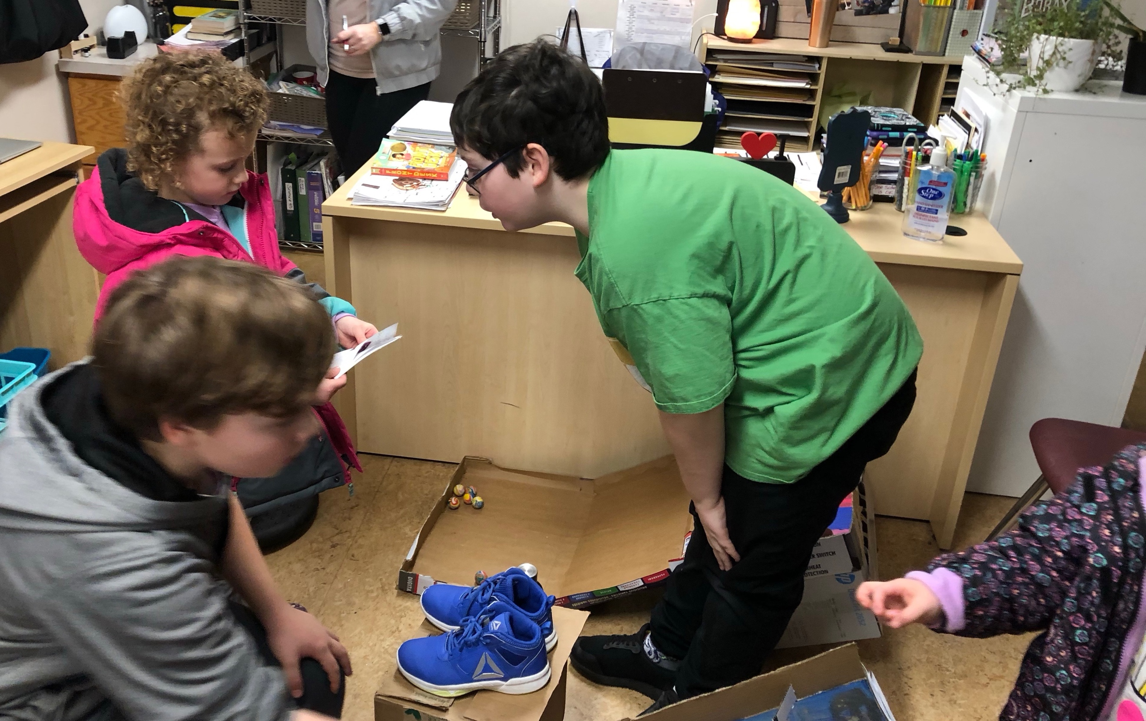

Intermediate students invite primaries to play the arcade style games they created.
They consider their own experiences and preferences to inform decisions on how they can make the games enjoyable and successful for the younger children.

