What is the importance of formative assessment in the classroom?

There are two types of classroom assessment. Summative assessment provides information about student progress for reporting purposes. Formative assessment provides feedback that supports student achievement and moves student learning forward. Clear goals with timely feedback inform students of where they are and what their next steps need to be. Formative assessment is given through written or verbal feedback and does not involve grading. When students are encouraged to act on teacher feedback, they begin to take ownership of their learning. As teachers work to build community and encourage students to take risks with their learning, they understand that mistakes should be embraced as opportunities to become proficient learners. In this way, teaching and learning become cyclical, each informing the other to promote independent and lifelong learning.

For more information about the curriculum, visit https://www.sd42.ca/new-curriculum/

Coming in January: Critical Thinking.

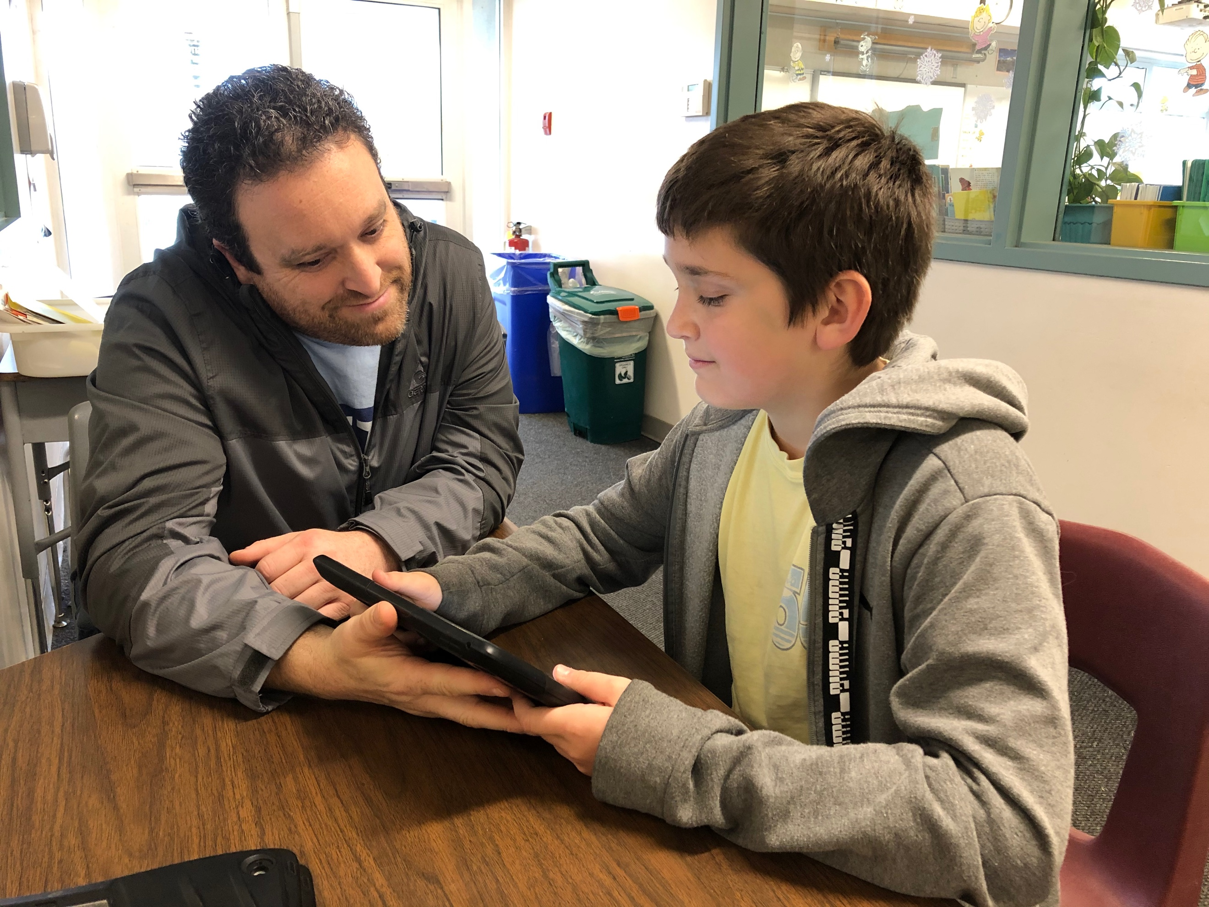

Students share their work with parents during student inclusive conferences. Portfolio samples (digital or paper) illustrate growth made as a result of feedback received through formative assessment. The artifacts provide talking points for rich conversations about learning.

