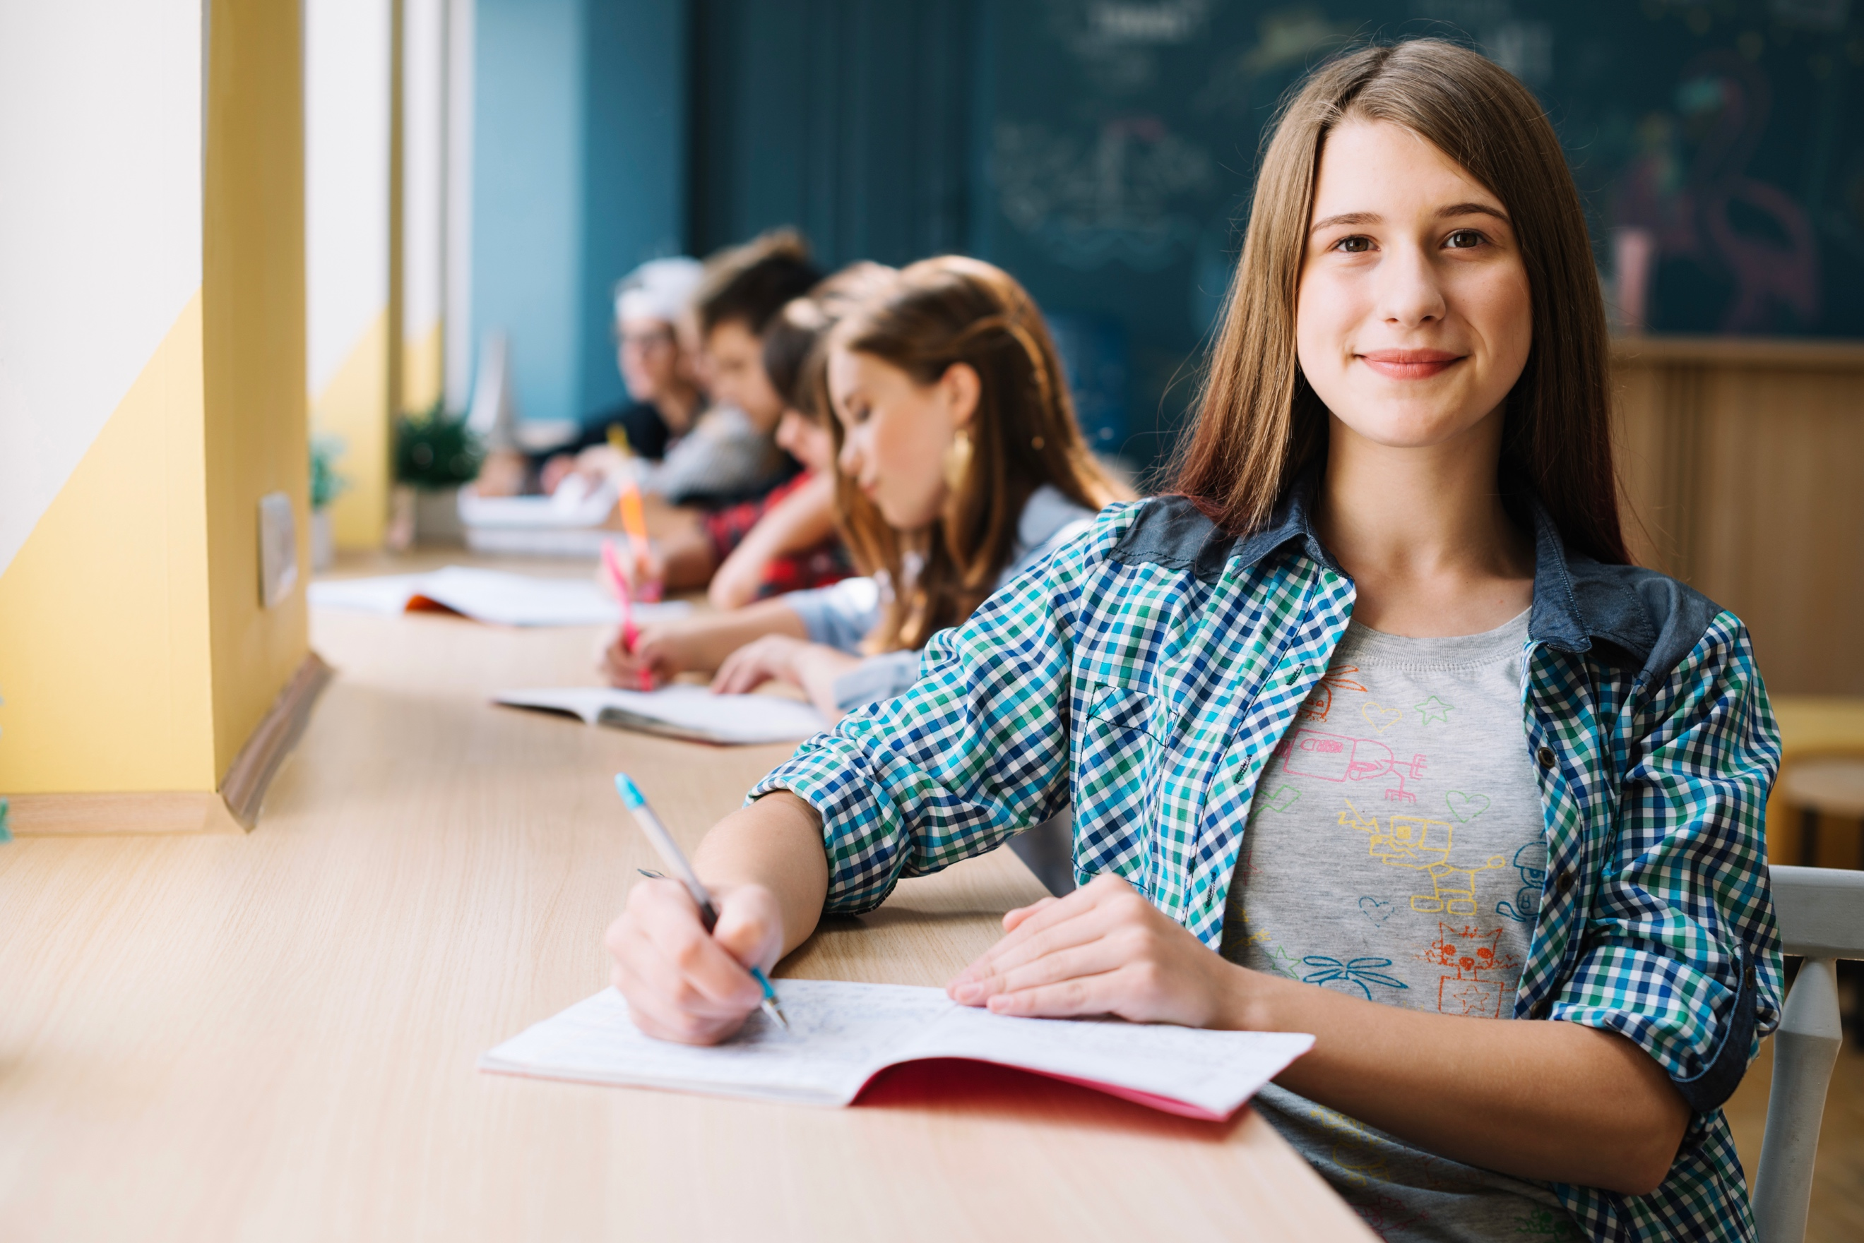

How has the curriculum been redesigned & how does this benefit student learning?

The BC curriculum has been redesigned to support the changing world students are entering. The redesigned curriculum is student-centred and flexible, maintains a focus on literacy and numeracy skills, and includes Aboriginal perspectives.

Kindergarten to Grade 10 teachers are already using the new curriculum in all our schools. The redesigned curriculum for Grade 11 and 12 is being fully implemented this September.

So how and what will your child be learning? Each month in our school newsletter, we will highlight a key feature of the redesigned curriculum and share stories about how this feature is being implemented in your child’s classroom. We will also tell you why these skills and abilities will help your child succeed

Below, you will find the first installment of our monthly feature on the redesigned curriculum.

For more information about the BC curriculum, visit: https://www.sd42.ca/new-curriculum/

Why does collaboration have a prominent role in the redesigned curriculum?

T
he ability to work effectively with others has become a critically important skill for career and life success. “Coordinating with others” is listed as one of the 10 skills to thrive by the World Economic Forum.

The Communication core competency highlights the importance of effective collaboration by focusing on the development of students’ listening skills, students’ ability to engage in formal and informal conversation, and their ability to generate and share ideas. When students work together to accomplish goals in areas such as inquiry, problem-solving, and community projects, they incorporate information from multiple sources of knowledge, perspectives, and experiences. Students learn to appreciate different perspectives and also learn to build consensus. As a result, the creativity and quality of the solutions students propose are both enhanced.

The relational importance of learning for all students is also captured by the First Peoples’ Principles of Learning, which recognize that learning is a highly social process that builds relationships within the family and the community. Ultimately, this emphasis on relationship “reinforces a way of being in the world that helps shape our actions, as we think about how our actions affect those around us.”
–From: Chrona. J: https://firstpeoplesprinciplesoflearning.wordpress.com/ 2019

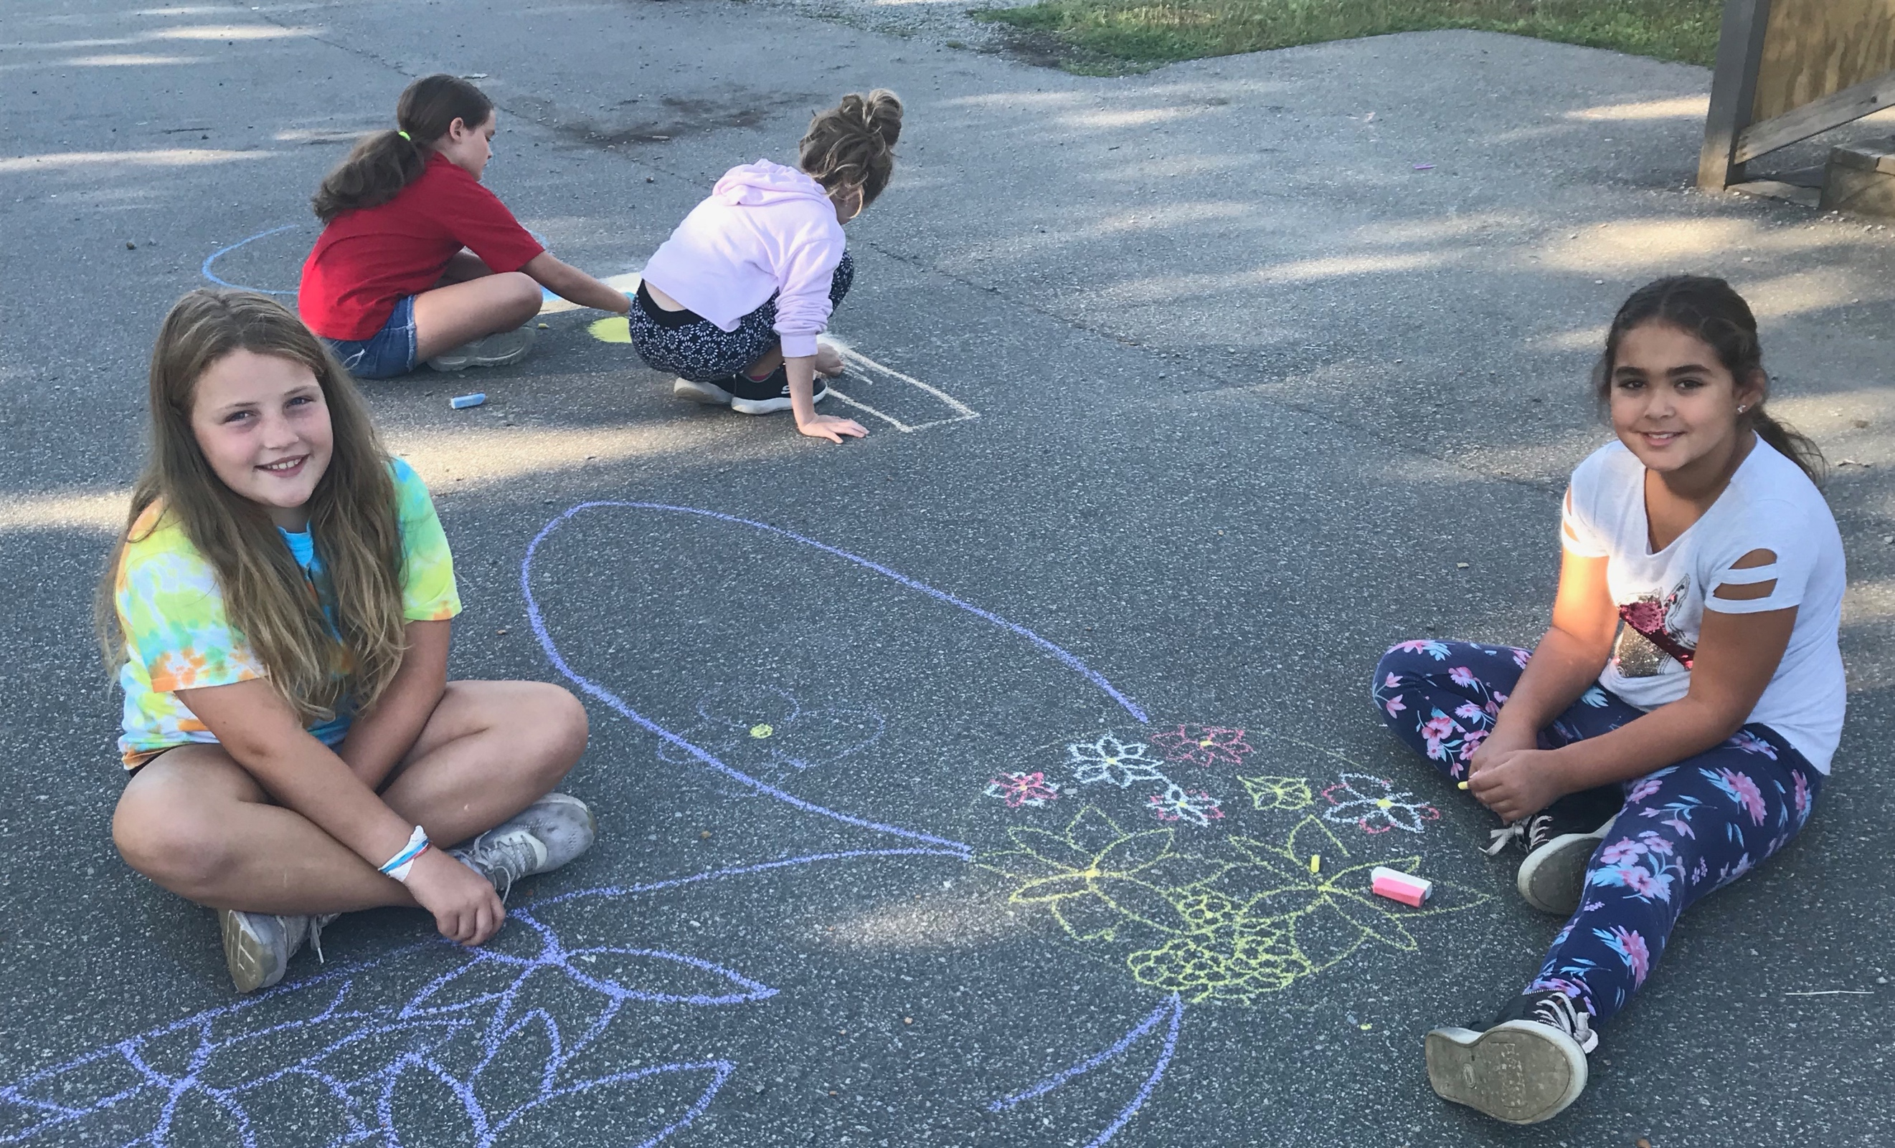

Students use different areas of expertise and learn from one another while working toward a common goal.

