HOW DO WE ASSESS AND CELEBRATE LEARNING?

H
ow Do We Assess and Celebrate Learning? Assessment, learning and the curriculum are interconnected. Assessment is rigorous and based on learning standards (curricular competencies and content), literacy and numeracy. Teachers design a wide variety of learning experiences to suit the needs of the students and the curriculum. Teachers engage in ongoing formative assessment, which guides their planning for learning and their feedback to students. Students reflect and self-assess to build important higher-level thinking skills. Students are given opportunities to set criteria, design inquiries, and participate in self and peer assessment, as well as setting goals for the next steps. Teachers document student learning over time using collections of student work and demonstrations to create a profile of individual strengths, areas of growth, and areas for further development. Through multiple means and varied strategies, the student’s learning is made visible, and their successes celebrated.

For more information about the new curriculum, visit http://www.sd42.ca/new-curriculum.

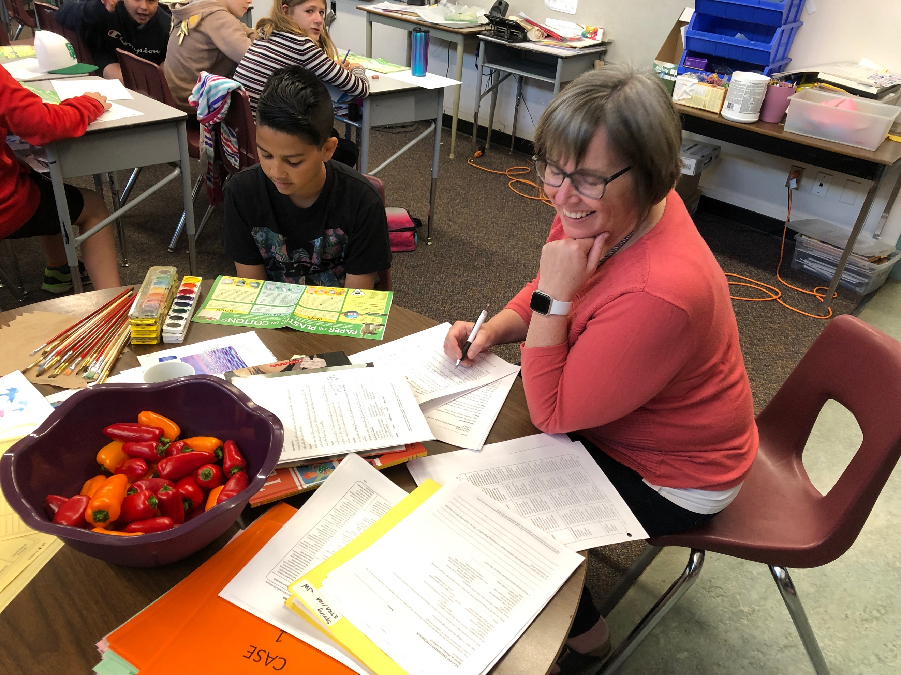
Teachers sometimes work one-on-one with students to assess growth over time in their oral reading and comprehension skills. Information gathered is used to inform next steps for both teaching and learning.

