INQUIRY LEARNING

I
nquiry Learning is a process where students investigate and explore answers to questions. Inquiry questions provide a focus for learning the curricular content, encourage students to develop important skills when answering questions, and make learning more meaningful and relevant.
Inquiry questions provide a framework for teachers to more easily meet the needs of each student
while allowing students to be more engaged in the content they are learning.

For more information about the new curriculum, visit http://www.sd42.ca/new-curriculum.

Coming in June – How do we assess and celebrate learning?

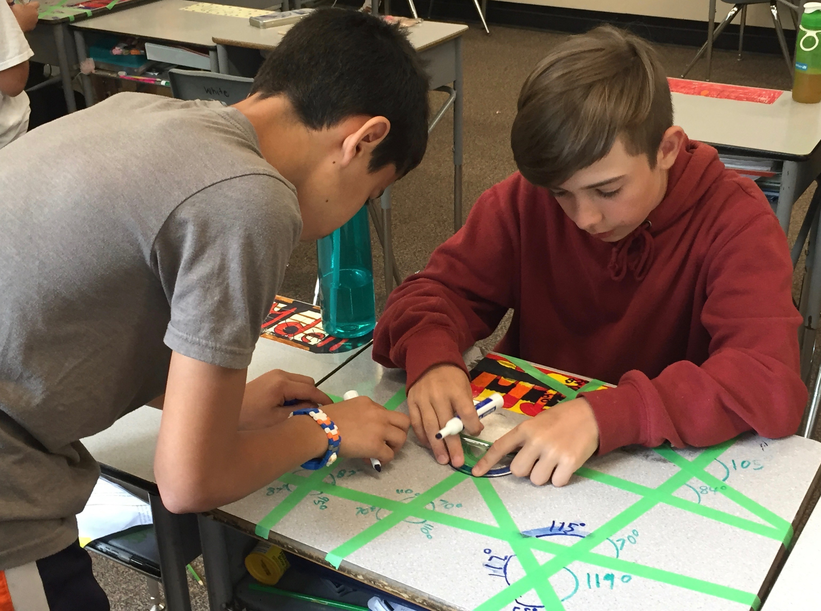

Students inquire into functions and relationships between angles. They take this learning into the “real world,” noticing the prevalence of angles in everyday environments. As learning goes deeper, they recognize how angles are used in structures and even how they affect performance in sports.

