PLACE-BASED LEARNING

P
lace-based learning connects students to the landscape, heritage and cultures in their community. They explore their own community and environment through project-based learning and outdoor education. It makes learning relevant as they look at real-life problems and situations and figure out ways to be involved and to help. Spending time outside can help students build independence and confidence, and improve their mental health through hands-on learning. Outdoor learning also allows them to build problem-solving and teamwork skills. When students feel connected to a place, they are invested in the long-term well-being of their community and environment.

For more information about the new curriculum, visit https://curriculum.gov.bc.ca/

Coming in May – Inquiry Learning.

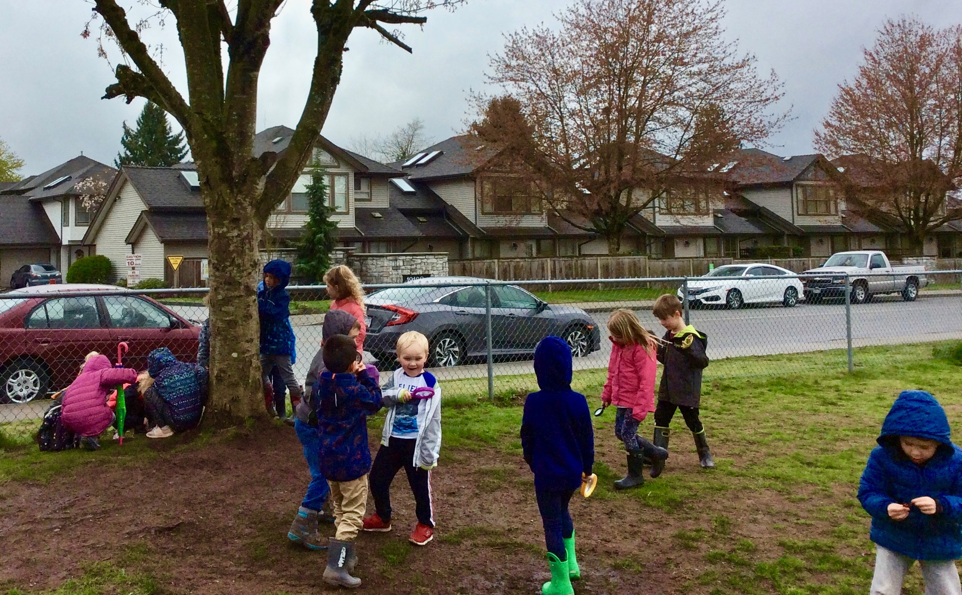

Placed-Based Learning can happen anywhere! Kindergarten students “adopt” a tree and its surrounding space right on PME’s schoolground. They make regular trips to investigate and document changes that occur throughout the year.

