COLLABORATIVE LEARNING

C
ollaborative learning is an educational approach to teaching and learning that involves groups of students working together to solve a problem, complete a task, or create a product. This approach requires students to be highly engaged in their learning, with a focus on process rather than on the right answer.
Students are expected to come prepared to discuss and collaborate. Teachers build in accountability with group marks and individual student assessments. Students teach each other through working on challenging class problems with the teacher as facilitator or coach. The goal is to shift learning from teacher-centered to a student-centered model.

For more information about BC’s new curriculum, visit https://curriculum.gov.bc.ca/

Coming in March – Aboriginal Worldviews & Perspectives in the Classroom.
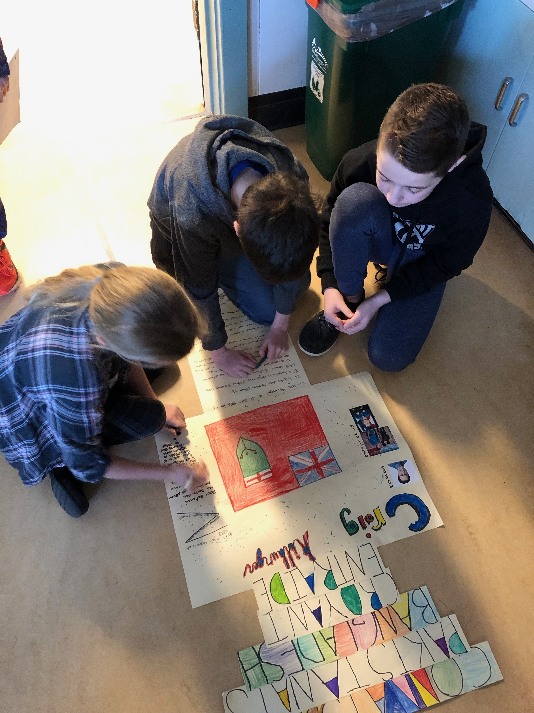

Comments by these grade 4/5 students reveal how they value each other’s strengths and learn from one another as they work collaboratively on their biography project

