How has the curriculum been redesigned & how does this benefit student learning?

The BC curriculum has been redesigned to support the changing world students are entering. The redesigned curriculum is student-centered and flexible, maintains a focus on literacy and numeracy skills, and includes Aboriginal perspectives.

So how and what will your child be learning? Each month in our school newsletter we will highlight a key feature of the redesigned curriculum and share stories about how this feature is being implemented in your child’s classroom. We will also tell you about why these skills and abilities will help your child succeed.

Kindergarten to Grade 10 teachers are now using the new curriculum in all our schools. The redesigned curriculum for Grades 11-12 will be introduced in 2019/20. For more information about the new curriculum, visit http://www.sd42.ca/new-curriculum.

Coming in October - Core Competencies.

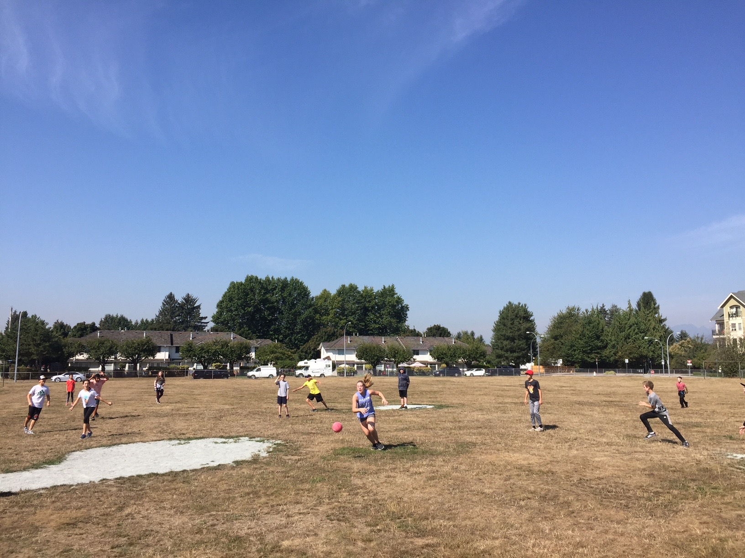
The redesigned curriculum provides flexibility to inspire the personalization of learning and addresses the diverse needs and interests of BC students. Physical literacy and fitness contribute to the success of PME students.

