INQUIRY LEARNING

I
nquiry Learning is a process where students investigate and explore answers to questions. Inquiry questions provide a focus for learning the curricular content, encourage students to develop important skills when answering questions and make learning more meaningful and relevant.
Inquiry questions provide a framework for teachers to more easily meet the needs of each student
while allowing students to be more engaged in the content they are learning.

For more information about the new curriculum, visit http://www.sd42.ca/new-curriculum.

Coming in June – How Do We Assess and Celebrate Learning?

Students in Division Four have been working on their final inquiry projects. They developed deep-thinking questions and took on the challenge of finding some answers! As part of their research, students conducted surveys and emailed and interviewed experts across the country.

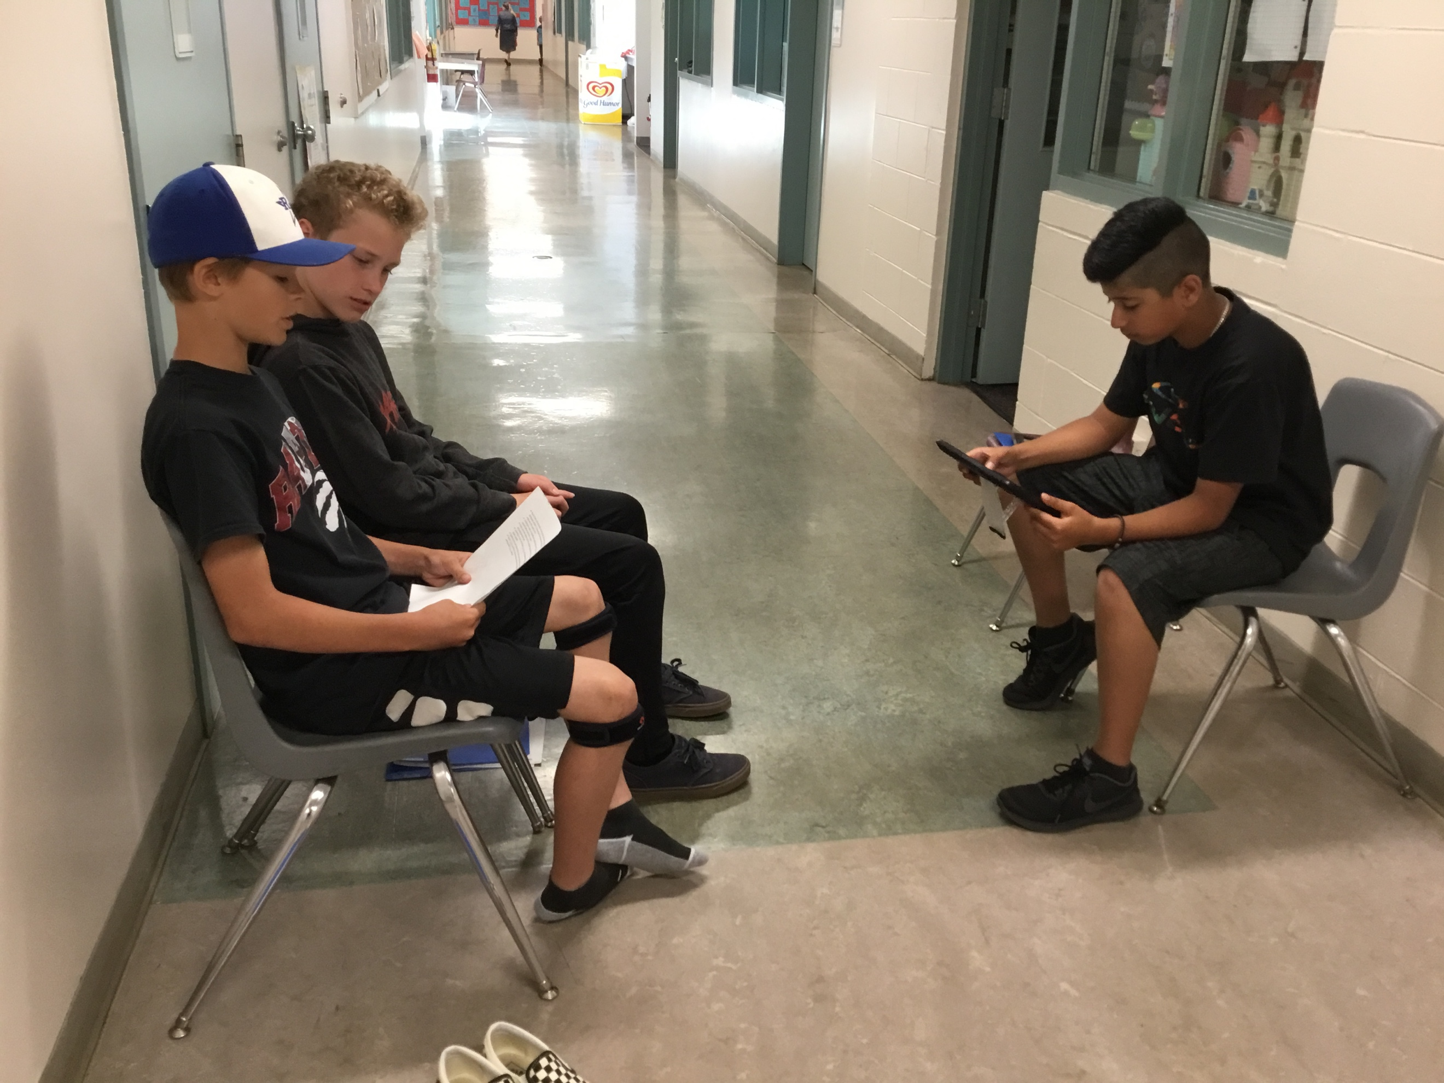

Students work on poster and video projects that illustrate their meaningful discoveries and collaborative efforts in creative and engaging ways!
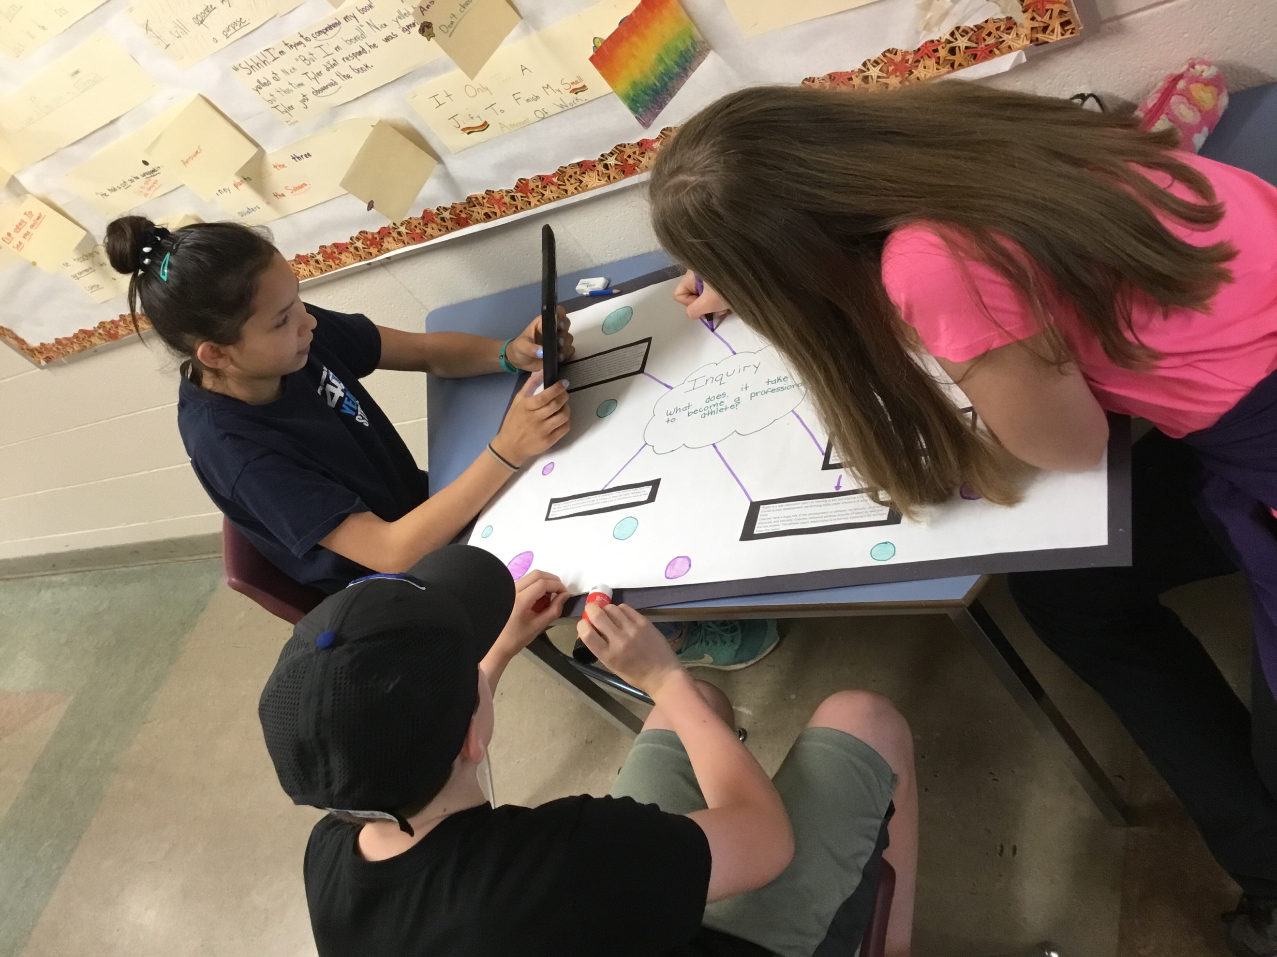

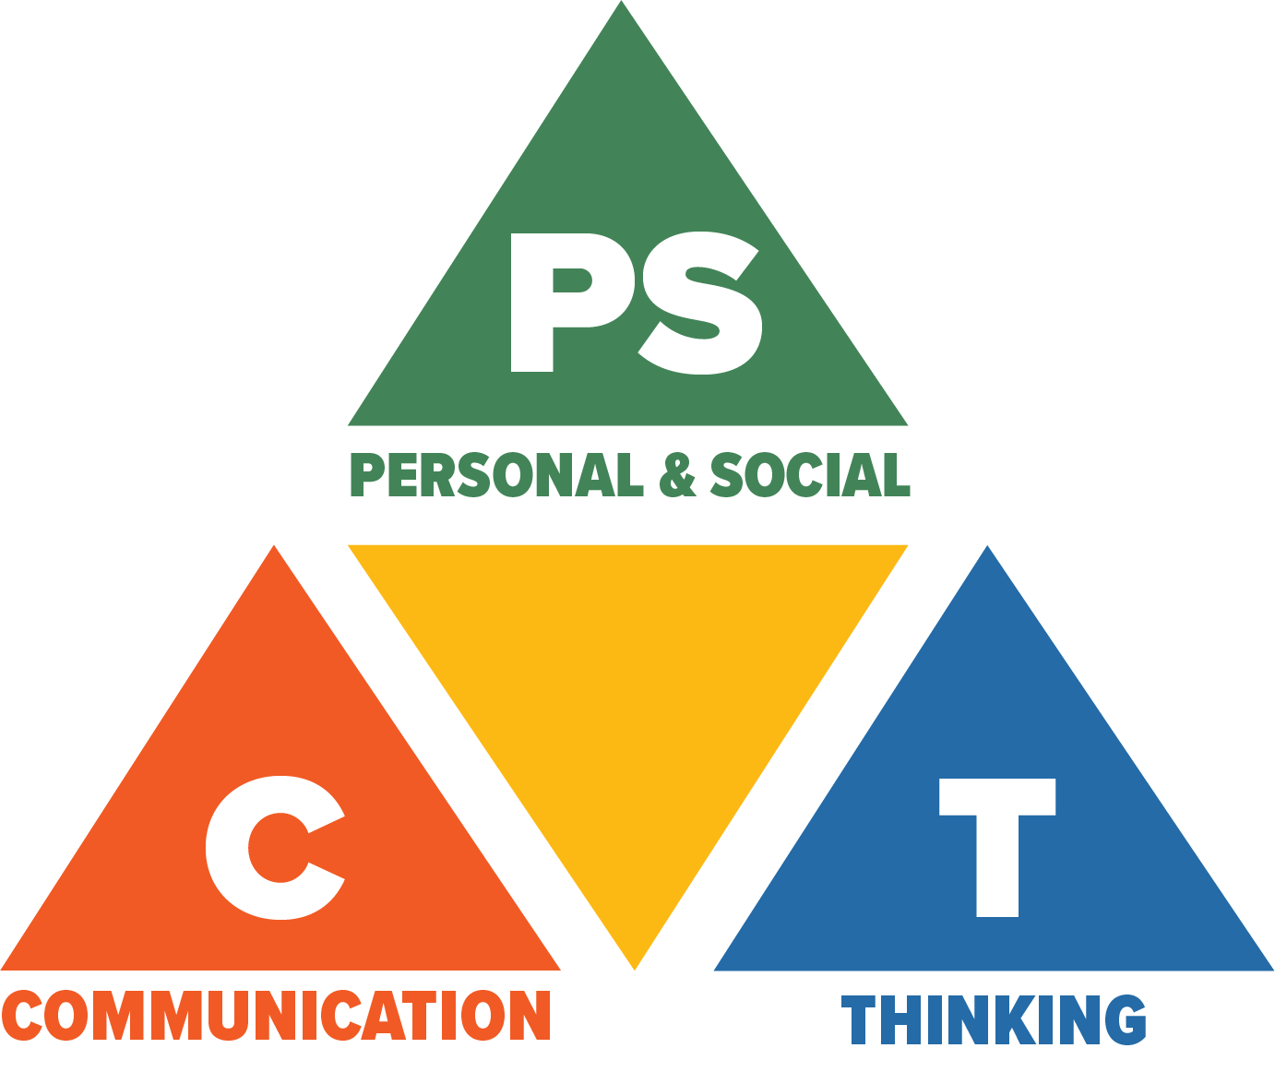
Core Competencies: What are they and why are they in the new curriculum?
The new curriculum centres around the following three core competency areas: communication, personal and social, thinking. They are sets of intellectual, personal, and social and emotional proficiencies that all students need to develop in order to engage in deep learning and life-long learning. Competencies are evident in every area of learning and in every grade, and come into play when students become actively engaged in their learning. During the school year, students will have an opportunity to self-assess their proficiencies in these core competencies.

