THINKING COMPETENCY
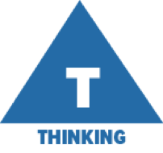
The thinking competency encompasses the knowledge, skills and processes we associate with intellectual development. It is through their competency as thinkers that students take subject-specific concepts and content and transform them into a new understanding. Thinking competence includes specific thinking skills as well as habits of mind, and awareness of thinking about thinking.

For more information about the new curriculum, visit http://www.sd42.ca/new-curriculum.

Coming in January 2018 – Personal & Social Competency.

This student uses a pyramid structure to represent the key ideas in a novel. He explains that this way of showing his thinking about a book encourages him to read it more carefully so that he can find specific information.
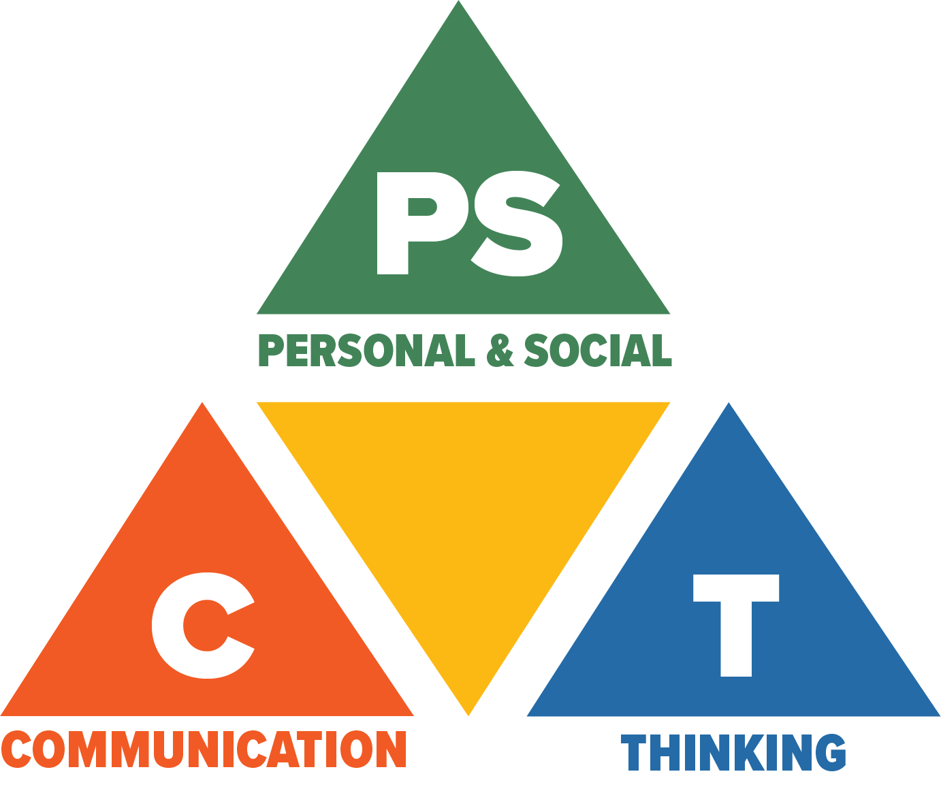
Core Competencies: What are they and why are they in the new curriculum?
The new curriculum centres around the following three core competency areas: communication, personal and social, thinking. They are sets of intellectual, personal, and social and emotional proficiencies that all students need to develop in order to engage in deep learning and life-long learning. Competencies are evident in every area of learning and in every grade, and come into play when students become actively engaged in their learning. During the school year, students will have an opportunity to self-assess their proficiencies in these core competencies.

