**Newsletter # 4 Thursday, October 26th, 2017**

Dear PME Families,

October has flown by and we are now heading into the second half of the first term. Teachers are actively working to ensure the best learning environment for all students and are starting to prepare for the upcoming parent teacher conferences in late November. Some teachers may be sending home interim reports or making phone calls around any concerns they may be seeing. As a parent, you too can contact your child’s teacher should you have questions of them. It is very much a three way process between teacher, child and parent, and we encourage honest, open communication between home and school.

There are several fundraising projects going on in the school right now, and as always we look to you for your support in these efforts. Having said that, we are aware of the financial pressure on families, and we encourage you to pick the fundraisers that you wish to support, if you can, and to pass on those you do not choose. There is no obligation at all to purchase items through a fundraiser and we truly appreciate the support you are able to give the school.

Our door, as always, is open to comments, concerns or questions.

Happy Halloween to everyone. Look for more information in this newsletter on our school events for Halloween on Tuesday, October 31.

Stephanie Dand

Principal

**Remembrance Day Assemblies**

This year we will be holding two separate assemblies on Thursday November 9th to honour Remembrance Day. The primary assembly for Kindergarten to Grade Three will be at 9am and the intermediate assembly for Grades 4-7 will be at 11am. Both assemblies will be approximately half an hour long. Parents and families are warmly invited to join us for this observance.

**Christmas Concert**

Our PME Christmas Concert will be held on Wednesday December 20th at 1 pm, and again on Thursday, December 21st at 9 am. Please mark your calendars for this wonderful family event.

**Hospital Homebound Support:** School District No. 42 provides support to students who are unable to attend school for medical reasons. The Hospital Homebound teacher works with elementary and secondary students who have not been allocated support teacher time through a special needs designation at their school. Students may be absent due to a non-contagious illness or they may be recovering from surgery or an injury. Instruction is provided in Ridge-Meadows Hospital or in the student’s home. Homebound students qualify for support if they are absent from school for 10 consecutive school days.

**Head Lice:** This is the time of year when head lice may show up in your child’s hair. To prevent head lice among children at school, we ask that you remind your child not to share any personal items, such as combs, brushes, or hats. Further information can be obtained by contacting the Public Health Nurse at (604) 476-7000.

**Tissue Boxes Needed**

Cold and flu season is definitely here and with it comes the need to have tissues on hand. Donate a box of tissues to the school and your child’s name will go into a draw to win a special book prize. Any donation you can make is much appreciated. Thank you in advance for supporting our school in this way!

**Westcoast Recess and Lunch**



A reminder to parents and guardians that PME students play outside even when it is cold, rainy or even snowy. Only on rare occasions will we keep students inside. We would ask that you send your child/ren to school dressed for the weather (boots, coats, mitts, umbrella …). If your child has a tendency to get wet playing on the slides or in the field, **please send an extra set of clothing that your child can change into.**

**Cross Country**

Congratulations to all **Primary Cross Country** Runners! Shout out to: Khiam, Cohen, Makenna, Eloise, Gabriella, Isabelle F. and Andrew C. who all had top 10 finishes. Special shout out to Hannah C. who finished first! Thank you Mme Belson, Mlle Abdulla, Mme Van Buskirk, Mme St-Amour, Mr. Severud and Mme Dand for all your help. What a beautiful day you had for the race!

**Intermediate Cross Country:**

We had an excellent intermediate cross-country meet Monday, October 23rd. The rain held off and conditions were perfect for running. This year we had a very large team, with an especially strong showing of grade 4 runners. We are very glad to see that there is a passion for running at PME. Our athletes did very well, with many top 20 finishes including Markus B.; Jocelyn B.; Mariko S.; Rebecca B.; Luke H.; Kynan S.; Sophie N, who finished 5th overall in grade 7 girls; and Tyler M, who lead and finished 1st overall for the grade 4 boys, by a country mile! Athletes: thank you for participating in practices and coming out to the meet; these also include: Makio S., Greyson D., Harry J, Antonio S., Kanen P., Terence B., Charlie M., Emily B., Chris E., Ethan S., Juno C., Meghan P. and Davyn B. We hope to see many of you representing PME in track events at this year’s track and field meet.

Mr. Severud and Mme Abdulla

[](https://www.google.ca/url?sa=i&rct=j&q=&esrc=s&source=images&cd=&ved=0ahUKEwi229f6stvPAhXqrFQKHccsBmIQjRwIBw&url=https://www.jerseycares.org/Halloween_Drive&psig=AFQjCNHZ2oTOImv8-9rR8lX_CTSkYsR1qQ&ust=1476572395770727&cad=rjt)**Halloween**

Many classes will be doing special activities on Halloween. We ask parents to help their children make appropriate decisions around costumes making sure that the costumes are appropriate for elementary school. Make up is fine but **no weapons or masks are allowed.**

Here is the plan for Tuesday, October 31st

8:40 a.m. Primary Parade

9-10 a.m. Halloween Creative Dances

10:30-11:15 a.m. Halloween Creative Dances

12:40 – 1:30 p.m. Grade 4 / 5 Dance in gym

1:30 – 2:15 p.m. Grade 6 / 7 Dance in gym

We look forward to a fun day!

**Counselling Corner**

LISTEN TO EACH OTHER, HAVE FUN TOGETHER, MAKE LOVELY

MEMORIES TOGETHER….

**Halloween** is a time for excitement, fun, costumes and harmless mischief.

Your children will store these memories. Memories and experiences help shape who they will become in later life. Make them good ones, not scary ones.

Allow your child’s voice to be heard and give them a sense of control over what they are exposed to. Make sure they are old enough and ready enough for the spookiness of Halloween. Remember your job is always to make your children feel cared for and safe, to always protect them from what may overwhelm them.

There can be scary stuff…

**PALS – Parents As Literary Supporters is a free literacy program for parents/caregivers and their kindergartners or children ages 3 and 4. Child receive a FREE BOOK with each session. Please call the office to register at (604) 465-5828.**

**DATES: November 20, 2017**

**January 22, 2018**

**April 23, 2018**

**TIME: 2:45 – 3:45 PM**

**Christmas Craft Fair – Tuesday, November 21st, 2017**

Vendors needed for this year's PME Christmas Market Tuesday, November 21st at 5pm -8pm.  We are looking for homemade crafters, home based businesses or businesses wanting to promo or sell their product.  It is a great community event and all proceeds go the PAC.  Tables are $25 each with a door prize donation.  Please contact Myra Golab -  [myragolab@gmail.com](mailto:myragolab@gmail.com) to reserve your table.

**It is beginning to look a lot like ................. Xmas Market   **

For those that do not know me, my name is Kristen McDonald and I have a daughter in grade 4 at PME.  I am very excited to be taking on the President roll for PAC which just happened recently.  We have lots of great volunteers at Pitt Meadows Elementary and PAC is so very thankful for each and everyone of you.

We are thrilled to host a **Cookie Walk on November 21st** during our XMas Market from 5-8pm.  We are hoping for this to be a family night but we need your help bakers (or barely bakers like me).

Please consider baking cookies/pastries for the Walk.  The only requirements:

* provide at least 24 cookies (2 dozen)
* please put them into 1 dozen batches
* Xmas themed so wrapping them in a xmas bag or using Xmas ribbon with clear plastic bags
* due to the library the morning or day of November 21st.

Please let me know your name and if you can bring anything and I will send a friendly reminder closer to the date.  Spread the word and forward this email to other Pitt Meadows Elementary parents.

Cheers,

PME PAC

**Middle Years Development**

We invite your child to take part in a study aimed at gathering important information about the health and well-being of 4th and 7th grade children inside and outside of school. Specifically, the **Middle Years Development Instrument (MDI)** is an online survey that students complete in schools in November/December. The survey takes about 1-2 class periods and is supervised by school staff. This study is led by researchers at the Human Early Learning Partnership (HELP) at the University of British Columbia (UBC), and is sponsored by your school or school board, the United Way of the Lower Mainland, and the Government of BC.

**If you want to withdraw your child, please, sign and return the appropriate section of the form**

to the classroom teacher **by Monday Oct 30, 2017** if you **do NOT** want your child to participate.

**STUDENT LEADERSHIP NEWS:**

**Bake sale October 27**

[](https://www.bing.com/images/search?view=detailV2&ccid=5NhV6u3Y&id=F5C969023F6A8AEFDE6FC0760B357FD4C70FA135&thid=OIP.5NhV6u3Yzvhqdh1E69LtVQEsDR&q=bake+sale+clip+art&simid=608019602564317334&selectedIndex=0)Student leaders are continuing their fundraising effort for the completion of their school in India.   At this time they are $900 away from their $10000 goal.   On October 27 they will be having a bake sale.  **All items will be a toonie**.   Amy help in providing baked goods for the sale would be greatly appreciated.  Help us accomplish our goal and make a difference.

**We scare hunger**

**Halloween for Hunger**

**October 23-November 3**

Did you know that each month, over 850,000 Canadians require help from food banks—more than one third of these individuals are children and youth. At PME, student leaders want to make a difference through we scare hunger.  They are asking students to bring a non-perishable food item to help

Support our local Pitt Meadows food bank.  We will be collecting all canned goods from October 23rd to November 3rd.

**Intermediate school dance**

On October 31st student leaders will be hosting a Halloween dance in the afternoon.  Grades 4 and 5 will attend from 12:45 to 1:30 and grades 6 and 7 from 1:30 to 2:15

We are asking students to bring in a canned donation for the food bank as an entry fee, although no student will be denied access.  Remember to wear your costumes.



**Pajama Day November 1**

After a long night of trick or treating student leaders would like all PME students to come to school on November 1st in their comfiest Pajamas.  Show your PME pride!

**PAC Movie Night**

**PME Movie Night**

Friday, November 24th, 2017

Details to follow

**The Resigned Curriculum at Pitt Meadows Elementary**

***CORE COMPETENCIES:***

***What are they and why are they in the curriculum?***

The BC curriculum has been redesigned to meet the needs of 21st century students. The new curriculum maintains a focus on literacy and numeracy while supporting deeper learning through three core competency areas: **communication**, **personal and social**, and **thinking.**

Core competencies are sets of intellectual, personal, and social and emotional proficiencies that all students need to develop in order to engage in life-long learning. Core competencies are evident in every area of learning and in every grade, and come into play when students become actively engaged in their learning.

For more information about the new curriculum, visit <http://www.sd42.ca/new-curriculum>.

**Coming in November –** *The Communication Competency.*

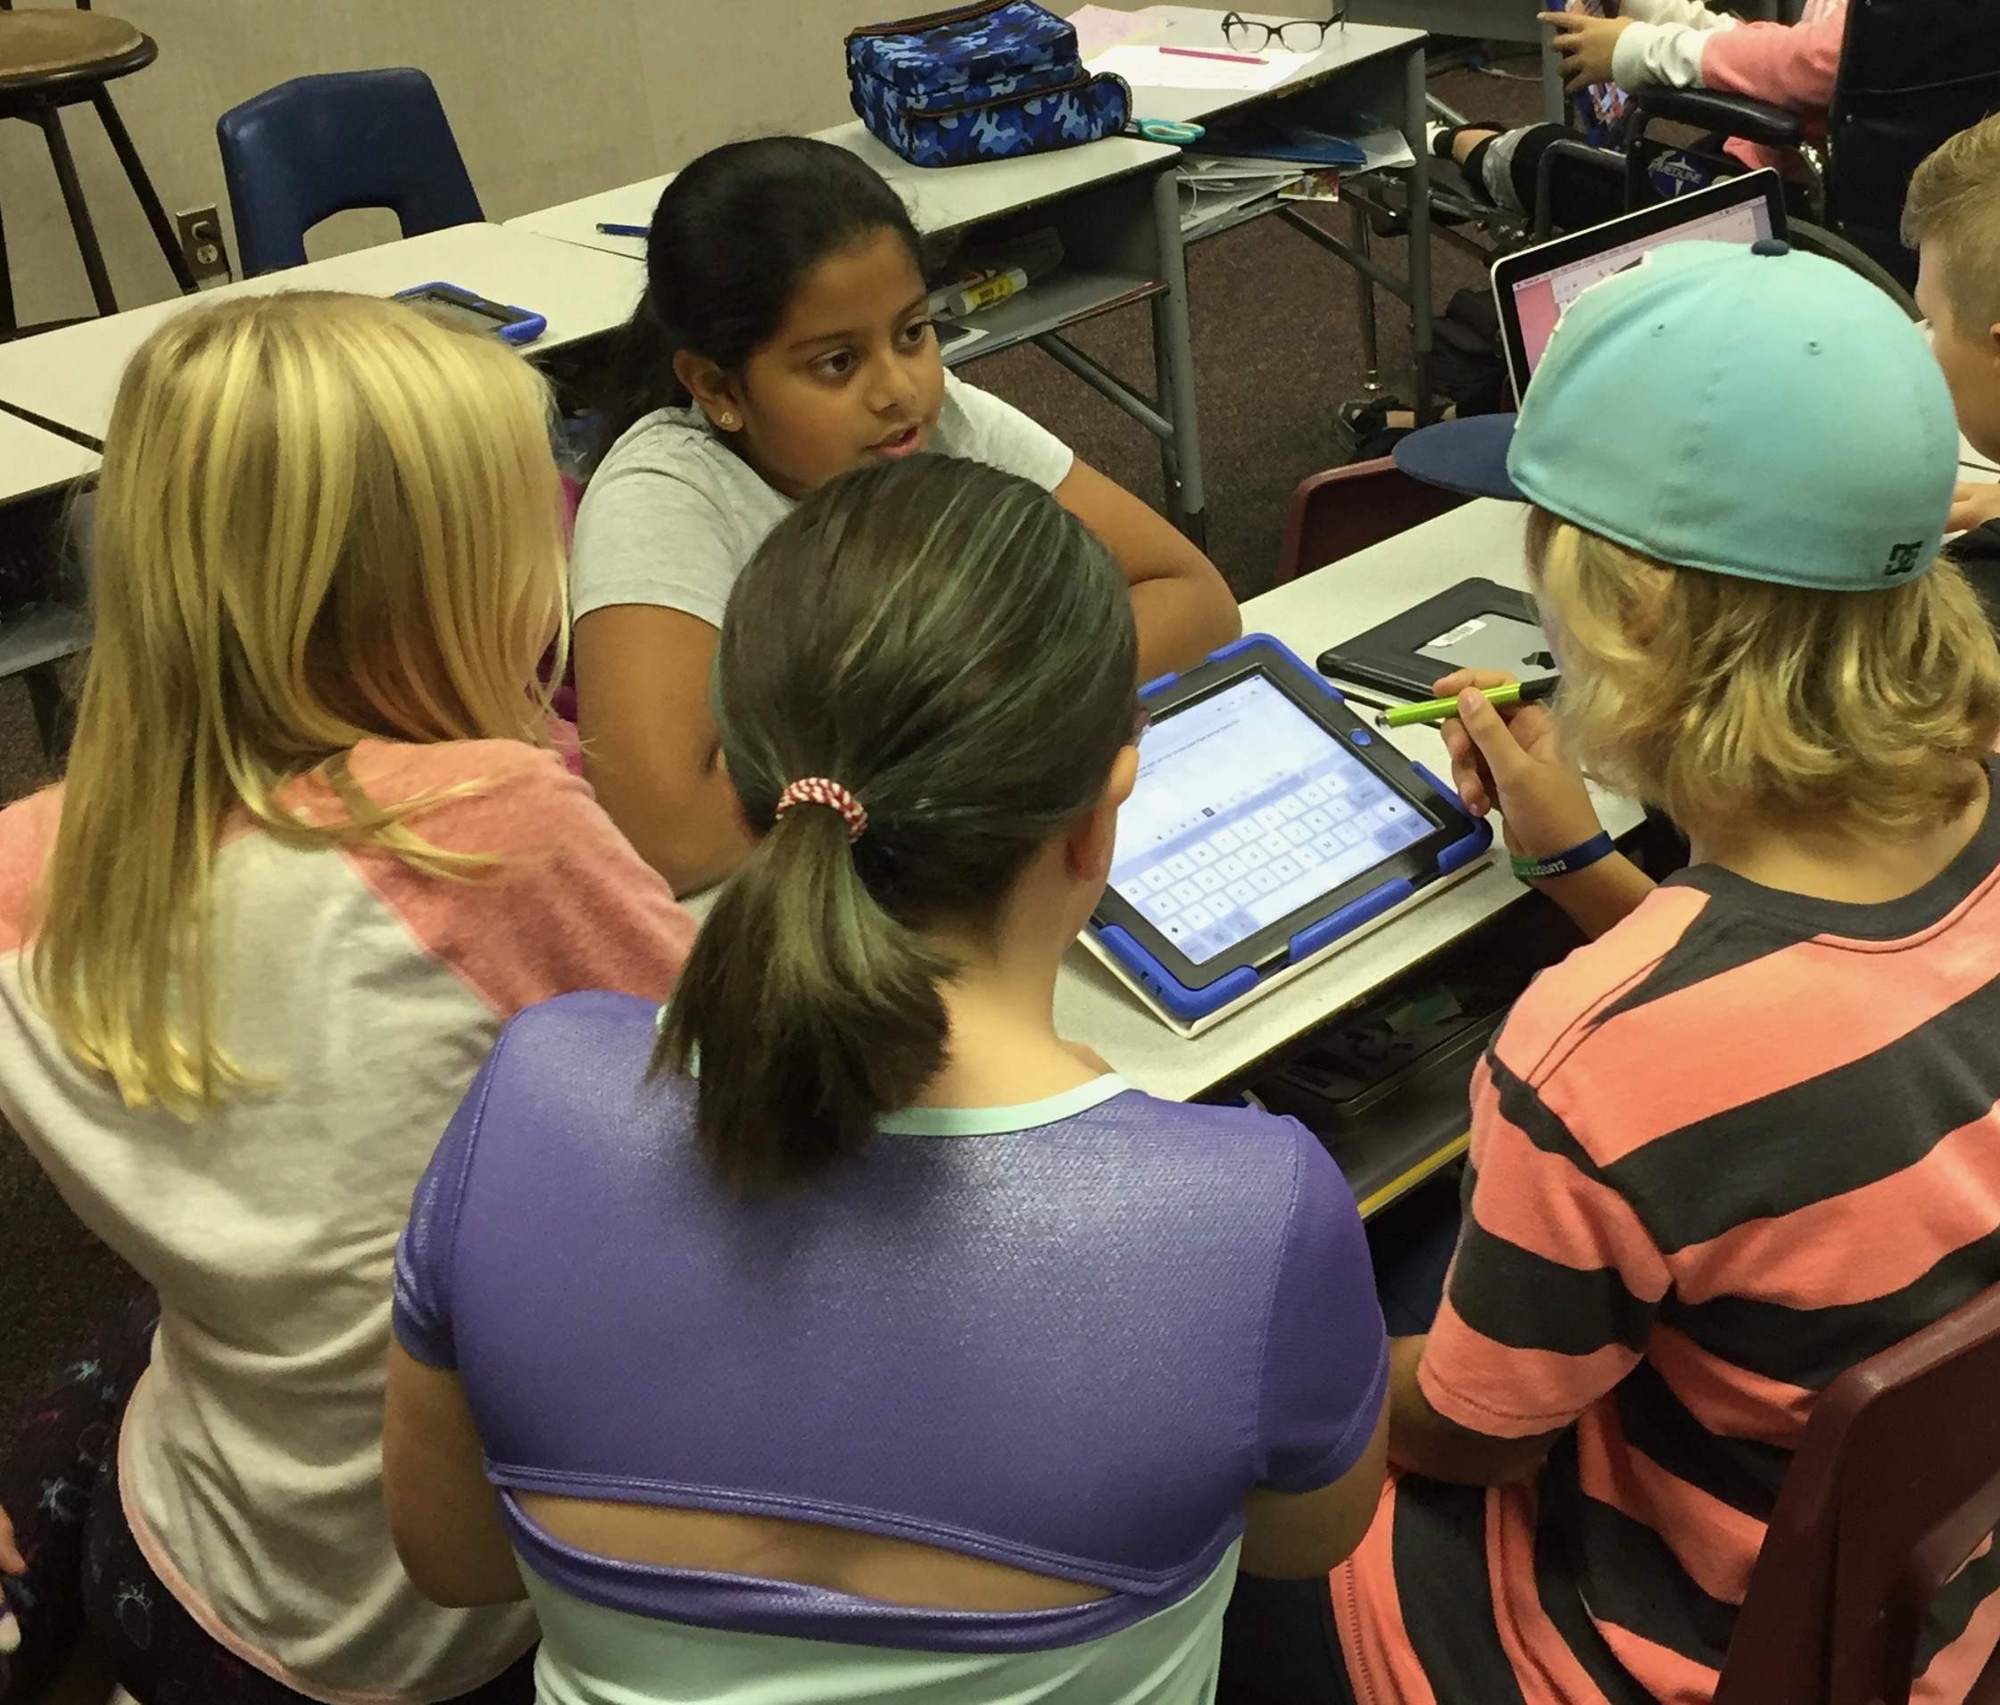

Grade 5/6 students collaborating to write a story for their class newspaper.

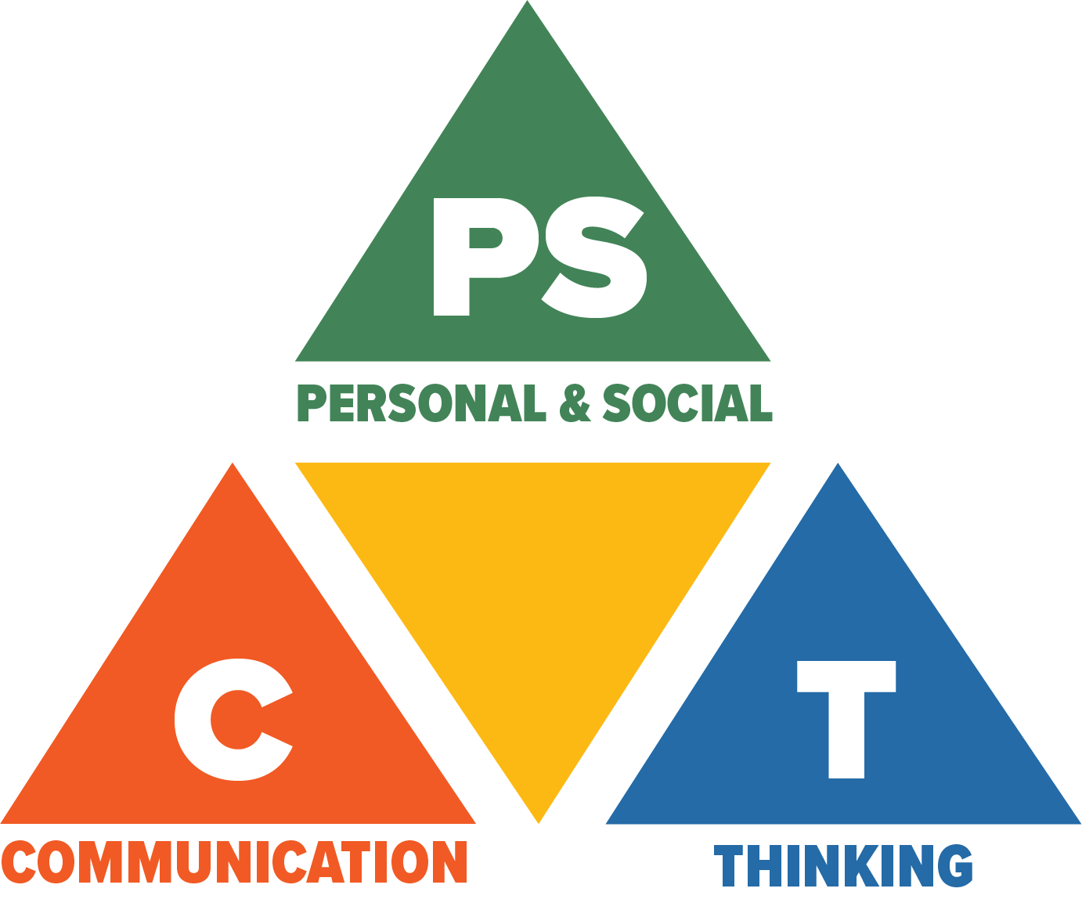***Core Competencies: What are they and why are they in the new curriculum?***

*The new curriculum centres around the following three core competency areas:* ***communication, personal and social, thinking.*** *They are sets of intellectual, personal, and social and emotional proficiencies that all students need to develop in order to engage in deep learning and life-long learning. Competencies are evident in every area of learning and in every grade, and come into play when students become actively engaged in their learning.* *During the school year, students will have an opportunity to self-assess their proficiencies in these core competencies*

**The Family Education and Support Centre**

[](http://familyed.bc.ca/)

**Conflict Resolution Parenting**

Learn how to use “I” statements, Conflict management parenting style, trigger scale, active listening, paraphrasing and open questions for parenting.

1x2hr. session

FREE

Tuesday, November 7th, 2017

Time: 6-8pm

Location: The Family Education & Support Centre

22554 Lougheed Hwy. Maple Ridge

Telephone: 604-467-6055

Website: http://familyed.bc.ca/

**THE FAMILY EDUCATION & SUPPORT CENTRE PRESENTS**

**Conflict Resolution for Teens**

A program for teenagers aged 13-16 to learn healthy conflict resolution and anger management skills

5-2hr sessions

Dates: Fridays November 3-December 1/2017.

Time 5-7pm

Cost: $100

Location: The Family Education and Support Centre

Registration: For registration contact Karen Hughes 604-467-6055(ext 101) reg@familyed.bc.ca, or register online at www.familyed.bc.ca

**Anger Monster**

For parents and their children ages 8-12 yrs old. This course includes two separate programs, one for the children and one for the parents at the same location.

Children’s program- children learn what anger is, their triggers and tools for learning to control their anger. Parent’s program - parents learn about anger cycles, goals of behaviour, how to support their child’s efforts to tame their anger monster, and skills for keeping themselves calm while their child is angry.

4-2 hr sessions

Price: $90 for 1 parent and 1 child ($25 for each additional parent of child)

Location: The Family Education and Support Centre

Dates: Wednesdays 6:30-8:30pm November 22– December 13 2017

Registration: For registration contact Karen Hughes 604-467-6055(ext 101) reg@familyed.bc.ca, or register online at www.familyed.bc.ca.

**FUNDRAISING NEWS:**

**Family Photo Fundraisers with Photo Express**

Photos will be taken in our portrait studio at 11916 207 St in Maple Ridge.  As in the past few years, we will have online booking available.  Here is the link for booking:

<http://www.photoexpressions.ca/portraits/fundraisers/>

**Family photos ($15 sitting fee) will be available between Nov 4 to Dec 17th,**

**and**

**our premium Christmas-themed event ($20 sitting fee) will run Nov 16 – 26th.**

**For the regular family photos each family also receives a free 8x10 portrait**, not available with the premium Christmas event.

Photo Express Facebook page is: <https://www.facebook.com/photoexpressfotosource>.

**CPF NEWS -** Canadian Parents for French Ridge Meadows

**French Immersion Boot Camp**

**Thurs, Nov 2 @ 7 – 8:30pm** Laity View Elementary

Parent lead orientation to surviving your first years as a French Immersion parent.

Tips and strategies for supporting your child when you don't speak French.

Of interest to parents of K to Grade 2.

 Free for Members / $5 for non-Members

RSVP to [cpf.ridgemeadows@gmail.com](mailto:cpf.ridgemeadows@gmail.com)

**Next CPF Chapter Meeting**

**Wed, Nov 15 @ 6:30 – 8pm** Eric Langton Elementary

[http://cpfridgemeadows.wordpress.com](http://cpfridgemeadows.wordpress.com/)

**Contact Us**

For more information visit our Chapter website <https://cpfridgemeadows.wordpress.com/> or email us at [cpf.ridgemeadows@gmail.com](mailto:cpf.ridgemeadows@gmail.com).

**PAC NEWS**

**The Pitt Meadows Elementary PAC now has it's own website!** Visit <http://pittmeadowselementarypac.weebly.com/> for the latest information about the PAC including budget spending, upcoming events and fundraisers, meetings and how you can get involved.

**Next PAC Meeting**

**Wednesday, November 7th @ 6:30 – 8pm** at Pitt Meadows Elementary in the library

Everyone welcome!

**COMMUNITY NEWS**



**Ridge Meadows College & First Aid Hero: Riverside Centre**

RED CROSS BABYSITTING – WINTER 2018 FOR 11 YEARS OLD PLUS

**COURSE DATES AND TIMES:**

Wednesday, January 3, 2018 8:30 am – 3:30 pm $63.00/1 session

LOCATION: Riverside Centre, 20575 Thorne Avenue, Maple Ridge

M – Th 8:00 am – 8:00 pm F 8:00 am – 3:30 pm

Phone: 604-466-6555 (Ext 203) Email: rmc@sd42.ca

To register, please contact Ridge Meadows College 604-466-6555 (Extension 203) or [rmc@sd42.ca](mailto:rmc@sd42.ca)

**SCHOOL DISTRICT #42**

**Have you thought about a career with our school district?**

Our vision is for every individual to feel valued, and for all learners to reach their full potential. This vision guides us in all the work we do. We deliver exemplary public education through diverse and inclusive environments that encourage learners to develop their full potential and pursue their aspirations. Our staff members are the foundation of our system. When you join our school district, you become part of a talented community of educators and support staff dedicated to enriching the lives of all students and helping them achieve success.

[Live and work in Maple Ridge and Pitt Meadows.](http://www.sd42.ca/maple-ridge-pitt-meadows/)

Please take alook at our website [www.sd42.ca](http://www.sd42.ca) careers tab for more information.

**Enclosures:**

*Canadian Parents for French*

*Family Photo Fundraiser – 2 pages*

*The Family Education and Support Centre – 3 pages*

*Ridge Meadows College – Red Cross Babysitting Course*

*Pitt Meadows Elementary Christmas Market Information Page*

**SCHOOL CLOSURE / EARLY DISMISSAL DAYS…**

* There is a Non-Instructional Day on **Friday, November 10th.**
* School will be closed for Remembrance Day, **Monday, November 13th.**
* Student Inclusive Interviews (early dismissal 11:30 am), **Monday, November 27, 2017**
* Student Inclusive Interviews (classes not in session – all day), **Tuesday, November 28, 2017**

**2017 – 2018 PME SCHOOL CALENDAR**

*PJ Day Wednesday, November 1, 2017*

*Non- Instructional day (curriculum implementation day) Friday, November 10, 2017*

*Remembrance Day Monday, November 13, 2017*

***Christmas Craft Fair Tuesday, November 21st, 2017***

***Ignite Camp Wednesday, November 22, 2017***

***Ignite Camp Thursday, November 23, 2017***

***PAC Movie Night Friday, November 24, 2017***

***Student Inclusive Interviews (early dismissal 11:30 am) Monday, November 27, 2017***

***Student Inclusive Interviews (classes not in session – all day) Tuesday, November 28, 2017***

*Hot Dog Day Wednesday, November 29, 2017*

*Christmas Concert Wed Dec 20 and Thurs Dec 21*

*Schools close for Winter Break Friday, December 22, 2017*

*Winter Break Monday, December 25, to Friday, January 5, 2018*

*Schools reopen after Winter Break Monday, January 8, 2018*

*Non-Instructional day Friday, January 26, 2018*

*Schools not in session Friday, February 9, 2018*

*Family Day Monday, February 12, 2018*

*Non- Instructional day (Curriculum Implementation Day) Tuesday, February 13, 2018*

*Student Inclusive Interviews (early dismissal 11:30 am) Wednesday, February 28, 2018*

*Student Inclusive Interviews (classes not in session – all day) Thursday, March 1, 2018*

*Schools close for Spring Break Friday, March 9, 2018*

*Spring Break Monday, March 12, to Friday, March 23, 2018*

*Schools reopen after Spring Break Monday, March 26, 2018*

*Good Friday Friday, March 30, 2018*

*Easter Monday Monday, April 2, 2018*

*Non- Instructional day Monday, April 30, 2018*

*Victoria Day Monday, May 21, 2018*

*Non- Instructional day Tuesday, May 22, 2018*

*Last day for students Wednesday, June 27, 2018*

*Year-end Administrative Day Thursday, June 28, 2018*

*Schools close for Summer Vacation Thursday, June 28, 2018*

As at: October 17, 2017