Newsletter # 2 Thursday, September 28th, 2017

Dear PME Families,

Here we are almost into October already! The month of September was a very busy and productive one. We welcome any feedback or comments you may have about how the start- up has gone for your family this year.

We have been working as a staff on our student expectations and code of conduct. Please look on our website or in your child’s agenda, if they use one. We are reinforcing the concepts of respect, responsibility and doing one’s best in all that we do here as a school community. Please talk to your children at home about this as well. The school/ home communication and connection is a vital key to student success at school, both socially and academically.

We are also renewing our focus on taking care of our environment and our school. We have juice box, paper and organics recycling programs running very well in our school, and I would like to take this opportunity to thank Mme Greene and her class for all their work each day collecting juice boxes and paper recycling from the classrooms. Thank you as well to Mrs. White’s class who collect and empty all of the organic waste to be recycled from the rooms each day. Both jobs are a bit messy, but the children are always very eager and ready to help.

Enjoy the early fall weather while it lasts. Our door, as always, remains open for any feedback or concerns you may have.

Stephanie Dand
Principal

Parking at PME
Parking Lot Reminders

- -Always drive in and out of the parking lot in the correct direction, that is enter through the west entrance and exit though the east entrance.
- -Use the drop off lanes for drop off only. Do not leave your car parked in the drop off lanes.
- -Please do not block the entrance or exit areas by waiting there for your child. The drop off lanes do not extend around the curve toward the entrance of the parking lot. There is a large lot across from our parking lot that you are able to use if our lot is full when you arrive.
- -Drive extremely slowly and with caution and vigilance. Students may be walking in the parking lot at any time.
- -Please do not park in staff parking spots. We have many itinerant staff coming and going during the day and they need a place to park. Thank you.
- -Most of all, please be respectful of your fellow drivers. We are all in a hurry at some point and we need to slow down and remember that student safety is the only thing that is truly important.
- -The section of 119th Avenue from Harris Rd to the first bus stop is a no stopping zone. Please do not drop off or pick up your children along this stretch of 119th.

Thank you so much for your patience and support. Together we can ensure the safety of everyone.

Our School District is recognizing Orange Shirt Day
on Friday, September 29.
Please feel free to wear orange on that day to show your support.

“Orange Shirt Day is a legacy of the St. Joseph Mission (SJM) residential school commemoration event held in Williams Lake, BC, Canada, in the spring of 2013. It grew out of Phyllis' story of having her shiny new orange shirt taken away on her first day of school at the Mission, and it has become
an opportunity to keep the discussion on all aspects of residential schools happening annually.

The date was chosen because it is the time of year in which children were taken from their homes to residential schools, and because it is an opportunity to set the stage for anti-racism and anti-bullying policies for the coming school year. It also gives teachers time to plan events that will include children, as we want to ensure that we are passing the story and learning on to the next generations.

Orange Shirt Day is also an opportunity for First Nations, local governments, schools and communities to come together in the spirit of reconciliation and hope for generations of children to come.” (www.orangeshirtday.org)​

Student Verification Forms
Student Verification forms were sent home with all students on Tuesday. It is imperative that all parents fill this form out as accurately as possible and return it to the school promptly. In the event of illness or an emergency we need accurate information about how to contact you. Your immediate attention to this matter is appreciated. Please ensure you check the complete form, sign and date it.

Medical Alert Forms - Just a reminder that if you have a child that uses an Epipen, or has other health related issues, proper paperwork is required to be updated each September. Forms are available to download and print from the portal. If you require a paper copy of these forms, please pick up at the office. Please complete and return the paperwork with the medication as soon as possible. If the medication is to be kept with the child or in the classroom, please make a note of this on your form.
Thank you.

Legal Issues:
The office must have the latest copy of custody/visitation agreements in order to be enforced. Please stop by the office and we will make a copy for our records.

Welcome Slips
We are excited to see every child every day. Late slips will now be called “Welcome Slips”.
“Welcome Slips” are not needed unless your child arrives after 8:40 a.m. Before then, your child should go directly to their classroom, where their teacher will mark them late. If you should arrive after 8:40 a.m. please sign in at the office.

WELCOME TO
We are so glad you are here!
Sickness/Vacation – If your child is going to be absent from school or late for any reason, please remember to contact the school at (604) 465-5828 or log in the absence on the portal. An answering machine is available 24 hours a day for your convenience. If your child is late, please check in at the office. If we do not know the reason why your child is absent, we will contact all emergency numbers available until we can be sure that your child is safe. For the safety of your children please be sure to advise the office if you have a change in any emergency contact phone numbers. To reduce congestion at the office, please do not come for a ‘welcome slip’ until after 8:40 a.m.
Please see the enclosed Flu Prevention Tips.

After School Arrangements - To minimize phone calls to the office and class disruption, please ensure that your children are aware of lunch and/or after school arrangements when they arrive at school in the morning. We are pleased to be of assistance when unexpected problems arise however we do appreciate your efforts to keep those occurrences minimal. Thank you for your understanding.
Home Reading Kick Off
We are excited to start our Home Reading Program again this year and we will be kicking it off with Mme Dand and Mrs. MacKinnon reading to our primary students in the library and telling them all about the program. On October 3 primary students are invited to bring a stuffie from home to listen to the story. They will come home sometime that week with a brand new Home Reading bag and book to get started. We look forward to another great year of reading and learning!

Photo Day October 5
Individual student photos will be taken on Thursday, October 5. A reminder will come home early next week. Please have your child dressed nicely for the day. We will have parent volunteers available to make sure they look their best right before their photo.

Christmas Craft Fair - November 21st, 2017
Advanced notice of our Christmas Craft Fair which will be held on Tuesday November 21. More details about times and how to rent tables to come.

Middle Years Development
We invite your child to take part in a study aimed at gathering important information about the health and well-being of 4th and 7th grade children inside and outside of school. Specifically, the Middle Years Development Instrument (MDI) is an online survey that students complete in schools in November/December. The survey takes about 1-2 class periods and is supervised by school staff. This study is led by researchers at the Human Early Learning Partnership (HELP) at the University of British Columbia (UBC), and is sponsored by your school or school board, the United Way of the Lower Mainland, and the Government of BC.
If you want to withdraw your child, please, sign and return the appropriate section of the form
to the classroom teacher by October 27, 2017 if you do NOT want your child to participate.

Communications:
Portal and Website
We are working hard this year to communicate as much as we can with you, as often as we can, and we are committed to keeping you up to date through the parent portal and through our website. Please check both of these frequently. Unless the portal is down, we will not be sending paper copies home from the office. If you do wish to receive a paper copy of our communication, please pick up a copy at the office.

Teachers will be using a variety of methods for their class level communication, and will be contacting you through paper, email, blogs or class websites very shortly, if they have not already done so.
Bicycles, Skateboards and Scooters
We have had several students bringing bikes and scooters to school already. However, some students have NOT been observing our rules about use on school grounds. Parents, please re-enforce with your child(ren) that if they wish to have the privilege of riding their bike or scooter to school that they MUST follow school rules as noted below.

Students are welcome to ride their bicycles, skateboards and scooters to and from school provided they:
1) wear a helmet
2) do NOT ride on school grounds
Parents, please reinforce these two rules with your children. The safety of all is our utmost concern.

Electronics at school
In order to learn well, students need to stay active and eat well while at school. With this goal in mind we have spoken to the students about not playing on electronic devices during recess or lunch hour, both inside and outside. Please encourage your child to leave his or her device at home. We want students to be running around while outside, getting exercise. Similarly, when they come inside at lunch, it is time to eat slowly and talk to their friends. Once again, it is not a time to play an electronic game and not have not have time to finish their lunch. If you wish your child to have a cell phone at school in order to contact you, that is fine, but should only take a moment or two over lunch. Parents, please do not text or call your child during instructional time unless it is a real emergency. Messages can always be passed on to students through the office. Thank you for your support on this.

School supplies this year have been bulk ordered for all students, K-7, so parents do not need to buy supplies for their child(ren). Please make payment on the portal if possible. A portal announcement for payment has now been posted.

Elementary Band Program is still enrolling students. The Band Program is looking for students in Grade 6 and 7 that are interested in learning an instrument. No musical history is required ...just the desire to learn an instrument. The students attend PMSS for classes. The classes are on Monday and Wednesday morning from 8:30 - 9:30 a.m.
If you are interested in the wonderful opportunity for your child to learn a musical instrument contact
Christine Gilmour @ PMSS. CGilmour@sd42.ca.

Reminder:
Orders must be submitted by:
Friday, September 29th
^{Cash only please!}

The BC School Fruit and Vegetable Nutritional Program provides fresh fruit and vegetable snacks to public schools throughout BC.
^{Next delivery item: pears}

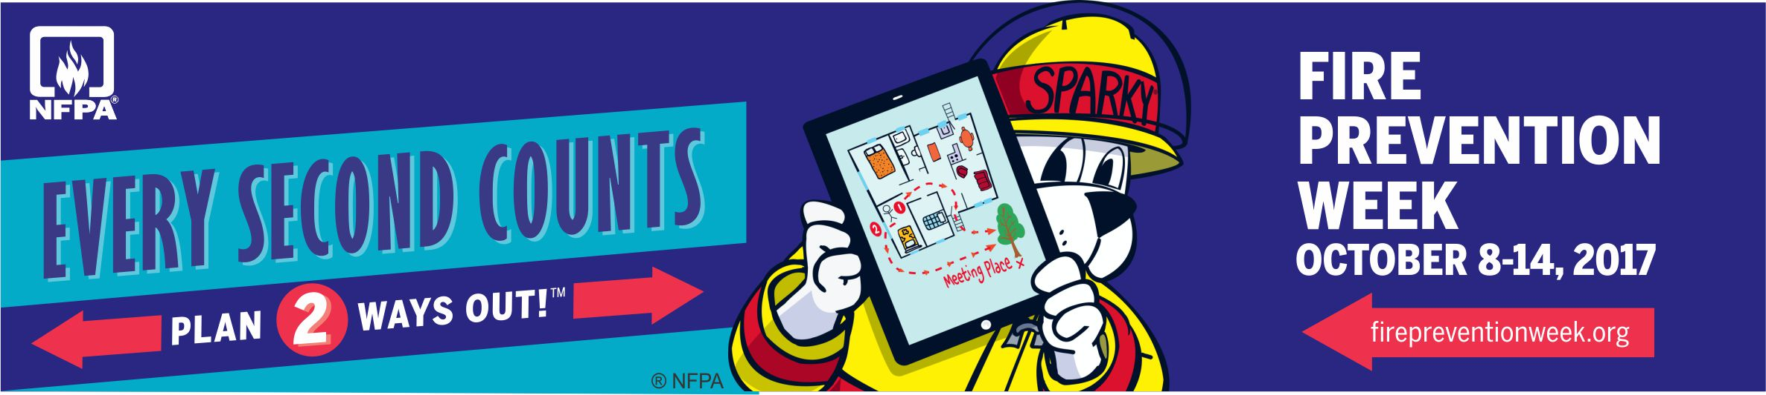

Fire Prevention Week: October 8 to 14th, 2017
Please spend some time with your child to review the “Fire Safety Starts with You” booklet which will be distributed shortly. Now is also a good time to review a fire escape plan at home and change your batteries in your smoke detectors.

Again, one iPad will be awarded to a child from each of B.C.’s five fire regions, and one to a child from a First Nations Band School. Please complete entry forms and return to the school no later than November 10th. The draw will be completed on November 17th and the selected form will be sent to the Office of the Fire Commissioner for the province-wide draw on December 1st.
Movie Night: Thursday, October 19th, 2017
^{Details to follow}

The Redesigned Curriculum at École Pitt Meadows Elementary

How has the curriculum been redesigned & how does this benefit student learning?

The BC curriculum has been redesigned to support the changing world students are entering. The redesigned curriculum is student-centered and flexible, maintains a focus on literacy and math skills, and includes Aboriginal perspectives.

So how and what will your child be learning? Each month in our school newsletter we will highlight a key feature of the redesigned curriculum and share stories about how this feature is being implemented in your child’s classroom. We will also tell you about why these skills and abilities will help your child succeed.

For more information about the new curriculum, visit http://www.sd42.ca/new-curriculum.
Coming in October - Competencies: Core vs. Curricular.

Grade 6/7 students worked together to create a lively and informative assembly about Terry Fox. They used maps, digital media, speeches, interviews and a skit to communicate their research to the entire school.

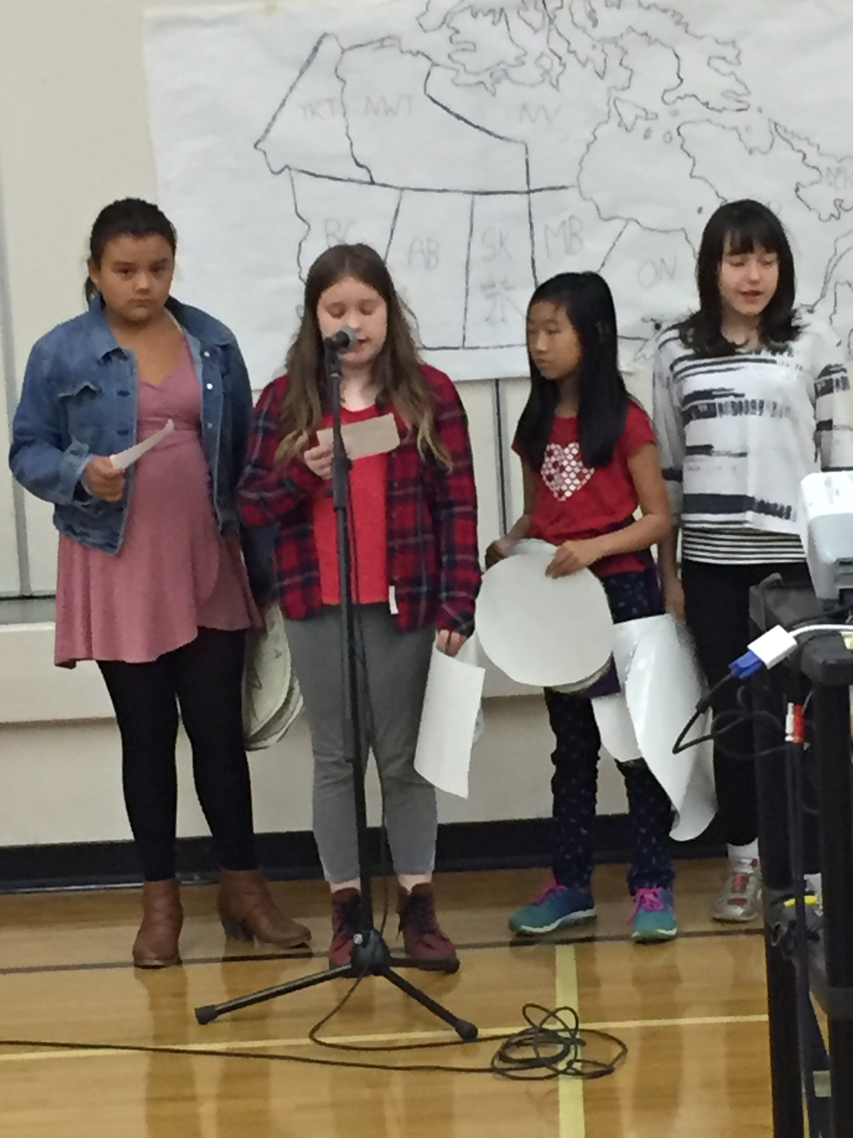

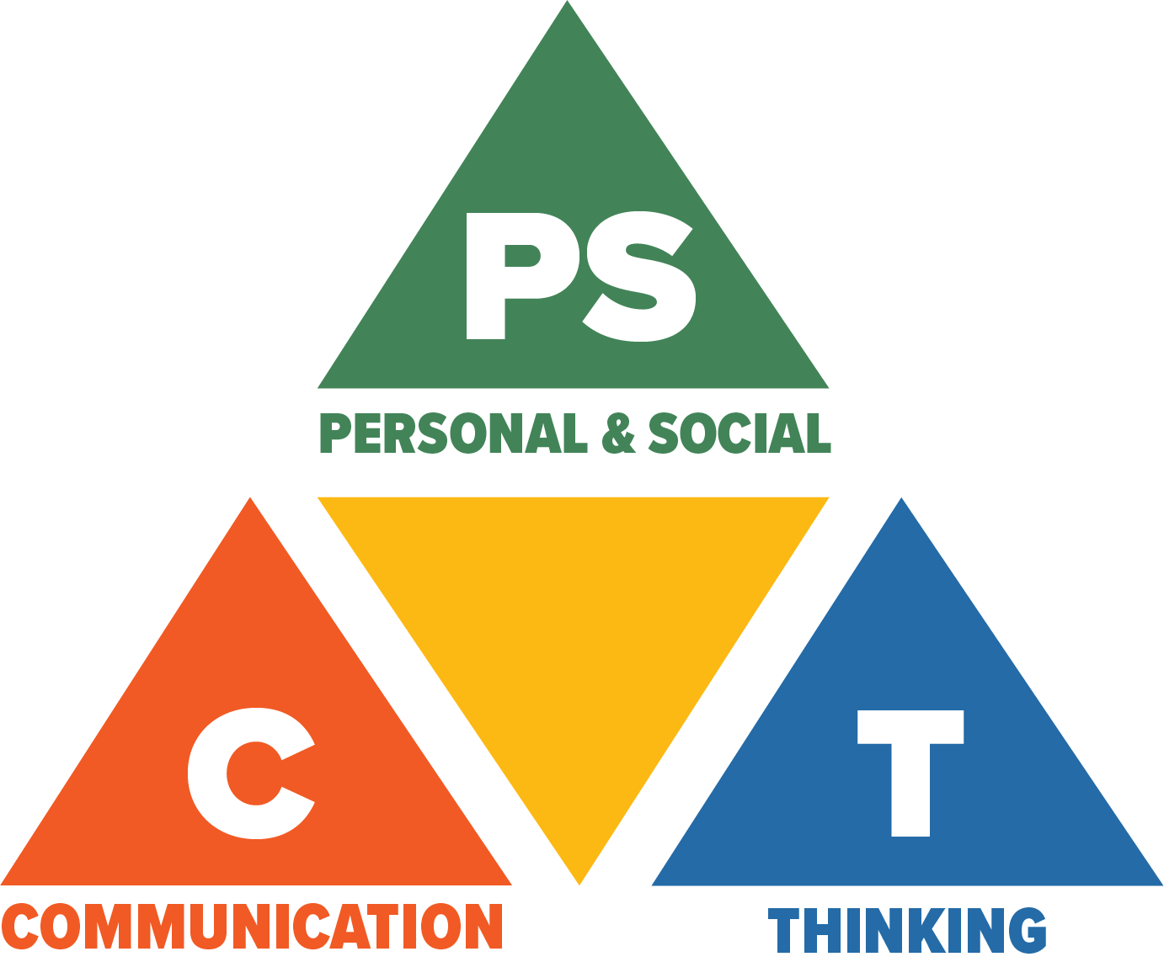
Core Competencies: What are they and why are they in the new curriculum?
The new curriculum centres around the following three core competency areas: communication, personal and social, thinking. They are sets of intellectual, personal, and social and emotional proficiencies that all students need to develop in order to engage in deep learning and life-long learning. Competencies are evident in every area of learning and in every grade, and come into play when students become actively engaged in their learning. During the school year, students will have an opportunity to self-assess their proficiencies in these core competencies.

Terry Fox Run 2017
Volunteers for the Terry Fox Run on September 29, 2017 12:25 – 2:15 p.m.
If you are interested in volunteering please email Mme Dand at Stephanie_Dand@sd42.ca. We need many volunteers to act as Marshalls along the route to ensure the safety of our students on both the primary and intermediate routes. Mr. Severud will organize all parent volunteers (and high school ones too) on the day of the run after the second lunch bell (the eating bell) has rung (approximately 12:25). Parents are always welcome to join us on the run too.

Terry showed us all that the impossible is possible. He reminded us all that we can make a difference in the world and change people’s lives for the better. Now’s your chance to do just that by raising funds for your school’s Terry Fox Run.

Our annual Terry Fox Run is happening Friday September 29th at 12:50. This is an annual event during which all students from grades 1 to 7 run to support Terry’s Marathon of Hope. This year, our goal is to raise up to $2500.

As part of our Terry Fox Run and our fundraising event, Student Leadership has decided to kick off the school year with their own Spirit Week.
Spirit Week will commence on Tuesday September 26th with Toonie Tuesday Terrible Hair Day - Come to school with your craziest hair do and bring a Toonie in support of Terry.
Wednesday, September 27th will be our Winning Wednesday Jersey Day. Show your pride for your favourite team by wearing your own soccer, hockey or football jersey. In fact, show your love for any sports team that you want, but bring a loonie in support of TERRY FOX.
Thursday, September 28th is Tired Thursday Pajama Day. Come to school in your comfiest PJ's and bring along any loose change or bills that you wish to contribute.
Finally on Friday, September 29th we will all take part in the Terry Fox Run on Fantastic Funky Friday. Bring any donations that you wish (bills, cheques or change) and run the race in your funkiest outfit. Remember to wear proper running shoes.
As incentives to raise funds, teachers have once again committed to do funny things to themselves and allow student to do funny things to them. Once again, Mr. Severud will wear a tutu and tiara during the warm-up and run, and Mr. Hume will allow some lucky students to tape him to the wall. A number of students may also win the opportunity to throw a pie in the face of some sacrificial teachers and Principle Dand, if enough funds are raised.

Routes

Primary Route
Our primary route remains the same as in previous years. The primary route is as follows: from the Spirit Square, primary students will run south down Harris Road; turn right on 119 Ave west to 189A St., following to the north; turn left on 119B Ave; turn right on 188A St.; turn right on 120B; immediate turn left on 188B St.; turn right on Ford heading east to 190A St.; turn right on 190A street to round-about crosswalk to PME, returning to the route on 119 Ave at the maintenance entrance for a second lap. At all times, students are expected to run on the sidewalk. Kindergarten classes will be doing their own Terry Fox run at a separate time.

Intermediate Route
Our intermediate route has changed this year due to the ever-escalating construction in the Airport Road corridor. Industrial park construction continues and there are many trucks coming and going.

The intermediate route is NOW as follows: from Spirit Square, students run south down Harris Road, crossing 119 Ave to Mitchell; cross Harris from south side of Mitchell/Hammond, heading east; down the south side of Hammond, crossing 193rd St., Blakely Rd., Bonson Rd., and Wildwood Cres., down the hill; turn right onto the “Hammond-Gold Ears Bridge” recreation/bike trail, heading south; leave trail at Joyner Pl, heading west; turn right on Bonson Rd, heading north, crossing Wildwood Cres, 116A Ave, 117A Ave; at Hammond, cross Bonson and head west down the south side of Hammond, returning on the same route from which we came.

For both routes, at all turns and crossings, we will have a number of parent and high school volunteers helping us to keep the kids safe. In addition, a water station will be set up at the bottom of Joyner Place for runners to access. All students will be encouraged to run and it is recommended they wear breathable clothing and drink plenty of fluids during the morning and at lunch. Sunblock is recommended, as our afternoons are still bright and warm.
Mr. Severud and Mme Chabot

STUDENT LEADERSHIP NEWS:
Thursday, September 28th is Tired Thursday Pajama Day. Come to school in your comfiest PJ's and bring along any loose change or bills that you wish to contribute.

Finally on Friday, September 29th we will all take part in the Terry Fox Run on Fantastic Funky
Friday. Bring any donations that you wish (bills, cheques or change) and run the race in your funkiest outfit. Remember to wear proper running shoes.​

LUNCH LADY NEWS
Please go online and check out the menu options available. Throughout the fall they will be randomly selecting students off our their network for a FREE LUNCH! No purchase is necessary but you must be registered for an account with the Lunch Lady. Don’t have an account? Go to www.thelunchlady.ca
Your community Lunch Lady is Jennifer (604) 460-9015. You can contact her at jennifer@thelunchlady.ca

CPF NEWS
Canadian Parents for French (CPF) Ridge-Meadows Chapter
CPF Ridge-Meadows chapter members are parents of students in BC’s Pitt Meadows / Maple Ridge School District No. 42 with an interest and focus on supporting French Language learning.

Some of the CPF Ridge-Meadows sponsored activities include, Parent Survival Night and French Summer Camp.

CPF Membership
Become a CPF member or renew your membership online at http://cpf.ca/en/membership/.

Next Meeting: Wednesday, October 18th , 2017 at Pitt Meadows Elementary.

Contact Us
For more information visit our Chapter website https://cpfridgemeadows.wordpress.com/ or email us at cpf.ridgemeadows@gmail.com.

PAC NEWS
The Pitt Meadows Elementary PAC now has it's own website! Visit http://pittmeadowselementarypac.weebly.com/ for the latest information about the PAC including budget spending, upcoming events and fundraisers, meetings and how you can get involved.

Next Meeting: Tuesday, October 17th, 2017 at 6:30pm in the library at Pitt Meadows Elementary.
Everyone welcome!

DISTRICT NEWS
Have you thought about a career with our school district?
To see the opportunities we have available, visit us at http://www.sd42.ca/careers/

Enclosures:
What’s On – Programs available and contact information
I Love Transit – October 2 to 6, 2017
Subway Order Form
Flu Prevention Tips

2017 – 2018 PME SCHOOL CALENDAR

Individual Student Photos Thursday, October 5, 2017
Free transit Week October 2 – 6, 2017
Kick Off Home Reading Program Tuesday, October 3, 2017
Thanksgiving Day Monday, October 9, 2017
Subway Day Wednesday, October 11, 2017
Grade 6 Immunizations Wednesday, October 11, 2017
PAC Meeting Tuesday, October 17, 2017
WE Day Vancouver Wednesday, October 18, 2017
Movie Night Thursday, October 19th, 2017
Non- Instructional day (province-wide) Friday, October 20, 2017
Photo Retakes Wednesday, October 25, 2017
Non- Instructional day (curriculum implementation day) Friday, November 10, 2017
Remembrance Day Monday, November 13, 2017
Christmas Craft Fair Tuesday, November 21st, 2017
Student Inclusive Interviews (early dismissal 11:30 am) Monday, November 27, 2017
Student Inclusive Interviews (classes not in session – all day) Tuesday, November 28, 2017
Schools close for Winter Break Friday, December 22, 2017
Winter Break Monday, December 25, to Friday, January 5, 2018
Schools reopen after Winter Break Monday, January 8, 2018
Non-Instructional day Friday, January 26, 2018
Schools not in session Friday, February 9, 2018
Family Day Monday, February 12, 2018
Non- Instructional day (Curriculum Implementation Day) Tuesday, February 13, 2018
Student Inclusive Interviews (early dismissal 11:30 am) Wednesday, February 28, 2018
Student Inclusive Interviews (classes not in session – all day) Thursday, March 1, 2018
Schools close for Spring Break Friday, March 9, 2018
Spring Break Monday, March 12, to Friday, March 23, 2018
Schools reopen after Spring Break Monday, March 26, 2018
Good Friday Friday, March 30, 2018
Easter Monday Monday, April 2, 2018
Non- Instructional day Monday, April 30, 2018
Victoria Day Monday, May 21, 2018
Non- Instructional day Tuesday, May 22, 2018
Last day for students Wednesday, June 27, 2018
Year-end Administrative Day Thursday, June 28, 2018
Schools close for Summer Vacation Thursday, June 28, 2018
As at: September 27, 2017

