Newsletter #1 Thursday, September 14th, 2017

Dear PME Families,

We are off to a great start to the 2017-2018 school year. The students are settling very well into their new classrooms and are smiling, eager and working hard already. Everyone has that wonderful new school year energy and on behalf of all of the staff, I want to say how happy we are to be working with your children this year. A special welcome to our new Kindergartens and to students new to our school. We hope you will soon feel very much at home.

We have had a few staff changes this year and I would like to introduce them to you. We welcome to our school the following staff members:

Mrs Tanya Scott – Grade 1/2 English
Mrs. Kelly Harris – Support teacher
Mme Aurore Chapiteau – Grade 6 FI (until October 1)
Mrs. Shona Wood - Counsellor
And of course, Mrs. Barb MacKinnon, our new Vice Principal

Parents often have questions about their child being placed in a combined (split) class. I have attached some information about combined classes to this newsletter, and I encourage you to read it, and by all means ask if you have any questions or concerns.

There are many important items in this newsletter so please take the time to read it carefully.
Happy September, and, as ever, our door is always open.

Stephanie Dand
Principal

SCHOOL NEWS:
Parking at PME
Parking Lot Reminders
-Always drive in and out of the parking lot in the correct direction, that is enter through the west entrance and exit though the east entrance.
-Use the drop off lanes for drop off only. Do not leave your car parked in the drop off lanes.
-Please do not block the entrance or exit areas by waiting there for your child. The drop off lanes do not extend around the curve toward the entrance of the parking lot. There is a large lot across from our parking lot that you are able to use if our lot is full when you arrive.
-Drive extremely slowly and with caution and vigilance. Students may be walking in the parking lot at any time.
-Please do not park in staff parking spots. We have many itinerant staff coming and going during the day and they need a place to park. Thank you.
-Most of all, please be respectful of your fellow drivers. We are all in a hurry at some point and we need to slow down and remember that student safety is the only thing that is truly important.
-The section of 119th Avenue from Harris Rd to the first bus stop is a no stopping zone. Please do not drop off or pick up your children along this stretch of 119th.
Thank you so much for your patience and support. Together we can ensure the safety of everyone.
Medical Alert Forms - Just a reminder that if you have a child that uses an Epipen, or has other health related issues, proper paperwork is required to be updated each September. Forms are available to download and print from the portal. If you require a paper copy of these forms, please pick up at the office. Please complete and return the paperwork with the medication as soon as possible. If the medication is to be kept with the child or in the classroom, please make a note of this on your form.
Thank you.

Legal Issues:
The office must have the latest copy of custody/visitation agreements in order to be enforced. Please stop by the office and we will make a copy for our records.

Communications:
Portal and Website
We are working hard this year to communicate as much as we can with you, as often as we can, and we are committed to keeping you up to date through the parent portal and through our website. Please check both of these frequently. Unless the portal is down, we will not be sending paper copies home from the office. If you do wish to receive a paper copy of our communication, please pick up a copy at the office.

Teachers will be using a variety of methods for their class level communication, and will be contacting you through paper, email, blogs or class websites very shortly, if they have not already done so.

Welcome Slips
We are excited to see every child every day. Late slips will now be called “Welcome Slips”.
“Welcome Slips” are not needed unless your child arrives after 8:40 a.m. Before then, your child should go directly to their classroom, where their teacher will mark them late. If you should arrive after 8:40 a.m. please sign in at the office.

WELCOME TO
We are so glad you are here!

Sickness/Vacation – If your child is going to be absent from school or late for any reason, please remember to contact the school at (604) 465-5828 or log in the absence on the portal. An answering machine is available 24 hours a day for your convenience. If your child is late, please check in at the office. If we do not know the reason why your child is absent, we will contact all emergency numbers available until we can be sure that your child is safe. For the safety of your children please be sure to advise the office if you have a change in any emergency contact phone numbers. To reduce congestion at the office, please do not come for a ‘welcome slip’ until after 8:40 a.m.

After School Arrangements - To minimize phone calls to the office and class disruption, please ensure that your children are aware of lunch and/or after school arrangements when they arrive at school in the morning. We are pleased to be of assistance when unexpected problems arise however we do appreciate your efforts to keep those occurrences minimal. Thank you for your understanding.

Student Verification Forms
Student Verification forms will be going home with all students soon. It is imperative that all parents fill this form out as accurately as possible and return it to the school promptly. In the event of illness or an emergency we need accurate information about how to contact you. Your immediate attention to this matter is appreciated. Please ensure you check the complete form, sign and date it.

PE/ Gym Information

Primary Students and Inside Shoes
Welcome back to a new year. We are super energized to get back into PE. As always, all students are expected to wear appropriate footwear and attire in their PE session. For primary students, this means supportive non-marking shoes that may also serve as their inside shoes in the classroom, library, etc. (we do not recommend flat-bottomed shoes, slip-on shoes, or Crocs). We emphasize wearing inside shoes in the gym to keep it clean for all classes to use. Shoes your child already has, but may have been worn outside, CAN be cleaned for use in the gym; there is no need to rush out and buy yet more school supplies! It is also recommended that, on their scheduled PE day, primary students wear clothes in which they can move freely and confidently during PE activities; primary students are NOT given time to change for PE due to time constraints (there may be possible exceptions in 3/4 splits).

Intermediate Students and Gym Strip
A PE strip for intermediate students also includes supportive and athletic non-marking shoes that are dedicated for PE and are NOT worn outside. As with the primaries, re-purposed outside shoes can be cleaned and used for PE. A full gym-strip also includes a shirt (tank-top shoulder straps should be at least two fingers in width) and shorts that we suggest are the same length as your child’s finger tips with their arms placed at their sides or longer. Sweat/yoga pants are also acceptable.

Over the past few years, it has steadily been observed that fewer students were coming to PE prepared with a proper complete strip. There are good reasons to change for PE. Peers and teachers appreciate it when students change out of their sweaty stinky clothes before returning to the classroom. We all appreciate a clean floor. When students are not in proper gym strip they still participate in our activities, but sometimes those activities require footwear, in which case they cannot participate for safety reasons (e.g: hockey when they do not have clean indoor shoes). Our goal is to get the maximum number of students moving for the maximum amount of time that we see them. You may be receiving phone calls in the day from your child, a student-written letter for you to sign, or other possible “assignments” to encourage or help remind your child to bring their strip if they struggle with coming prepared for PE. With your help, none of these strategies will be required.

Injury or Illness
As we know, our children get colds or sometimes suffer injuries, barring them from full participation in PE. Please provide your child with a hand-written note or a note written in their planner if there injury or illness affects there participation in PE. These notes can be for both the classroom teacher and the PE teacher(s). It can be helpful if you give us a sense of their limitations as well as a sense of things they CAN do. Our philosophy is to encourage students to do what they can when they are not at 100%, even if that simply means helping us by observing activities or setting up/moving equipment. Students who are so ill that they cannot participate in PE should probably not be at school.

We’re very excited about the new school year and about teaching your children.

Coaches
School sports are set to get underway. Volleyball season will be starting in the week of September 25th and runs until early November (specific information will come soon). Students are already signing up. We have teacher coaches interested in both the boys and girls volleyball, so we are covered, coaching-wise, for these teams. However, when basketball season begins, we may possibly be short two coaches. Typically, we have enough interest to run two boy teams and one girl team (possibly two, even). Mr. Severud is stepping away from coaching two boys teams to coach only one of the teams (either boys or girls). We would still like to offer the boys (and girls, if the demand is there) a development team and a senior team; development teams naturally lead to seasoned senior teams. This means we will need two or three coaches. We may also need a coach for Ultimate Frisbee this spring (we’ll have a better idea about this in late February). Coach Crump has moved to another elementary school and Mr. Severud has to focus on the track and field season, which unfortunately runs concurrently with Ultimate. Ultimate Frisbee has a small core of interested students from last year that might want to play again. It’s a positive, low-competitive co-ed sport that’s easy to learn and fun to play.

If you coach a community team or have a background in basketball or Ultimate from your high school or college days and are interested in coaching a team this year, let Mr. Severud know. Parent coaches require a parent volunteer form to be filled out and need to have a sponsor teacher to be present for games and practices in a supervisory role. Mr. Severud can help to coordinate supervision and some management aspects of all sports teams for parents who may be interested in helping us out.

Mr. Severud and Ms. Abdulla
PE Dept.

Bicycles, Skateboards and Scooters

We have had several students bringing bikes and scooters to school already. However, some students have NOT been observing our rules about use on school grounds. Parents, please re-enforce with your child(ren) that if they wish to have the privilege of riding their bike or scooter to school that they MUST follow school rules as noted below.

Students are welcome to ride their bicycles, skateboards and scooters to and from school provided they:
1) wear a helmet
2) do NOT ride on school grounds
Parents, please reinforce these two rules with your children. The safety of all is our utmost concern.

Electronics at school
In order to learn well, students need to stay active and eat well while at school. With this goal in mind we have spoken to the students about not playing on electronic devices during recess or lunch hour, both inside and outside. Please encourage your child to leave his or her device at home. We want students to be running around while outside, getting exercise. Similarly, when they come inside at lunch, it is time to eat slowly and talk to their friends. Once again, it is not a time to play an electronic game and not have not have time to finish their lunch. If you wish your child to have a cell phone at school in order to contact you, that is fine, but should only take a moment or two over lunch. Parents, please do not text or call your child during instructional time unless it is a real emergency. Messages can always be passed on to students through the office. Thank you for your support on this.

School supplies this year have been bulk ordered for all students, K-7, so parents do not need to buy supplies for their child(ren). Please make payment on the portal if possible. A portal announcement for payment has now been posted.

Elementary Band Program is still enrolling students. The Band Program is looking for students in Grade 6 and 7 that are interested in learning an instrument. No musical history is required ...just the desire to learn an instrument. The students attend PMSS for classes. The classes are on Monday and Wednesday morning from 8:30 - 9:30 a.m.
If you are interested in the wonderful opportunity for your child to learn a musical instrument contact Christine Gilmour @ PMSS. CGilmour@sd42.ca.

BC School Fruit & Vegetable Nutritional Program (BCSFVNP)
Eating fruits and vegetables is essential for good health. Canada’s Food Guide to Healthy Eating recommends that we should all eat at least five servings of fruit and vegetables a day. Many children eat much less. In fact, research shows that only 1 out of 4 children eat this daily requirement.
Our snacks are served during class time, so a teacher can use this opportunity to engage students in discussion about fruits and vegetables and healthy eating habits. Many children will be trying a food for the first time and will love how good these snacks taste and make them feel. These are the building blocks towards a lifetime of healthy eating.
The BCSFVNP is a collaborative program from the provincial government’s Healthy Families BC with funding from the BC Ministry of Health. It is administered through the BC Agriculture in the Classroom Foundation, a non-profit organization dedicated to “Working to bring BC’s agriculture to our students.” The Foundation works with local growers and distributors to bring the fresh BC products to students
If your child has any allergies to the following fruits or vegetables, please let your child’s teacher know.

Sep 19th |  | Plums, Italian Prune
Oct 3rd |  | Apples
Oct 24th |  | Carrots, baby
Nov 7th |  | Pears
Nov 28th |  | Apples
Dec 12th |  | Oranges, Mandarin
Jan 30th |  | Apples
Feb 20th |  | Kiwifruit
Apr 17th |  | Cucumbers
May 1st |  | Tomatoes, Asst Types
May 15th |  | Peppers, Mini
Jun 5th |  | Tomatoes, Grape

Terry Fox Run 2017
Volunteers for the Terry Fox Run on September 29, 2017 12:25 – 2:15 p.m.
If you are interested in volunteering please email Mme Dand at Stephanie_Dand@sd42.ca. We need many volunteers to act as Marshalls along the route to ensure the safety of our students on both the primary and intermediate routes. Mr. Severud will organize all parent volunteers (and high school ones too) on the day of the run after the second lunch bell (the eating bell) has rung (approximately 12:25). Parents are always welcome to join us on the run too.

Terry showed us all that the impossible is possible. He reminded us all that we can make a difference in the world and change people’s lives for the better. Now’s your chance to do just that by raising funds for your school’s Terry Fox Run.

Our annual Terry Fox Run is happening Friday September 29th at 12:50. This is an annual event during which all students from grades 1 to 7 run to support Terry’s Marathon of Hope. This year, our goal is to raise up to $2500.

As part of our Terry Fox Run and our fundraising event, Student Leadership has decided to kick off the school year with their own Spirit Week.
Spirit Week will commence on Tuesday September 26th with Toonie Tuesday Terrible Hair Day - Come to school with your craziest hair do and bring a Toonie in support of Terry.
Wednesday, September 27th will be our Winning Wednesday Jersey Day. Show your pride for your favourite team by wearing your own soccer, hockey or football jersey. In fact, show your love for any sports team that you want, but bring a loonie in support of TERRY FOX.
Thursday, September 28th is Tired Thursday Pajama Day. Come to school in your comfiest PJ's and bring along any loose change or bills that you wish to contribute.
Finally on Friday, September 29th we will all take part in the Terry Fox Run on Fantastic Funky Friday. Bring any donations that you wish (bills, cheques or change) and run the race in your funkiest outfit. Remember to wear proper running shoes.
As incentives to raise funds, teachers have once again committed to do funny things to themselves and allow student to do funny things to them. Once again, Mr. Severud will wear a tutu and tiara during the warm-up and run, and Mr. Hume will allow some lucky students to tape him to the wall. A number of students may also win the opportunity to throw a pie in the face of some sacrificial teachers and Principle Dand, if enough funds are raised.

Routes

Primary Route

Our primary route remains the same as in previous years. The primary route is as follows: from the Spirit Square, primary students will run south down Harris Road; turn right on 119 Ave west to 189A St., following to the north; turn left on 119B Ave; turn right on 188A St.; turn right on 120B; immediate turn left on 188B St.; turn right on Ford heading east to 190A St.; turn right on 190A street to round-about crosswalk to PME, returning to the route on 119 Ave at the maintenance entrance for a second lap. At all times, students are expected to run on the sidewalk. Kindergarten classes will be doing their own Terry Fox run at a separate time.

Intermediate Route

Our intermediate route has changed this year due to the ever-escalating construction in the Airport Road corridor. Industrial park construction continues and there are many trucks coming and going.

The intermediate route is NOW as follows: from Spirit Square, students run south down Harris Road, crossing 119 Ave to Mitchell; cross Harris from south side of Mitchell/Hammond, heading east; down the south side of Hammond, crossing 193rd St., Blakely Rd., Bonson Rd., and Wildwood Cres., down the hill; turn right onto the “Hammond-Gold Ears Bridge” recreation/bike trail, heading south; leave trail at Joyner Pl, heading west; turn right on Bonson Rd, heading north, crossing Wildwood Cres, 116A Ave, 117A Ave; at Hammond, cross Bonson and head west down the south side of Hammond, returning on the same route from which we came.

For both routes, at all turns and crossings, we will have a number of parent and high school volunteers helping us to keep the kids safe. In addition, a water station will be set up at the bottom of Joyner Place for runners to access. All students will be encouraged to run and it is recommended they wear breathable clothing and drink plenty of fluids during the morning and at lunch. Sunblock is recommended, as our afternoons are still bright and warm.
Mr. Severud and Mme Chabot

STUDENT LEADERSHIP NEWS:
As part of our Terry Fox Run and our fundraising event, Student Leadership has decided to kick off the school year with their own Spirit Week.

Spirit Week will commence on Tuesday September 26th with Toonie Tuesday Terrible Hair Day - Come to school with your craziest hair do and bring a Toonie in support of Terry.

Wednesday, September 27th will be our Winning Wednesday Jersey Day. Show your pride for your favourite team by wearing your own soccer, hockey or football jersey. In fact, show your love for any sports team that you want, but bring a loonie in support of TERRY FOX.

Thursday, September 28th is Tired Thursday Pajama Day. Come to school in your comfiest PJ's and bring along any loose change or bills that you wish to contribute.
Finally on Friday, September 29th we will all take part in the Terry Fox Run on Fantastic Funky

Friday. Bring any donations that you wish (bills, cheques or change) and run the race in your funkiest outfit. Remember to wear proper running shoes.​

LUNCH LADY NEWS
Please go online and check out the menu options available. Throughout the fall they will be randomly selecting students off our their network for a FREE LUNCH! No purchase is necessary but you must be registered for an account with the Lunch Lady. Don’t have an account? Go to www.thelunchlady.ca
Your community Lunch Lady is Jennifer (604) 460-9015. You can contact her at jennifer@thelunchlady.ca

CPF NEWS
Canadian Parents for French (CPF) Ridge-Meadows Chapter
CPF Ridge-Meadows chapter members are parents of students in BC’s Pitt Meadows / Maple Ridge School District No. 42 with an interest and focus on supporting French Language learning.

Some of the CPF Ridge-Meadows sponsored activities include, Parent Survival Night and French Summer Camp.

CPF Membership
Become a CPF member or renew your membership online at http://cpf.ca/en/membership/.

Contact Us
For more information visit our Chapter website https://cpfridgemeadows.wordpress.com/ or email us at cpf.ridgemeadows@gmail.com.

PAC NEWS
The Pitt Meadows Elementary PAC now has it's own website! Visit http://pittmeadowselementarypac.weebly.com/ for the latest information about the PAC including budget spending, upcoming events and fundraisers, meetings and how you can get involved.

Next Meeting: Tuesday, September 26th 2017 at 6:30pm in the library at Pitt Meadows Elementary.
Everyone welcome!

DISTRICT NEWS
Have you thought about a career with our school district?
To see the opportunities we have available, visit us at http://www.sd42.ca/careers/

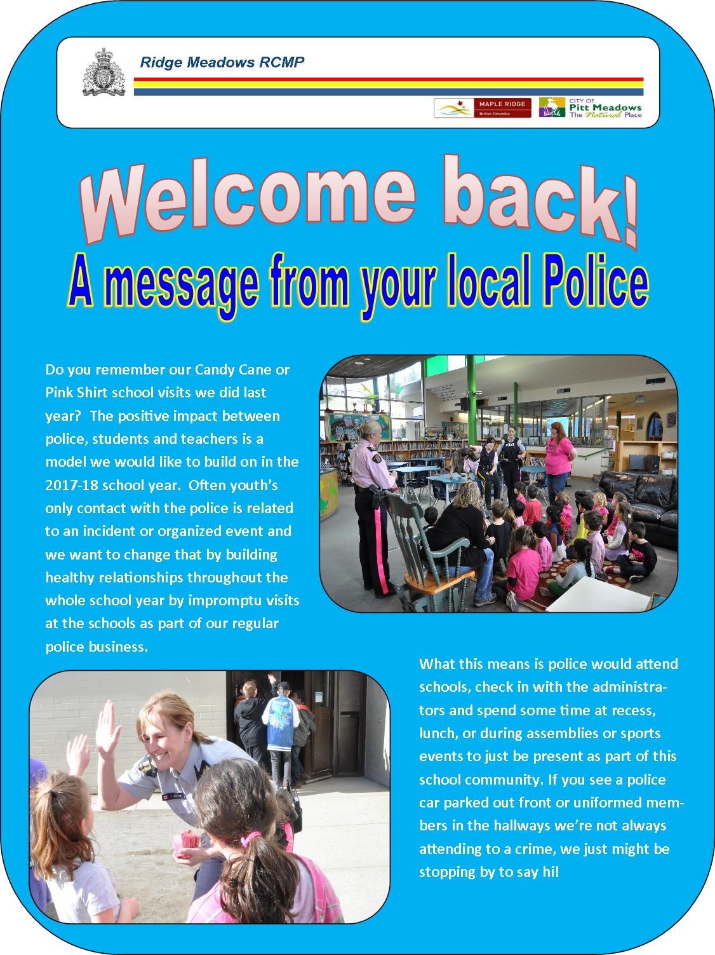

Enclosures:
2017-2018 Programs& Services www.familyed.bc.ca
Lunch Lady
Will My Child Be OK in a Split Class Information

2017 – 2018 PME SCHOOL CALENDAR

Schools opening day for students Tuesday, September 5, 2017

Non- Instructional day Monday, September 25, 2017
Thanksgiving Day Monday, October 9, 2017
Non- Instructional day (province-wide) Friday, October 20, 2017
Non- Instructional day (curriculum implementation day) Friday, November 10, 2017
Remembrance Day Monday, November 13, 2017
Student Inclusive Interviews (early dismissal 11:30 am) Monday, November 27, 2017
Student Inclusive Interviews (classes not in session – all day) Tuesday, November 28, 2017
Schools close for Winter Break Friday, December 22, 2017
Winter Break Monday, December 25, to Friday, January 5, 2018
Schools reopen after Winter Break Monday, January 8, 2018
Non-Instructional day Friday, January 26, 2018
Schools not in session Friday, February 9, 2018
Family Day Monday, February 12, 2018
Non- Instructional day (Curriculum Implementation Day) Tuesday, February 13, 2018
Student Inclusive Interviews (early dismissal 11:30 am) Wednesday, February 28, 2018
Student Inclusive Interviews (classes not in session – all day) Thursday, March 1, 2018
Schools close for Spring Break Friday, March 9, 2018
Spring Break Monday, March 12, to Friday, March 23, 2018
Schools reopen after Spring Break Monday, March 26, 2018
Good Friday Friday, March 30, 2018
Easter Monday Monday, April 2, 2018
Non- Instructional day Monday, April 30, 2018
Victoria Day Monday, May 21, 2018
Non- Instructional day Tuesday, May 22, 2018
Last day for students Wednesday, June 27, 2018
Year-end Administrative Day Thursday, June 28, 2018
Schools close for Summer Vacation Thursday, June 28, 2018

As at: June 23, 2017

