Friday Blast
Maple Ridge Elementary
January 8, 2021

WELCOME BACK
While the winter holiday was lovely, we are so pleased to see our students and staff at MRE once again. We hope you all had a restful and peaceful break and look forward to the learning opportunities that the winter and spring will bring us!

CONSTRUCTION
Fortis BC will be working at the intersection of River Road and Steeves Street. Work will commence on January 11th and should be completed before January 15^{th.}

CHANGE OF CLOTHES
As the blustery weather is forecasted to continue, please ensure your child has a change of clothes at school at all times. Even on rainy days we go outside at MRE for recess and lunch, making warm dry clothes a must!

SPIRIT DAY FRIDAYS
Our school spirit day Fridays continue in the month of January. Every Friday wear you best MRE gear or house team colours to receive a house point and be entered in the book draw at the end of the month.

PARENTING WORKSHOP
Please see the attached flyer for information regarding a workshop for parents and caregivers of children of all ages. This workshop focuses on understanding childhood anxiety and helping your child to manage stress.

SPRING BREAK WORKSHOPS
Please see the attached flyers below for various camps available over spring break.

MRE FACEBOOK PAGE
You can follow us on Facebook for the most up to date information and reminders! Use this link: https://www.facebook.com/Maple-Ridge-Elementary-SD42-106513777847643

ATTENDANCE
Please let us know if your child is going to be late or absent from school through either the parent portal, by emailing mre_reception@sd42.ca or by calling us at 604-467-5551. If you know your child will be absent multiple days in a row you can enter them all at once.

MESSAGES FROM OUR PAC
Our next PAC meeting will be on January 11, 2021 at 7:00 pm on Zoom.

All parents of MRE students are welcome! https://ca01web.zoom.us/j/68801044938?pwd=V2tuRnFSZWxQS0JXSlBkd2ZBYmxuQT09

You can learn more about our PAC and get updates by following them on Facebook. Just search for: MRE Parent’s Association!

MARK YOUR CALENDAR

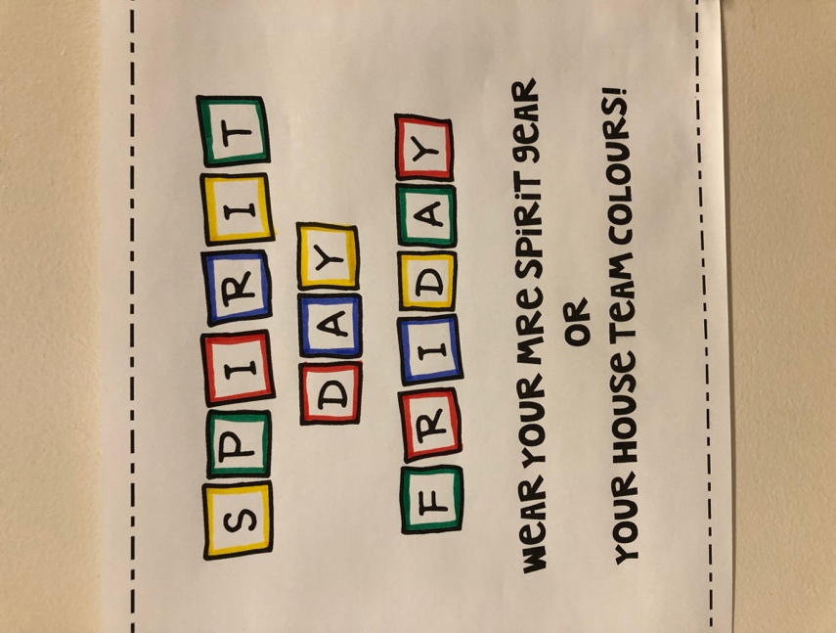
Friday January 8 – MRE Spirit Day
Monday January 11 – PAC meeting 7 pm
Friday January 15 – MRE Spirit Day
Friday January 22 – MRE Spirit Day
Monday January 25 – Pro D Day (No School)
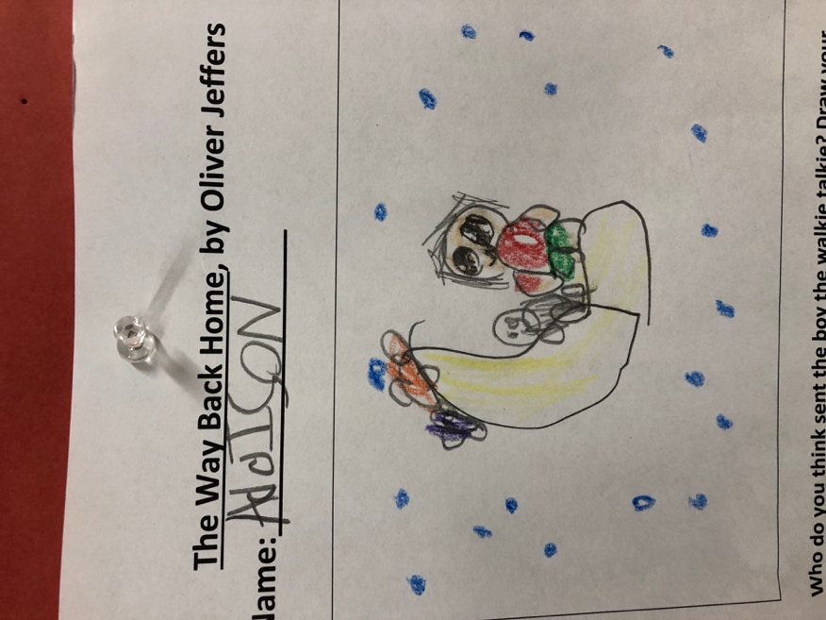
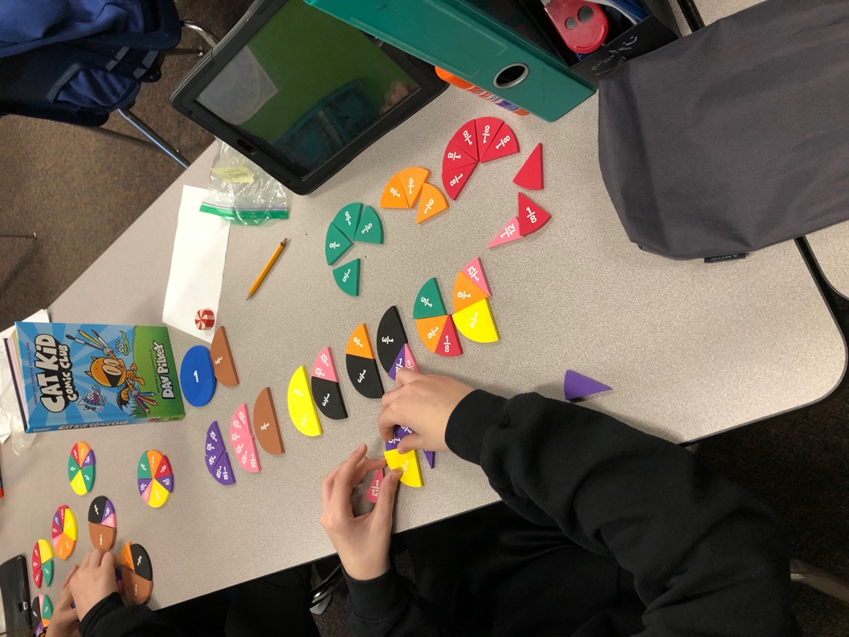
Friday January 29 – MRE Spirit Day

