Friday Blast
Maple Ridge Elementary
November 13, 2020

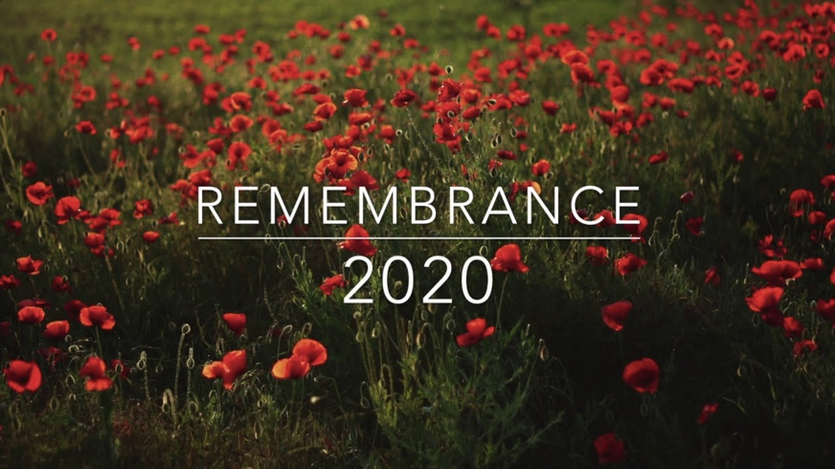
REMEMBRANCE DAY
Thank you to all the classes that participated in our virtual Remembrance Day assemblies this week. The respectful and solemn behaviour demonstrated by students was greatly appreciated. We regret that due to FIPPA regulations we are unable to invite parents to view the virtual assemblies and appreciate your understanding.

SPIRIT DAYS
Mark your calendar! This Friday November 13th (today) is Pajama Day and Friday November 20th will be Moustache Day.

SCHOOL PHOTOS
Our school photographer has offered the opportunity to have school photos completed for students who were absent on photo day. Photo Expressions will be opening their studio from Thursday Nov 12th to Saturday Nov 14th. Portraits will be by appointment only and there will be a $30 fee that will go towards your portrait order. Please book online using the following link:
https://photoexpressions.ca/portraits/booking/studio-school-portraits-2020/

Photo Expressions abides by strict Covid safety measures, some of which include:
· Studio doors will remain open, only photographer and subject in studio
· Maximum 4 people waiting in studio lobby
· Standing poses only and no props
· Frequent sanitation of studio
· Proofs will be emailed within a week of your sitting

Photo Expressions is located at: 140-2250 Fremont St, Port Coquitlam, BC
If you have any questions please email studio@photoexpressions.ca

GRADE 6 IMMUNIZATIONS
Please be advised that Public Health will commence the School Immunization Program for Grade 6 students in January 2021. Public Health will also provide catch-up immunizations to students who did not complete theirs last school year or over the summer. More information to come.

TOYS FROM HOME
Reminder to parents and students to please refrain from bringing toys from home to school. Due to our Health and Safety protocols we are requesting that home toys stay at home. Thank you for your cooperation!

PARKING
Our school is on a very busy road and student safety is vital. Please do not pull into the staff parking lots to drop off students. We suggest parking on a nearby street and walking the rest of the way to school. When doing so, please be cautious not to block the driveways of our neighbours.

Students may be dropped off in the drive-thru at the front of the school, but there is no parking in this area (except for daycare buses, taxis, and vehicles displaying the SPARC tag in their windshield). Students may NOT BE PICKED UP from the drive through area. It is closed between 2:00 and 2:30.
WEST COAST RECESS
The cold and rainy days are officially upon us! Please ensure you are sending your child to school in weather appropriate outer wear. This year we will be heading outside no matter what the weather. Your child may also want to consider keeping a back-up change of clothes in their bag in case it is needed.

FACEBOOK PAGE
Please like and follow us on Facebook! We will be sharing information, updates and reminders regularly. Please use this link: https://www.facebook.com/Maple-Ridge-Elementary-SD42-106513777847643

ATTENDANCE
Please let us know if your child is going to be late or absent from school through either the parent portal, by emailing mre_reception@sd42.ca or by calling us at 604-467-5551. If you know your child will be absent multiple days in a row you can enter them all at once so that you do not need to update it each day.

MESSAGES FROM OUR PAC

Our next PAC meeting will be on January 11, 2021 on Zoom
https://ca01web.zoom.us/j/68801044938?pwd=V2tuRnFSZWxQS0JXSlBkd2ZBYmxuQT09
All parents of MRE students are welcome at our PAC meetings!

Flip Give
This year the PAC is making fundraising easier! FlipGive is a simple way to support our school, while doing your regular shopping. Simply download the FlipGive app and then use it to shop! You can shop popular brands including Well.ca, Starbucks, Indigo, Sportchek and Esso. Join now by clicking here: FlipGiveApp If you are prompted for a join code use: FJF5TC
Online Book Fair
On November 23rd the book fair will be opening online. Just in time for the holiday season! Give the gift of reading a good book. All orders will be shipped directly to your home. Please use this link to access: https://bookfairs-canada.myshopify.com/pages/5149063

Neufeld Farms Fundraiser
Mark your calendars! If you ordered from the Neufeld Farms fundraiser, the delivery date is Wednesday November 25th @ 5:30pm

You can pick up your order “drive-thru style” at the front of the school.

PAC Hot Lunches
It would be wonderful to reinstate PAC Hot Lunch Days, but this is contrary to the guidelines set by both the Ministry of Education and BCCDC - particularly within our current context of increasing case numbers. We will let you know as soon as we get the green light!

Interested in learning about our PAC? Why not follow them on Facebook!
Just search for: MRE Parent’s Association!

MARK YOUR CALENDAR

Friday November 13 – PJ Day

Friday November 20 – Mustache Day

Wednesday November 25 – Neufeld Farms Order Pick Ups

Thursday November 26 – Early Dismissal at 11:30 a.m. for Conferences

Friday November 27 – Conferences all day (classes not in
session for students)

