Friday Blast
March 6, 2020

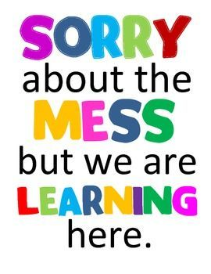
A Few Reminders
1. Please keep checking our Lost and Found bin for clothing that belongs to your children. All leftover clothing will be donated before we leave for Spring Break.
2. Zumba is coming to Harry Hooge! Students in Divisions 5-22 will be doing Zumba all next week with final performances during the afternoon of March 13 (12:45pm performance for Divisions 14-22 and 1:15pm performance for Divisions 5-13).

Upcoming Events
Monday, March 30 Schools Reopen After Spring Break
Tuesday, April 7 P.A.C. Hot Lunch (Aburiya Sushi)
Friday, April 10 Good Friday
Monday, April 13 Easter Monday
Tuesday, April 14 P.A.C. Meeting 7:00pm
Wednesday, April 15 Green Bricks Presentation for Divisions 7 & 9 (in school)
Ready, Set, Learn 5:30-7:00pm
Wednesday, April 22 Variety Show Dress Rehearsal 9:00am
Evening Show 6:00pm
Tuesday, April 28 Divisions 12 & 14 Drum Workshop
Wednesday, April 29 Public Speaking Grades 4-7 (AM)
Primary Poetry Recital (PM)

THE WEEK AT A GLANCE

Monday, March 9

Tuesday, March 10
P.A.C. Meeting 7:00pm

Wednesday, March 11

Thursday, March 12

Friday, March 13
P.A.C. Hot Lunch (Subway)
Last Day Before Spring Break

