Friday Blast
February 14, 2020
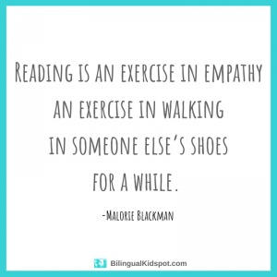
A Few Reminders:
1. At the end of the day, please pick up your children from their designated drop off areas.
2. With the cold, rainy weather in the forecast, please ensure that your child has a change of clothes at the school.
3. Please keep checking our Lost and Found bin for clothing that belongs to your children. All of the clothing will be laid out at the beginning of March and donated before we leave for Spring Break.

Upcoming Events
Wednesday, February 26 Pink Shirt Day
Kindergarten Vision and Hearing Screening
Thursday, February 27 Kindergarten Vision and Hearing Screening (continued)
Friday, February 28 Divisions 10 & 11 Skating Field Trip
Thursday, March 5 Student Led Conferences (Early Dismissal 11:30am)
Friday, March 6 Student Led Conferences (School Not In Session)
Tuesday, March 10 P.A.C. Meeting 7:00pm
Friday, March 13 Last Day Before Spring Break
Monday, March 30 Schools Reopen After Spring Break

THE WEEK AT A GLANCE

Monday, February 17
Family Day (No School)

Tuesday, February 18
Divisions 1 & 14 Skating Field Trip

Wednesday, February 19
Book Fest Pizza Party 1:00-2:00pm (library)

Thursday, February 20

Friday, February 21
PAC Hot Lunch (Pizza Hut)

