Friday Blast
January 10, 2020

A Few Reminders:
1. At the end of the day, please pick up your children from their designated drop off areas.
2. If you have not already done so, please log onto the Parent Portal and complete the Consent Forms and Emergency Release Forms for your child(ren).
3. With the cold, snowy weather in the forecast, please ensure that your child has a change of clothes at school.
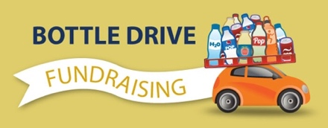
Grade 7 Bottle Drive – Saturday, January 11
Our Grade 7s have organized a bottle drive for tomorrow from
9:00am – 1:00pm. Please drop off your bottles and cans at the school. All money raised will go towards the year-end grade 7 activities.

Messages from the P.A.C.
1. The Carnival Committee is requesting donations for the Silent Auction. Teachers will be gathering items within a given theme to add to the baskets. Please refrain from sending money (gift cards are okay). Please see your child(ren)’s teacher for the theme. Items are due by Feb 1st.

2. Our upcoming Hot Lunch dates are as follows:
January 10th - Carl’s Jr.
January 20th - Subway
February 3rd - Taco Del Mar
February 21st - Pizza Hut
March 13th - Subway
April 7th - Aburiya Sushi
April 24th - Little Caesars Pizza
May 4th - Taco Del Mar
May 22nd - Subway
June 1st - Carl’s Jr.
June TBD Fun Day - Subway
*Ordering is now available on hhpac.hotlunches.net These hot lunches are the biggest fundraiser for the school throughout the year. Please e-mail a P.A.C. member at harryhoogepac@gmail.com if you have any questions.

THE WEEK AT A GLANCE

Monday, January 13
Tuesday, January 14
Girls Basketball Game at home
P.A.C. Meeting 7:00pm

Wednesday, January 15
Jump Rope for Heart Kickoff Assembly 9:00am

Thursday, January 16

Friday, January 17
“How the Raven Stole the Sun” presentation 1:00pm (gym)

