Friday Blast
December 6, 2019

Attention: Parents of Students in Grades 4 and 7
Our school district is participating in the Middle Years Development Instrument (MDI) project in January/February. It is a self-report questionnaire for students in Grades 4 and 7. The questionnaire asks about how students think and feel about their experiences both inside and outside of school. The questionnaire is completed online through the e-MDI and takes one to two class periods to administer. The MDI
questions align with the BC Ministry of Education’s K-12 curriculum which includes a focus on promoting children’s personal and social competencies. Please check the Parent Portal for further information, as well as an informed passive consent letter for those parents who do not want their child to participate in the questionnaire.

Coins for Kids – December 9-13
Next week, we will be collecting Coins for Kids on behalf of the Maple Ridge – Pitt Meadows Christmas Hamper Society. Their goal is to provide a memorable Christmas Day for financially disadvantaged families in Maple Ridge and Pitt Meadows. We will be collecting coins as follows:
Monday nickels
Tuesday dimes
Wednesday quarters
Thursday loonies
Friday toonies
Please help us provide a Christmas for our local families and put smiles on children’s faces on Christmas morning!

Lost and Found
Please come and check the Lost and Found bin to see if any of the clothing belongs to your child(ren). Any unclaimed clothing will be picked up and donated to the Diabetes Clothing Line next week.

Upcoming Events
Tuesday, December 17 Christmas Concert Dress Rehearsal starting at 10:40am
Wednesday, December 18 Christmas Concert 12:45pm
Thursday, December 19 Christmas Concert 12:45pm

THE WEEK AT A GLANCE

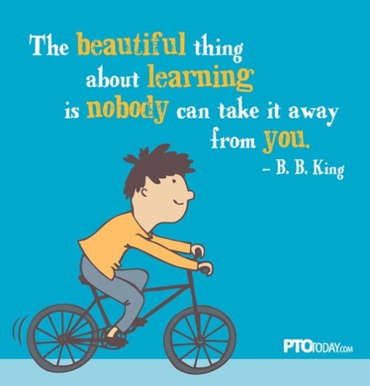
Monday, December 9

Tuesday, December 10

Wednesday, December 11

Thursday, December 12
DPAC Meeting 7:00-8:30pm

Friday, December 13
Divisions 10 and 11 Scissors and Glue Art Workshop

