Friday Blast
December 13, 2019

Important Reminders!
1. If you have not already done so, please log onto the Parent Portal and complete the Consent Forms and Emergency Release Forms for your child(ren).
2. With the rainy weather and low visibility, this is a reminder to please drive with caution on the roads and in the pull through of the school as there have been a few near misses of students walking to and from school.

Attention: Parents of Students in Grades 4 and 7
Our school district is participating in the Middle Years Development Instrument (MDI) project in January/February. It is a self-report questionnaire for students in Grades 4 and 7. The questionnaire asks about how students think and feel about their experiences both inside and outside of school. The questionnaire is completed online through the e-MDI and takes one to two class periods to administer. The MDI questions align with the BC Ministry of Education’s K-12 curriculum which includes a focus on promoting children’s personal and social competencies. Please check the Parent Portal for further information, as well as an informed passive consent letter for those parents who do not want their child to participate in the questionnaire.

Upcoming Events
Monday, January 6 First Day Back to School
Thursday, January 9 Division 10 (Harmston) Rock Workshop
Friday, January 10 Division 11 (Stewart) Rock Workshop
Tuesday, January 14 P.A.C. Meeting 7:00pm
Friday, January 17 “How the Raven Stole the Sun” presentation 1:00pm (gym)

THE WEEK AT A GLANCE

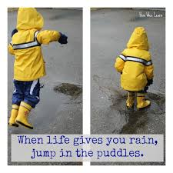
Monday, December 16

Tuesday, December 17
Divisions 5 and 17 Skating Field Trip
Christmas Concert Dress Rehearsal starting at 10:40am

Wednesday, December 18
Christmas Concert 12:45pm

Thursday, December 19
Christmas Concert 12:45pm

Friday, December 20
Pretzel Treat Day
Last Day of School Before Winter Break

