Friday Blast
November 15, 2019

Our Harry Hooge Christmas Craft Fair is tomorrow (Saturday, November 16) from
10:00am-3:00pm. We hope to see you there

From the Library
The Scholastic Book Fair is coming to Harry Hooge next week and we invite you to share in this celebration of books and reading with us. You will find hundreds of quality books at our Book Fair with a wide assortment of titles for all reading interests. We need volunteers on clean-up day (Friday, November 22). If you are able to help, please sign up outside the library door.

Book Fair Dates & Hours (in the library):
Tuesday, November 19 8:15-9:00am and 2:00-3:00pm
Wednesday, November 20 8:15-9:00am and 2:00-3:00pm
Thursday, November 21 8:15-9:00am and 2:00-3:00pm

Lost and Found
Please come and check the Lost and Found bin to see if any of the clothing belongs to your child(ren). Any unclaimed clothing will be picked up and donated to the Diabetes Clothing Line during the second week of December.

Domino’s Fundraiser Cards
We have Domino’s Fundraiser Cards available for purchase at the office (cash or cheque accepted). They cost $10 each and are valid at three Maple Ridge locations. The cards have nine free pizzas (2 for 1) and a free medium
one-topping pizza with no purchase necessary. Please see Mrs. Timperio at the office if you’d like to purchase a card or two.

Upcoming Events
Wednesday, November 27 Bookfest 2019 at Greg Moore Youth Centre and The ACT 8:30-12:00pm
Thursday, November 28 Author Visit for grade 6/7 students 10:15-11:15am (gym)
Thursday, November 28 Student Led Conferences *Early dismissal 11:30am
Friday, November 29 Student Led Conferences (school not in session)

THE WEEK AT A GLANCE

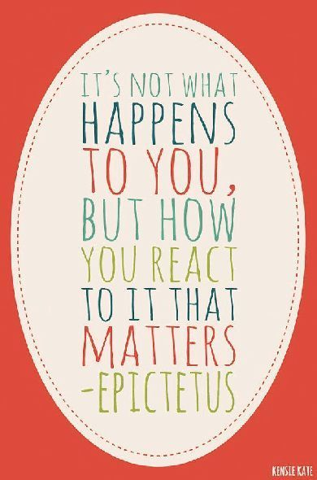
Monday, November 18
Division 2 Celebration of Learning 5:30-8:30pm (gym and classroom)

Tuesday, November 19
WE Day at Rogers Arena
Scholastic Book Fair 8:15-9:00am and 2:00-3:00pm
Divisions 2 and 4 Extreme Air Park Field Trip

Wednesday, November 20
Scholastic Book Fair 8:15-9:00am and 2:00-3:00pm
Student Voice Meeting 12:30-2:00pm

Thursday, November 21
Scholastic Book Fair 8:15-9:00am and 2:00-3:00pm
Divisions 1 and 5 Skating Field Trip
Division 12 Library Fieldtrip re: Author Visit 10:00am
Paint Night PAC Fundraiser 6:30-9:00pm

Friday, November 22

