Friday Blast
November 1, 2019

It’s been an action-packed week at Harry Hooge. Our P.A.C. ran the Halloween Family Dance on Wednesday night and our grade 7 teachers and students put on the Breakfast with Ghouls on Thursday morning. Thank you to all of the parents and grandparents who volunteered at these events.
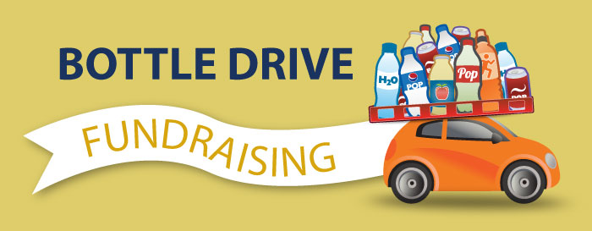
Just a reminder that our Grade 7s have their bottle drive on Saturday, November 2 from 9:00am – 1:00pm. Please drop off your bottles and cans at the school. All money raised will go towards the year-end grade 7 activities.

Harry Hooge Boutique – November 12-22
Harry Hooge Elementary will be holding its annual clothing drive starting November 12th. Items such as jackets, pants, shirts, dresses, boots, costume jewelry, scarves and hats will be collected under the trophy case in the front hallway. All sizes wanted. During student-led conferences on November 28 and 29, the Harry Hooge Boutique will be open for shopping in our gym. The best part…all items are free!

Scholastic Book Fair – November 19-21
The Scholastic Book Fair is coming to Harry Hooge and we invite you to share in this celebration of books and reading with us! You will find hundreds of quality books at our Book Fair with a wide assortment of titles for all reading interests. Scholastic flyers will be coming home next week. We are looking forward to seeing you there. We need parent volunteers for this event, so if you are able to help, please sign up outside the library door.

Book Fair Dates & Hours (in the library):
Tuesday, November 19 8:15-9:00am and 2:00-3:00pm
Wednesday, November 20 8:15-9:00am and 2:00-3:00pm
Thursday, November 21 8:15-9:00am and 2:00-3:00pm

Message from the P.A.C.
Volunteers Needed for Christmas Craft Fair – Saturday, November 16
The PAC is in need of approximately 30 volunteers to help make the Christmas Craft Fair a success. If you are able to volunteer, you will be entered into a draw to win either a “Great Escape Movie Pass” which includes 2 general admissions, 2 drinks and a popcorn to any Cineplex theatre OR an Admission to the SOLD OUT Christmas Paint Night. Please email the PAC at harryhoogepac@gmail.com or speak with a PAC Executive. Thank you!”

Upcoming Events
Monday, November 11 Remembrance Day (no school)
Tuesday, November 12 P.A.C. Meeting (library). All parents are welcome to attend
Thursday, November 14 Grade 6 Immunizations
Friday, November 15 Div. 5 (Keenan) Alouette River Management Society - In Class Field Trip
Friday, November 15 Kernels Popcorn Treat Day

THE WEEK AT A GLANCE

Monday, November 4
Division 18 (Hoyes) Malcolm Knapp Field Trip

Tuesday, November 5
Division 17 (Smith) Malcolm Knapp Field Trip

Wednesday, November 6
Division 16 (Gernaey) Malcolm Knapp Field Trip

Thursday, November 7
Remembrance Day Assembly 10:45am
Hot Lunch (Sushi)

Friday, November 8
Non-Instructional Day (no school for students)

