Friday Blast
October 4, 2019

Student Emergency Release Forms
All schools in the district will have a Controlled Student Release on Thursday, October 17 at 1:30pm. Parents/guardians or their listed emergency contact designate will need to come to the school to pick up their children. Children will be with their classroom teacher and will only be released to parents/guardians or listed emergency contact designates once their show photo ID to school staff. We will start with an earthquake drill, followed by the evacuation and Controlled Student Release exercise. Therefore, it is imperative that parents complete the Student Emergency Release Form on the Parent Portal as soon as possible.

Messages from Ms. Goodwin
- Katzie elder Coleen Pierre visited Harry Hooge on Wednesday afternoon to hold drum circles for both Division 5 and Division 7. After a 40 minute presentation, Ms. Pierre left the district set of aboriginal ceremonial drums for music classes to use on Thursday and Friday.
- Grade 3 and Grade 4/5 classrooms will be starting recorder lessons in music class in late October. An information letter has been released through the portal.
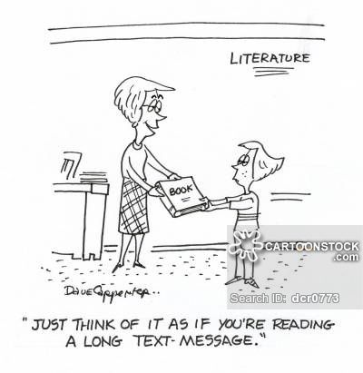
School Supply Fees
If you have not already done so, please pay for your child’s school supply fees at the office (cash or cheque accepted) or on the parent portal. For those students who are purchasing planners, the cost is $10.00 and it can be paid by cash or cheque.

Student Verification Forms
If you have not already done so, please sign and return the Student Verification Form that was sent home a few weeks ago. If the form has been misplaced, please contact the office for another copy.

Messages from the P.A.C.
- We need some parent volunteers for the Halloween Family Dance on Wednesday, October 30. All volunteers will be entered into a draw to win tickets to the Vancouver Canucks game on
November 12. One entry per hour of volunteering. Please email harryhoogepac@gmail.com if you are interested in volunteering for this event.
- Our Entertainment Book fundraiser ends on Friday, October 11. Please return all books and order forms by the 11th.
- There will be a Mala Bracelet Workshop (for adults only) on Thursday, October 17 at 7:00pm. To register for the workshop, go to hotlunches.net (access code HHE) before October 11.

Upcoming Events
October 14 Thanksgiving Day (no school)
October 15 Divisions 20 and 21 Laity Pumpkin Patch Field Trip
October 16 Divisions 19 and 22 Laity Pumpkin Patch Field Trip
October 17 ShakeOut! BC/Controlled Student Release 1:30pm
October 17 Mala Bracelet Fundraiser (organized by the P.A.C.)
October 18 Rice Krispy Treat Day

THE WEEK AT A GLANCE

Monday, October 7
National School Library Day 2019 – Drop Everything and Read 1:00pm
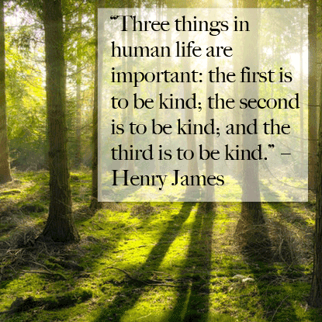
Tuesday, October 8
P.A.C. Meeting at 7:00pm in the Library
Girls Triple Ball Home Game 2:30pm

Wednesday, October 9

Thursday, October 10
Photo Retakes
Divisions 16, 17 and 18 Friendship Feast

Friday, October 11
Grade 7 Sleepover (school gym) 5:00pm – 8:30am
Little Caesars Hot Lunch

