Friday Blast
October 25, 2019

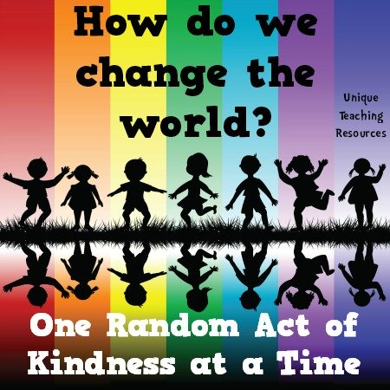
Scholastic Book Fair – November 19-21
The Scholastic Book Fair is coming to Harry Hooge and we invite you to share in this celebration of books and reading with us! You will find hundreds of quality books at our Book Fair with a wide assortment of titles for all reading interests. Scholastic flyers will be coming home next week. We are looking forward to seeing you there. We need parent volunteers for this event, so if you are able to help, please sign up outside the library door.

Book Fair Dates & Hours (in the library):
Tuesday, November 19 8:15-9:00am and 2:00-3:00pm
Wednesday, November 20 8:15-9:00am and 2:00-3:00pm
Thursday, November 21 8:15-9:00am and 2:00-3:00pm

Message from the P.A.C.
1. The Halloween Family Dance will be held on Thursday, October 30 at the Harry Hooge gym. It will run from 6:00-8:00pm and admission is $10.00 per family (payable at the door). There will be candy bags, chips and drinks for purchase. Don’t forget to bring a food donation for We Scare Hunger.
2. The PAC is in need of approximately 30 volunteers to help make the Christmas Craft Fair a success. If you are able to volunteer, you will be entered into a draw to win either a “Great Escape Movie Pass” which includes 2 general admissions, 2 drinks and a popcorn to any Cineplex theatre OR an Admission to the SOLD OUT Christmas Paint Night. Please email the PAC at harryhoogepac@gmail.com or speak with a PAC Executive. Thank you!”

Upcoming Events
Monday, November 4 Division 18 Malcolm Knapp Field Trip
Tuesday, November 5 Division 17 Malcolm Knapp Field Trip
Wednesday, November 6 Division 16 Malcolm Knapp Field Trip

THE WEEK AT A GLANCE

Monday, October 28

Tuesday, October 29
Girls Triple Ball Home Game
Gr. 6 Immunization Forms Due

Wednesday, October 30
Halloween Family Dance 6:00-8:00pm
Photo Retake Proofs Due

Thursday, October 31
Breakfast with Ghouls 7:15-8:15am
Costume Parade 9:00am

Friday, November 1

Saturday, November 2
Grade 7 Bottle Drive 9:00am-1:00pm *Bring your cans and bottles to the school.

