Friday Blast
October 18, 2019
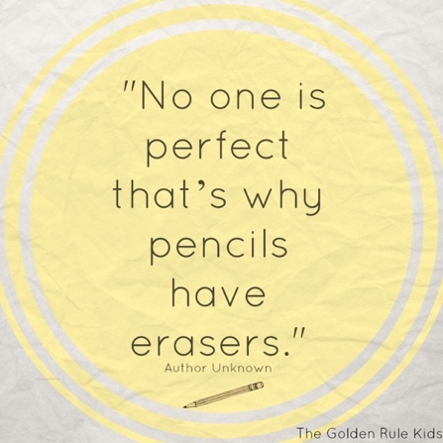
Harry Hooge Boutique – November 12-22
Harry Hooge Elementary will be holding its annual clothing drive starting November 12th. Items such as jackets, pants, shirts, dresses, boots, costume jewelry, scarves and hats will be collected under the trophy case in the front hallway. All sizes wanted. During student-led conferences on November 28 and 29, the Harry Hooge Boutique will be open for shopping in our gym. The best part…all items are free!

Message from the P.A.C.
We need some parent volunteers for the Halloween Family Dance on Wednesday, October 30. All volunteers will be entered into a draw to win tickets to the Vancouver Canucks game on November 12. One entry per hour of volunteering. Please email harryhoogepac@gmail.com if you are interested in volunteering for this event.

Upcoming Events
Tuesday, October 29 Girls Triple Ball Home Game
Wednesday, October 30 Halloween Family Dance
Thursday, October 31 Breakfast with Ghouls
Thursday, October 31 Costume Parade
Saturday, November 2 Grade 7 Bottle Drive 9am-1pm
Monday, November 4 Division 18 Malcolm Knapp Field Trip
Tuesday, November 5 Division 17 Malcolm Knapp Field Trip
Wednesday, November 6 Division 16 Malcolm Knapp Field Trip
Thursday, November 7 Remembrance Day Assembly 10:45am

THE WEEK AT A GLANCE

Monday, October 21
National School Library Day (In Class D.E.A.R. at 1:00pm)
Election Polling Station (Harry Hooge gym)

Tuesday, October 22
Intermediate Cross Country Run – Alouette

Wednesday, October 23
Primary Cross Country Run – Albion Sports Complex

Thursday, October 24
Division 3 Curling 12:00pm

Friday, October 25
Non-Instructional Day (no school for students)

