Friday Blast
October 11, 2019

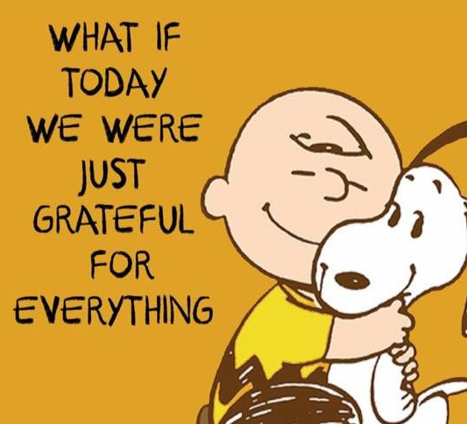
Student Emergency Release Forms
All schools in the district will have a Controlled Student Release on Thursday, October 17 at 1:30pm. Parents/guardians or their listed emergency contact designate will need to come to the school to pick up their children. Children will be with their classroom teacher and will only be released to parents/guardians or listed emergency contact designates once their show photo ID to school staff. We will start with an earthquake drill, followed by the evacuation and Controlled Student Release exercise. Therefore, it is imperative that parents complete the Student Emergency Release Form on the Parent Portal as soon as possible.

Harry Hooge Boutique – November 12-22
Harry Hooge Elementary will be holding its annual clothing drive starting November 12th. Items such as jackets, pants, shirts, dresses, boots, costume jewelry, scarves and hats will be collected under the trophy case in the front hallway. All sizes wanted. During student-led conferences on November 28 and 29, the Harry Hooge Boutique will be open for shopping in our gym. The best part…all items are free!

Message from the P.A.C.
We need some parent volunteers for the Halloween Family Dance on Wednesday, October 30. All volunteers will be entered into a draw to win tickets to the Vancouver Canucks game on November 12. One entry per hour of volunteering. Please email harryhoogepac@gmail.com if you are interested in volunteering for this event.

Upcoming Events
October 21 National School Library Day (In Class D.E.A.R. at 1:00pm)
Election Polling Station (Harry Hooge gym) 6:00am – 10:00pm
October 22 Intermediate Cross Country Run – Alouette
October 23 Primary Cross Country Run – Albion
October 24 Division 3 Curling 12:00pm
October 25 Non-Instructional Day (no school for students)

THE WEEK AT A GLANCE

Monday, October 14
Thanksgiving Day (no school)
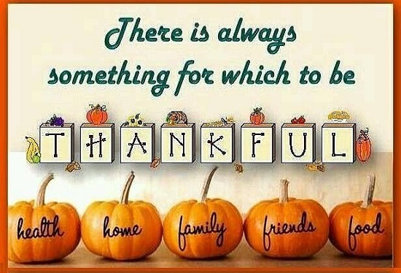
Tuesday, October 15
Divisions 20 & 21 Laity Pumpkin Patch Field Trip

Wednesday, October 16
Divisions 19 & 22 Laity Pumpkin Patch Field Trip

Thursday, October 17
Shake Out! BC/Controlled Student Release 1:30pm
Mala Bracelet Fundraiser (organized by the P.A.C.)

Friday, October 18
Rice Krispy Treat Day

