We value all members of the Glenwood community, and we work together to create a safe, caring and welcoming environment so that all learners can reach their full potential!

September 2018
Dear Glenwood Families!
Welcome back to school to all – former students and staff, and those new to Glenwood. We are welcoming quite a few new(er) students, so, please take a moment to say “HI!” to an unfamiliar face!
Both Jennifer and I are excited to work with you, your child(ren) and our amazing staff this year. Glenwood is not only a school, it is a family. We are collaborative, all of use truly love kids, and we are proud of our inclusive nature and diverse culture. So, let us know if there is anything we can do to support your child’s learning needs better.
Our staff list will be updated on the website, but in the mean-time – a quick welcome to all new(er) staff members to Glenwood:
Ms. Shona Wood (counselor),
Ms. Murray (Gr. 5/6),
Ms. Miriam Silveira (ELL), and
Ms. McKenzie in support,
we also will have a person in for additional clerical hours in the office on certain days.
Welcome also to:
Ms. Black,
Ms. Higginson,
Ms. Levens,
Ms. Meier, and
Ms. Johnson – AKA Whizzy
Ms. Romanoff.

Shape of start-up week:
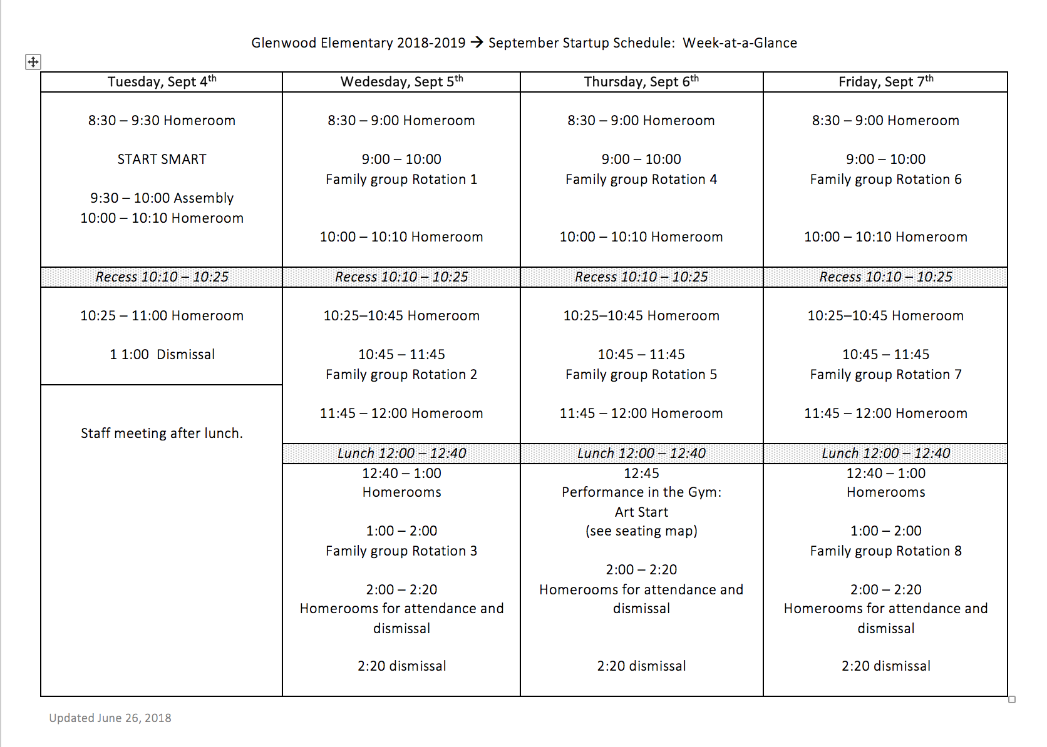

Tuesday, September 4, 2018:
- First bell is at 8:25 am.
- Students are to return to their previous school year’s teacher/classroom
- New students are to report to the library
- Please, do not send your child with school supplies in the first week.
- At the end of the day, your child will have information about his/her next day(s).
- Students will be in “Family Groups” (different ages) for the rest of the first week.
- Assembly at 9:00 am
- Dismissal at 11:00 am

Wednesday, September 5, 2018:
- Students will follow rotations in their “Family Groups” … and will be in temporary homerooms. This is important for class placement decisions and building community. In addition, the students will meet all of the e teachers of their grade group and will make connections with a variety of peers. We are committed to creating a safe, caring learning space foal l our student s so that everyone feels valued and understood. These rotations set a positive tone for your school community and allow for increased connections between all.
- Our goal is to finalize placements as soon as possible for students to start in their newly assigned classrooms by the beginning of next week. We will inform you about your child’s class placement/teacher as soon as possible.

IMPORTANT TO KNOW:
- Follow us on Twitter - @GlenwoodSD42 for updates in timely fashion
- OR: Follow us on our Facebook page - https://www.facebook.com/GlenwoodSD42/
- And/or: Visit our Website - http://elementary.sd42.ca/glenwood/
- Follow Glenwood PAC on their Facebook page -https://www.facebook.com/GlenwoodPAC/
- Additionally, please ensure to register on the portal. All newsletters etc. will be going out on the portal, as well as PAC information.
- IT IS IMPERATIVE TO CONTACT THE OFFICE IF YOUR CHILD WILL BE ABSENT.
Please, get in the habit of calling or emailing gl_reception@sd42.ca in a timely fashion.
We have limited clerical time, and our practice is to call home for every student whose parent(s)/guardian(s) haven’t called to inform us about his/her absence. A timely endeavour.
Thank you for understanding.

Before and After school:
- School opens at 8 am. Students are welcome to:
- Go to the library for reading club OR
- Go to the Multi-purpose room for breakfast club
- Students are not allowed without supervision in the hallways.
- To avoid hallway congestion – please, parents are asked to drop off and pick up their child(ren) from the OUTSIDE DOORS to the classrooms. Please, touch base with your child’s teacher in this regard.

Parking:
- Please, beware that our parking lot is tight! If one person parks in the fire lane, chances are the traffic may be blocked. Parking in fire lanes are prohibited, and we occasionally will have RCMP officers who will help with our traffic flow. The staff parking lot will be closed at 8:15 am.
- Additionally, we have only 3 handicapped parking spots. These are meant for students who have mobility issues. Please, do not park in those stalls.

Sincerely,

Anelma Brown Jennifer Beveridge
Principal Vice-Principal
Anelma_brown@sd42.ca Jennifer_beveridge@sd42.ca
“Building Engaged Learners …
One GRIZZLY at a Time!”

