PLACE-BASED LEARNING

P
lace-based learning connects students to the landscape, heritage and cultures in their community. They explore their own community and environment through project-based learning and outdoor education. It makes learning relevant as they look at real-life problems and situations and figure out ways to be involved and to help. Spending time outside can help students build independence and self-esteem and builds confidence through hands-on learning. Outdoor learning also allows them to build problem-solving and teamwork skills. When students feel connected to a place, they are invested in the long-term well-being of their community and environment.

For more information about the new curriculum, visit http://www.sd42.ca/new-curriculum.

Coming in May – Inquiry Learning.

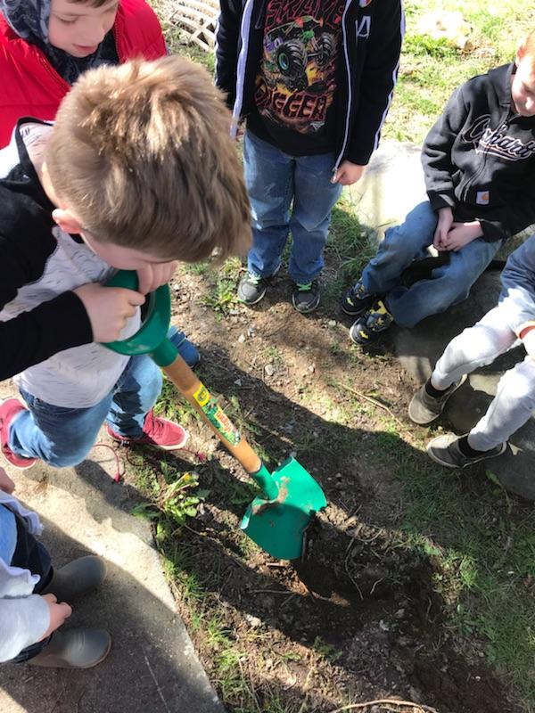

Earth day experiment! We buried our pumpkin in the fall filled with garbage from outer lunches. When we dug it up today, the pumpkin, apple core, orange peel and paper towel had all disappeared and all was left was our plastic and tinfoil

We now know that biodegradable waste materials are and can be degraded by natural factors like microbes (e.g. bacteria, fungi and few more), abiotic elements like temperature, UV, oxygen, etc. Some examples of such wastes are food materials, kitchen wastes and other natural wastes. Plastic is not bio-degradable. And that’s why we recycle!

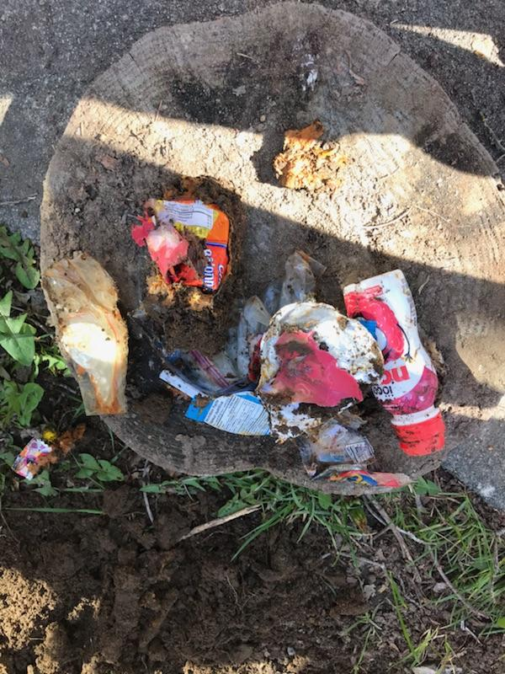
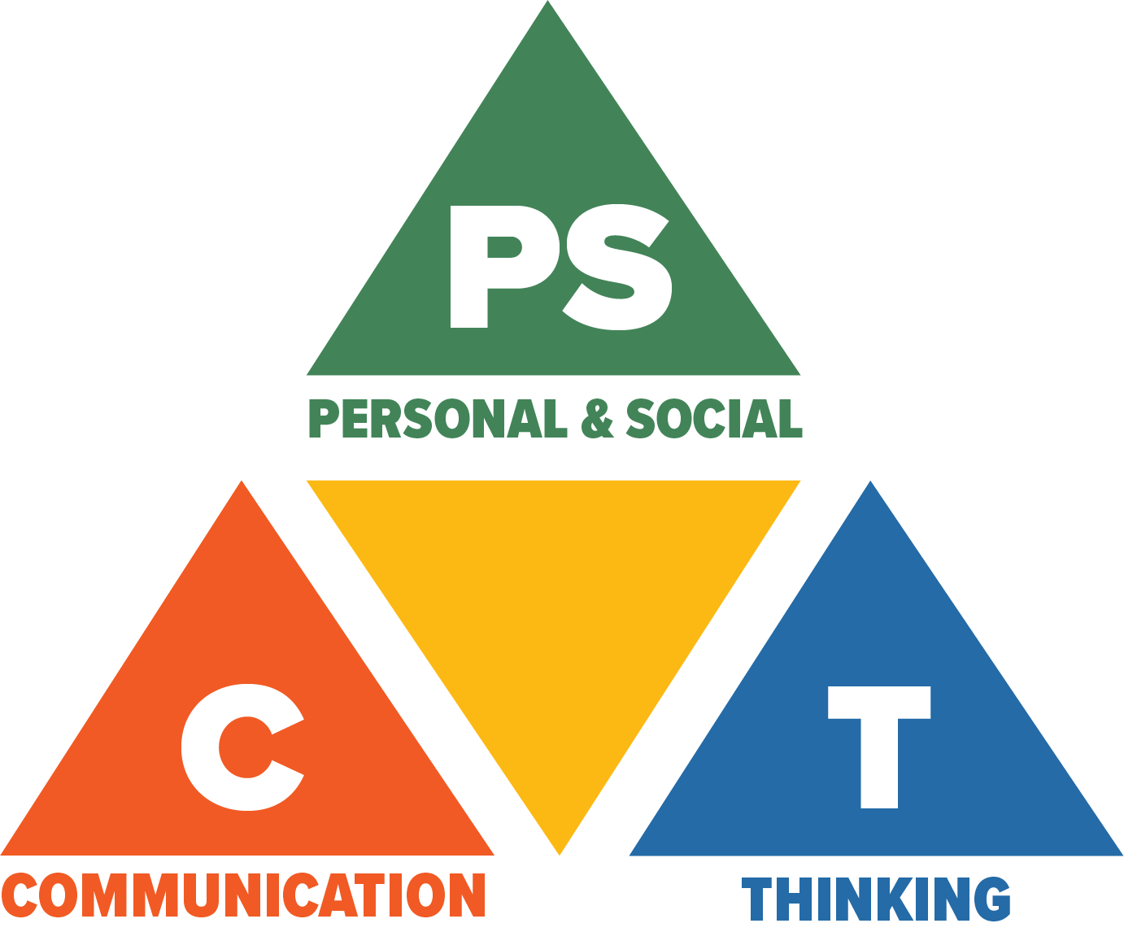
Core Competencies: What are they and why are they in the new curriculum?
The new curriculum centres around the following three core competency areas: communication, personal and social, thinking. They are sets of intellectual, personal, and social and emotional proficiencies that all students need to develop in order to engage in deep learning and life-long learning. Competencies are evident in every area of learning and in every grade, and come into play when students become actively engaged in their learning. During the school year, students will have an opportunity to self-assess their proficiencies in these core competencies.

