January 2018

Good day parent(s)/guardian(s)!
I trust you had a relaxing break, and that the flu season did not disrupt your festivities.
News:
- Ms Beveridge, our new VP started in January, and loves Glenwood’s community already.
- We have quite a few news items from the community – please, refer to inserts below.

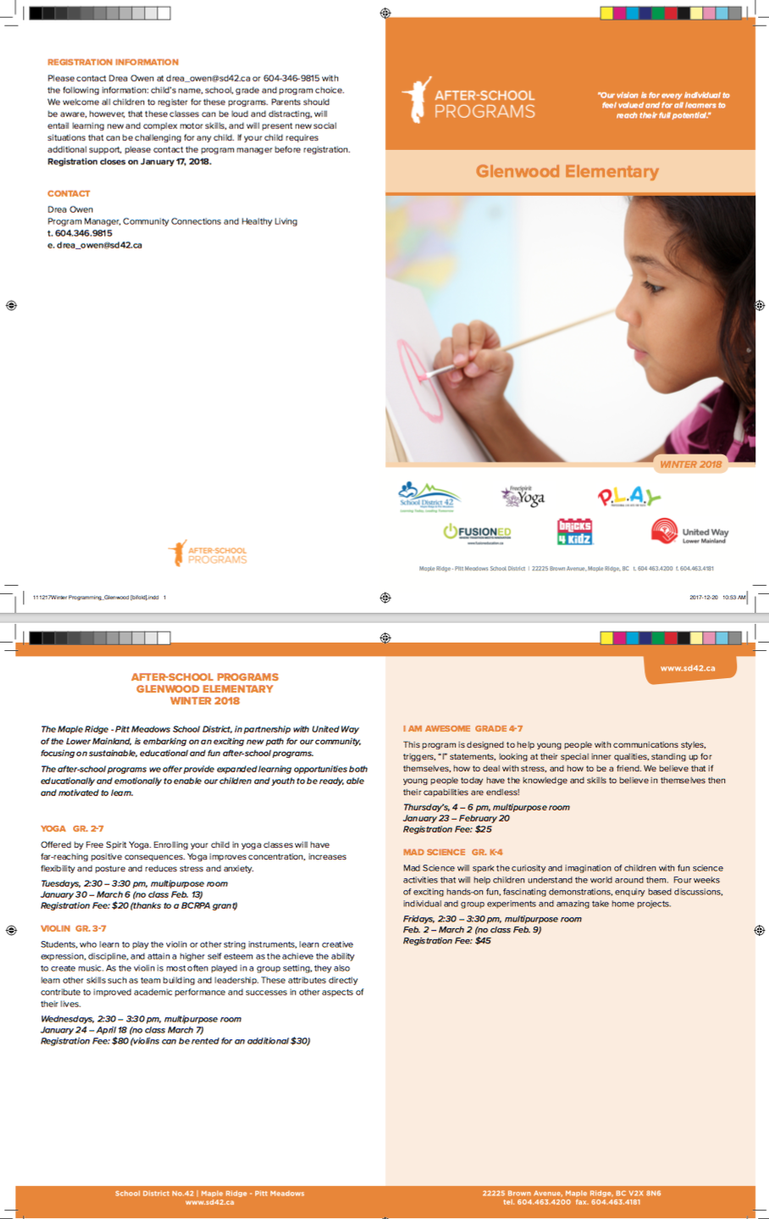

- Body Science presented to our students the first week in January. The presentations were lively and the students learned a lot!
- Family Literacy Day, Saturday, January 27, 11 am – 2 pm
The best family party in Maple Ridge! Celebrate Family Literacy Day at Maple Ridge Public Library. Check out the community resource fair for lots of fun activities, performances by Showstoppers Academy or join in the Family Dance Party. Enjoy free popcorn and the chance to win prizes while taking in the sights, sounds and awesome activities!
For more information about Family Literacy Day, contact Maple Ridge Public Library at 604-467-7417 or check out our event information online at www.fvrl.ca.
Important dates/events coming up this month:
- We invite parents to participate in the BC Ministry of Education’s Satisfaction Surveys – logon numbers are available in the office. Electronic surveying is available until April 27, 2018. The website to access the electronic survey is:

http://www.bced.gov.bc.ca/sat_survey/access.htm

- REGISTRATION:
SIBLING
January 4-10, 2018 (Documentation to school by January 17) (Although schools are closed for the first 2 days of this registration period, support will be available at the DEO. Schools will be open for registration 3 days the following week.)

CHOICE
January 18-22, 2018 (Documentation to school by January 31)

GENERAL
February 1-8, 2018 (Documentation to school by February 28)

LATE
March 28-June 7, 2018 (Documentation to school 5 business days after confirmation of placement)

· All phases open at 12:00 noon and close at 11:59 pm.
· The SD42 website has been updated with these dates.
Registration starts during Winter Break to allow adequate time for Grade registration before Spring Break.
· Kindergarten pamphlets and posters will be distributed to schools within the next week or so.
Information on Grade 8 registration will be sent out shortly, but registration will start around mid-February. Parents will be advised of grade 8 placement after Spring Break.

January 16 -
- Primary Play Day
- PAC at 6-30 pm
January 17 at 10 am - January Assembly (date and time to be confirmed!)
January 22 at 1 pm – BC Lions presentation on Energy Champions
January 26 Non-instructional Day
January 26 8:30-3:30 - Red Cross Babysitting Course at Alouette,
Grade 6+ ; $60 + GST online registration
http://www.firstaidhero.com/babysitting-vancouver.html Registration coming in the fall.

Congratulations and way to go:
2017-2018 Volleyball Team
Jaelyn Turmel, Daniela Zerbinos, Jusmine Chu, Mackenzie Brown, Emma Williams, Bobbi Symmes, Bella Martinez, Kiah Knnak, Tyler Ramak, Natalie Masse, Marissa Barclay, Kaleigh Mertz, Sandra Burton, Sabrina Lutwinski, and Shalin Bilodeau.
Congratulations to the girls’ volleyball team for an excellent season! Each of you has improved tremendously since our first practice. It was a bit of a challenge at first learning the new ‘Triple Ball Volleyball’ rules but in the end, you mastered it! The amount of sportsmanship, cooperation, team work and fun in all practices and games was a pleasure to be a part of. It was a pleasure to coach you this year and thank you for a great volleyball season!
I would also like to thank all of the parent drivers for transporting the girls to and from their away games. Without you, we wouldn’t be able to play.
Mrs. Wadge

Lastly a few requests:
BEFORE SCHOOL - The expectation is that students will gather in one of 3 places before classes start at 8 am:
- The Library for READING club, or
- The Multi-purpose room for BREAKFAST (if a student has finished his/her breakfast, he/she is to proceed to READING club.)
- Outside
Supervision starts at 8 am only, and it is a huge safety concern when students are unsupervised before classes start. Thank you for your help in this regard.

If your child is absent/late – please, let the office know via email gl_reception@sd42.ca , a call to the office, or the portal! We call every “unexcused” student to ensure his/her whereabouts, but it is time consuming if our secretary has to call every parent/guardian/care giver who has not notified the office to find out where their child is.
Additionally, personal messages and deliveries for students won’t be taken to their respective classes. Thank you for understanding our position.

Parents are strongly encouraged to “get online” to access not only the portal, but also our “real time” updates via Twitter that appears on both our website and our Facebook page, and the “new and improved” Munchalunch program PAC is rolling out to order hot lunches for your child(ren) on the web.
It you need help, speak to your child’s teacher ASAP please.

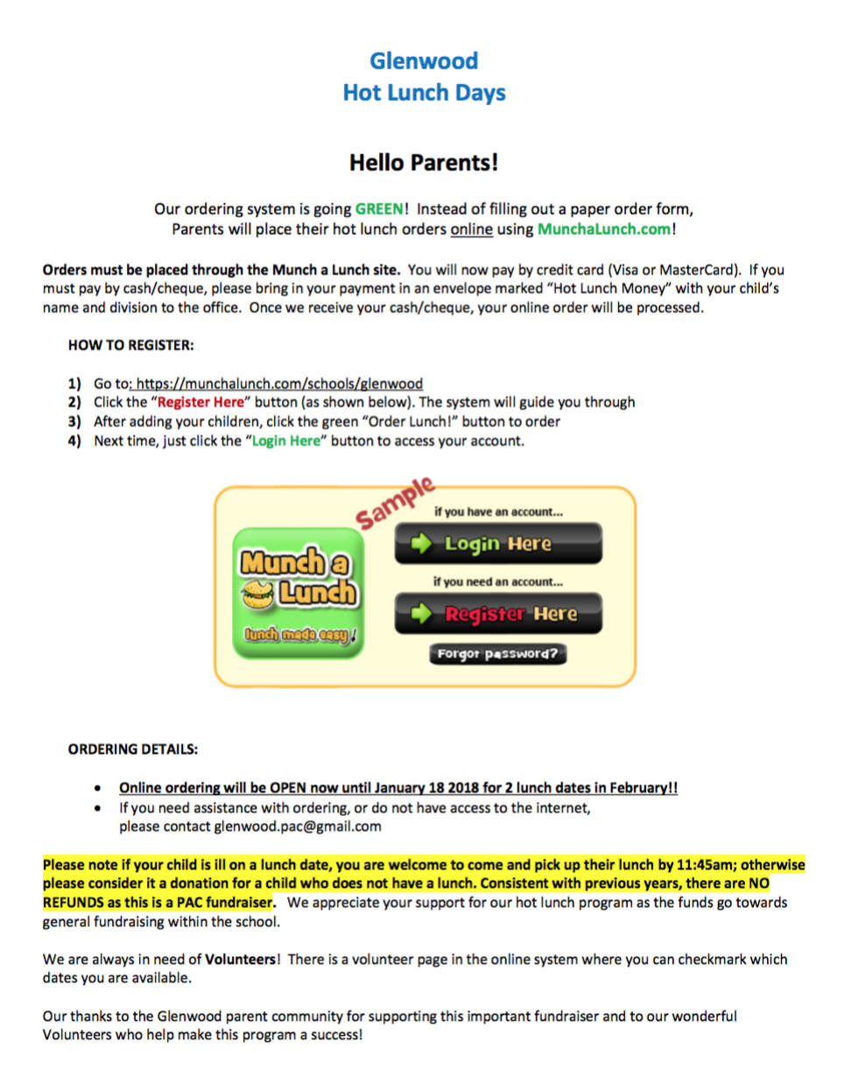

Thank you for your continued support!

