**Newsletter December 2017**

Good day parent(s) and guardian(s)!

**Forthcoming attractions: the end of November and December:**

Nov. 30:

* Dismissal at 11-30 am; 3-way conferences, a Celebration of Learning begin.

Dec. 1:

* 3-way conferences, a Celebration of Learning continues; classes not in session – please, see your child’s teacher if you haven’t done so already.
* The chain will go up to secure our grounds – 11pm to 7am

Dec. 7:

* Tad, from <https://www.bullyingendshere.ca> will present to Gr 6 and 7 in the afternoon.

Dec. 8:

* We will have a short assembly at 11 am, to tell our students that Ms. Michelle Davis will go to Davie Jones Elementary next January, and we will welcome Ms. Jenn Beveridge (from Golden Ears Elementary.)
* Report cards going home!

Dec. 15:

* Primary craft day

Dec. 18:

* Glenwood will join MRSS for the afternoon for hot chocolate, a cookie and some festivities. Thanks to MRSS for the invite.

Dec. 20 and 21 - Our holiday concert:

* Dec. 20 – rehearsal
* Dec. 21 – two shows: 1pm and 6-30pm

Dec. 22:

* Last day of classes before winter break

🡪 Leadership Fun and Fundraising:

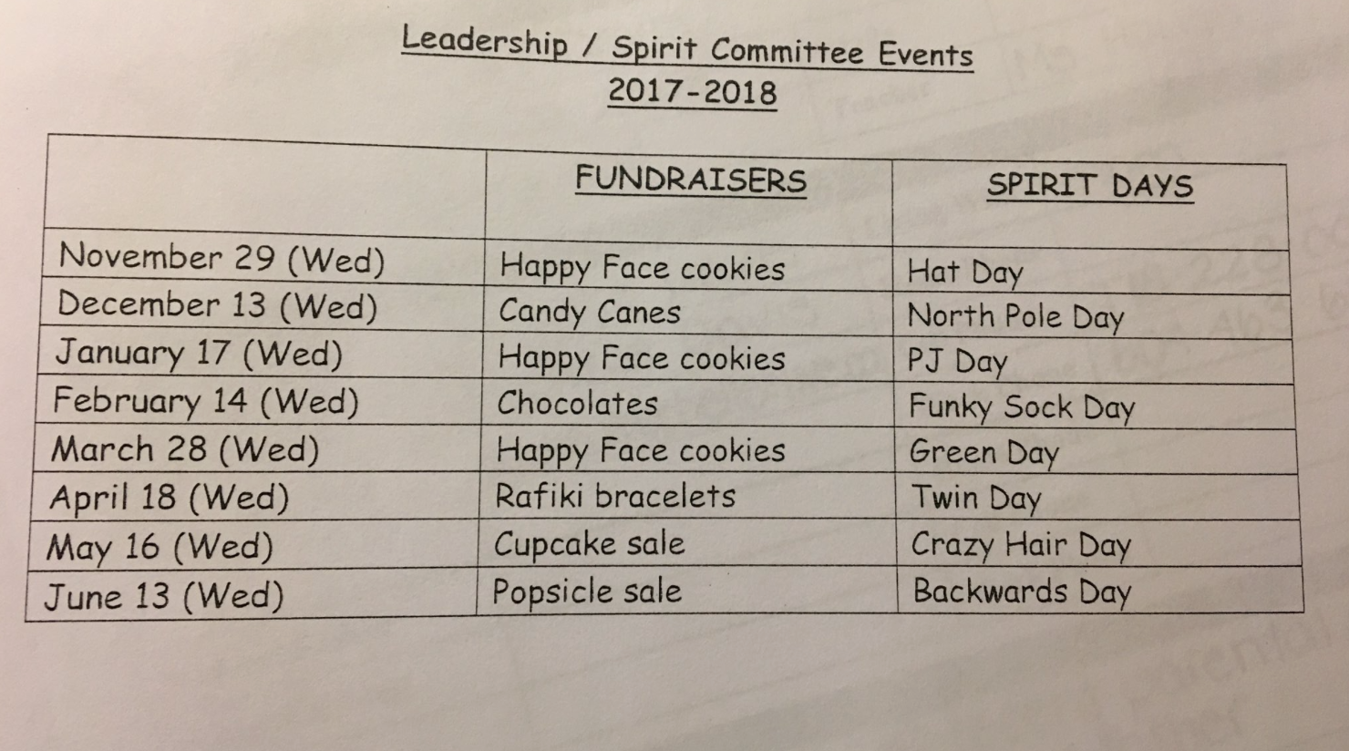

**Important to remember:**

1. Registration:

**K registration dates/phases for 2018-19 to include in your newsletters and websites:**

SIBLING

January 4-10, 2018             (Documentation to school by January 17)    (*Although schools are closed for the first 2 days of this registration period, support will be available at the DEO.  Schools will be open for registration 3 days the following week.)*

CHOICE

January 18-22, 2018        (Documentation to school by January 31)

GENERAL

February 1-8, 2018           (Documentation to school by February 28)

LATE

March 28-June 7, 2018    (Documentation to school 5 business days after confirmation of placement)

·        All phases open at 12:00 noon and close at 11:59 pm.

·        The SD42 website has been updated with these dates.

·        Registration starts during Winter Break to allow adequate time for Grade 8 registration before Spring Break.

·        Kindergarten pamphlets and posters will be distributed to schools within the next week or so.

**Concerns:**

We find Graffiti in our building and inappropriate signs/words etc. in our building and on our playground often. We have significant supervision; however, things still occur. Please, have a word at home about

* Respecting self, others, the building, the staff and the opportunity to learn. Additionally, please, let students know to report something they feel “is not right”. There is a difference between “ratting” and “reporting”, I always tell the students.

**Thank you:**

Thank you to PAC for our decorations! It’s beginning to look a lot like Christmas!

Talking about PAC – the annual 12 Days at GW is starting soon! Please, refer to PAC’s Facebook page, but here is the calendar in the meantime:

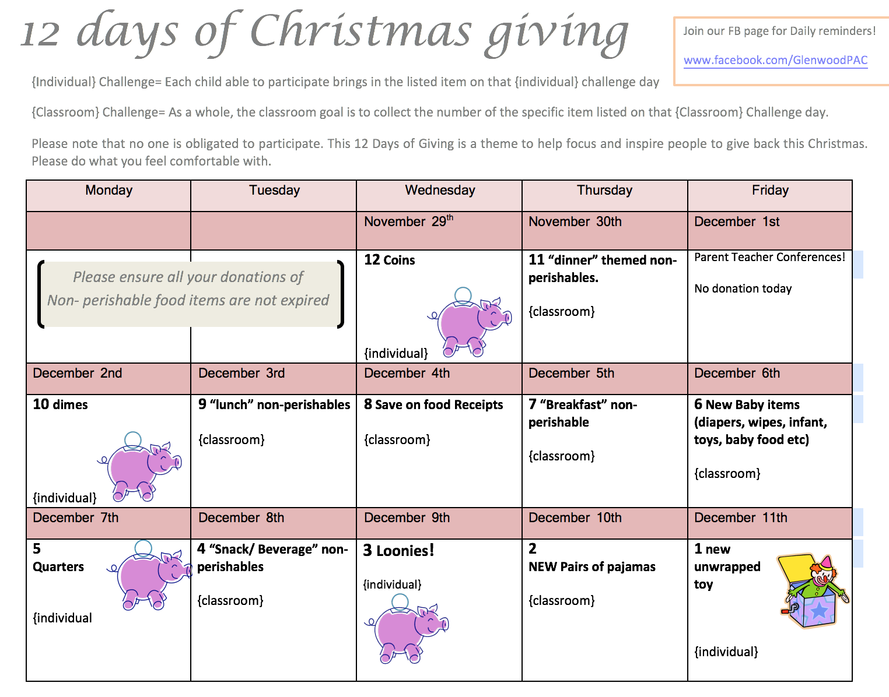

***Reminder to follow us on Twitter/check Facebook and/or our website for Real Time info.***

Have a great December!