***THINKING COMPETENCY***



The **thinking competency** encompasses the knowledge, skills and processes we associate with intellectual development. It is through their competency as thinkers that students take subject-specific concepts and content and transform them into a new understanding. Thinking competence includes specific thinking skills as well as habits of mind, and awareness of thinking about thinking.

The creative thinking competency involves the generation of new ideas and concepts that have value to the individual or others, and the development of these ideas and concepts from thought to reality.

Critical thinking involves making judgments based on reasoning: students consider options; analyze these using specific criteria; and draw conclusions and make judgments. Critical thinking competency encompasses a set of abilities that students use to examine their own thinking, and that of others, about information that they receive through observation, experience, and various forms of communication.

For more information about the new curriculum, visit <http://www.sd42.ca/new-curriculum>.



We thought about our heroes’ contributions on Remembrance Day!

***Core Competencies: What are they and why are they in the new curriculum?***

*The new curriculum centres around the following three core competency areas:* ***communication, personal and social, thinking.*** *They are sets of intellectual, personal, and social and emotional proficiencies that all students need to develop in order to engage in deep learning and life-long learning. Competencies are evident in every area of learning and in every grade, and come into play when students become actively engaged in their learning.* *During the school year, students will have an opportunity to self-assess their proficiencies in these core competencies.*

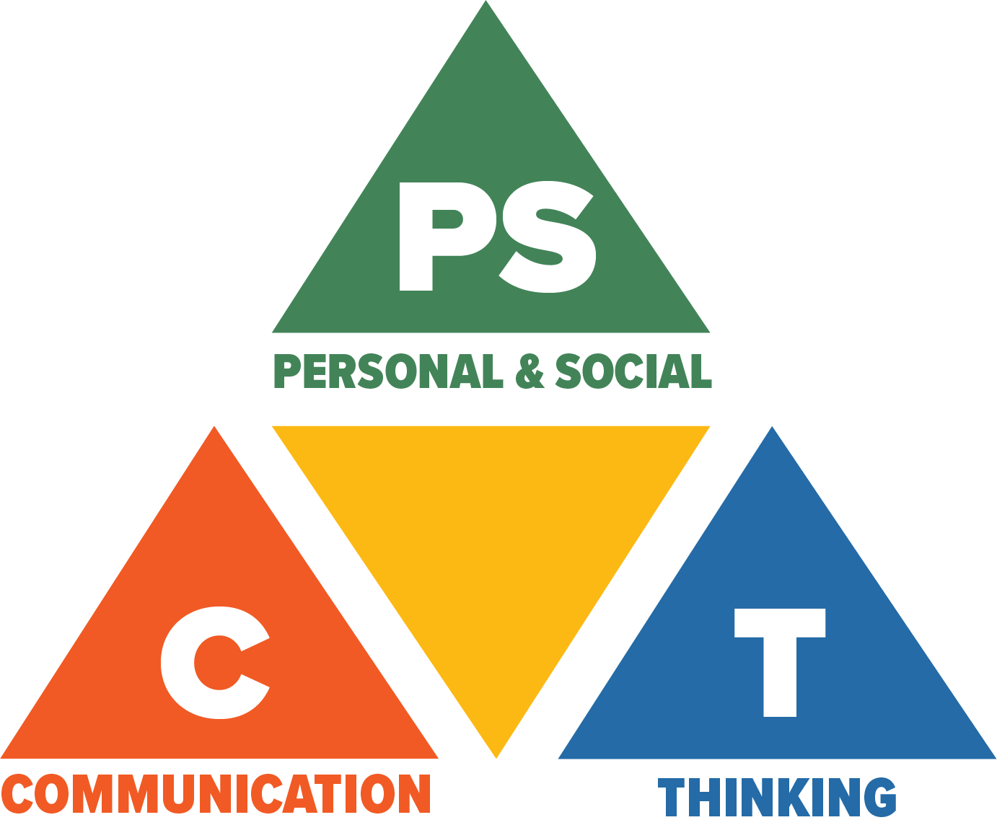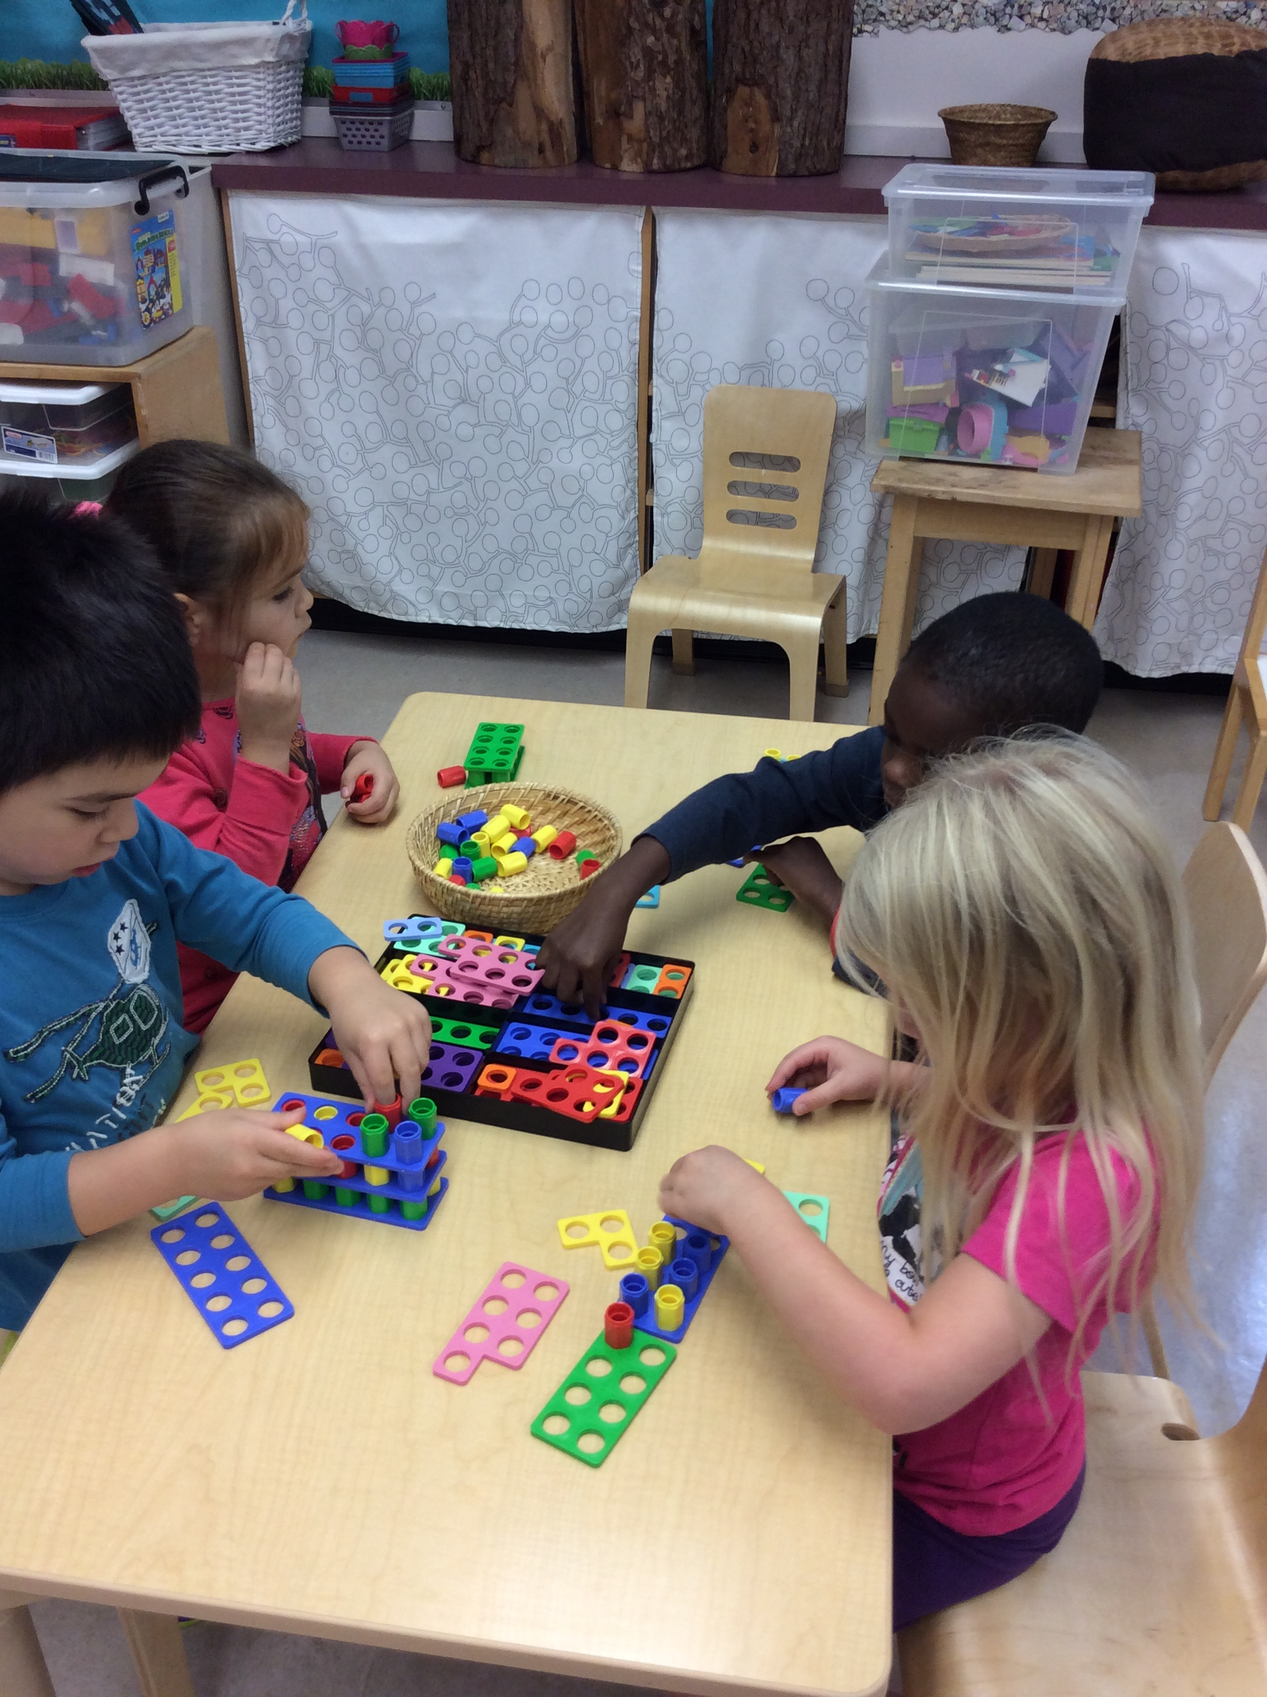

***Core Competencies: What are they and why are they in the new curriculum?***

*The new curriculum centres around the following three core competency areas:* ***communication, personal and social, thinking.*** *They are sets of intellectual, personal, and social and emotional proficiencies that all students need to develop in order to engage in deep learning and life-long learning. Competencies are evident in every area of learning and in every grade, and come into play when students become actively engaged in their learning.* *During the school year, students will have an opportunity to self-assess their proficiencies in these core competencies.*

Thinking how to proceed collaboratively!

**Coming in January 2018 –** Personal & Social Competency*.*