COMMUNICATION COMPETENCY

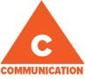
The communication competency encompasses the set of abilities that students use to impart and exchange information, experiences and ideas, to explore the world around them, and to understand and effectively engage in (1) the use of digital media. Development of this competency focuses on four key areas: connecting and engaging with others; acquiring, interpreting and presenting information; collaborating to plan, (2) carry out and review constructions and activities; and explain, recount and reflect on experiences and accomplishments.

For more information about the new curriculum, visit http://www.sd42.ca/new-curriculum.

Development of communication competency begins within families, before students enter formal schooling, and expands at every level of schooling. At each stage, students maintain and enhance competencies from previous stages, while developing new skills. Students move from basic or highly supported to increasingly complex, sophisticated, and independent communication. The development of competence in communication does not end with school graduation, but continues to develop in personal, social, educational, and workplace contexts.
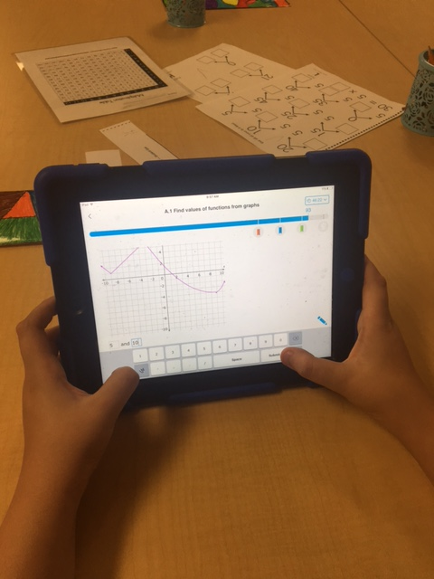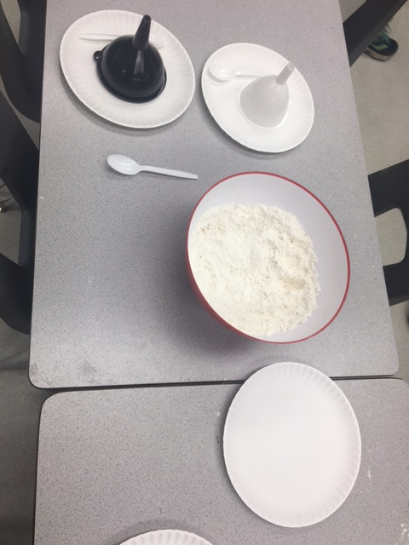
Following
Recipes!
2.
1.

(1) the use of digital media 2) carry out and review constructions and activities

Core Competencies: What are they and why are they in the new curriculum?
The new curriculum centres around the following three core competency areas: communication, personal and social, thinking. They are sets of intellectual, personal, and social and emotional proficiencies that all students need to develop in order to engage in deep learning and life-long learning. Competencies are evident in every area of learning and in every grade, and come into play when students become actively engaged in their learning. During the school year, students will have an opportunity to self-assess their proficiencies in these core competencies.
Coming in December – The Thinking Competency.

