**NOVEMBER 2017 NEWS**

Dear parent(s)/guardian(s):

Welcome to rainy November!

October went by with many highlights! Thanksgiving, Halloween, Cross Country, Craft Day, PAC Movie Night were just a few amazing events which students and staff will remember!

A gentle reminder – please don’t send you child with candy to school. We have students who have severe allergies.

Reminder too: Photos of highlights are posted regularly in Real Time via Twitter (which will also appear on our website AND Facebook, so you won’t miss a thing!) We are cognizant to putting pictures out on social media! Students need permission from parents to have their pictures published!

A personal highlight for me these days, is reading with students. I try to get out weekly/daily if I am lucky, to read with classes. Your children are insightful and engaging, and I love it. I find it refreshing that they are trusting me enough to share personal stories of home. On the other side of this coin: if they come home with strange tales of African lore, I am the guilty one!

**CONCERNS:**

A few concerns from my end are the

* hands-on (sic!) problem-solving “skills” some of our students display, often accompanied by inappropriate language! We try to be pro-active and not reactive in our approach, and our whole school culture is that of Kindness.
* Staff – and I am quoting the School Act – assume the role of “*prudent parents*” during school hours; we will address / redirect / modify the behaviours and language via Glenwood’s Code of Conduct, aka our ***ROAR***. It’s imperative that school and parents are on the same page here, so thanks for your help in this regard!
* Please, refer to <http://cdn.elementary.sd42.ca/glenwood/2017/07/Glenwood-Elementary-School-Code-of-Conduct-1.pdf> for more information about Glenwood’s Code of Conduct.

**NEWS:**

1. And as this is November, flu season is upon us! Please, don’t send your child to school ill, as we need to keep our environment as germ-free (!) as possible! And, if your child is going to be absent, please call the school. We have to call to find out WHERE a student is, if he/she is not at school, and if our secretary has to call 20 parents daily, it takes a huge chunk out of her day, unfortunately.

* Additionally, a reminder to check your child’s hair regularly for nits or live lice to help prevent it from spreading.

1. We want to remind you to please have a plan in place in case you might be a few minutes late picking your child(ren) up. The office gets busy at the end of the day and it can be a challenge to ensure that students get messages. We get a lot of students wanting to use the phone if their parents are not immediately here at the bell. The students should know to wait at a certain spot after school, and after 10 or 15 minutes they can check at the office if parents still haven’t arrived by that time.
2. Our RCMP officers are making regular appearances to help drivers make safe choices. Glenwood’s staff members have parking passes… it’s a matter of time before we put notices on the unidentified vehicles in the lot. Staff parking lot will be chained by 11 pm and will be unlocked by 7-30 am to keep that part of our lot and the school safe(r).
3. Additionally, our FSA’s are done, and our **next assessment will be our MDI**  - **November 1 – December 10. The MDI – (for grade 4 and 7)** [**http://earlylearning.ubc.ca/mdi/**](http://earlylearning.ubc.ca/mdi/) **- is data we really value as it reflects a snapshot of students’ SEL** 🡪 **Social-Emotional learning (**[**http://www.casel.org/what-is-sel/)**](http://www.casel.org/what-is-sel/))

Staff has a huge focus on Social-emotional learning at Glenwood. We all know that relationships are the foundation of academics! Here is a snapshot of what we consider aspects of emotional intelligence -

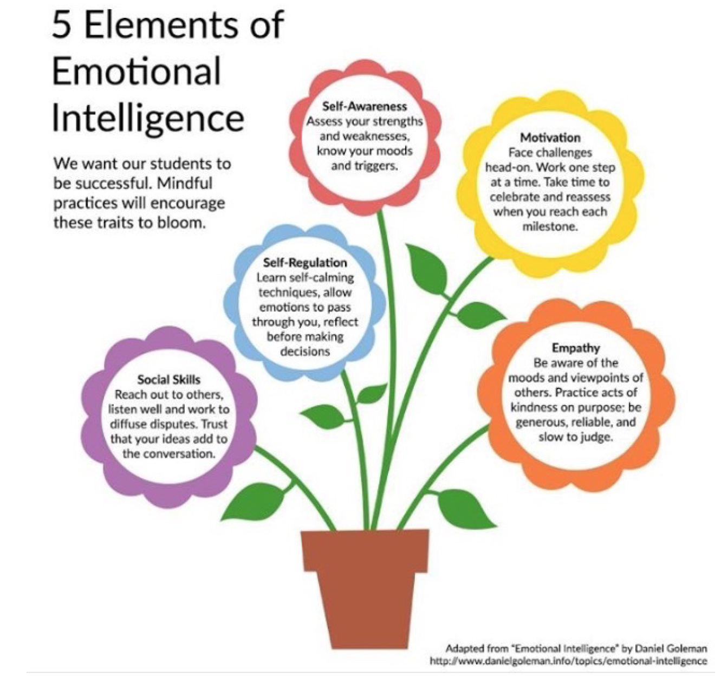

Literacy – 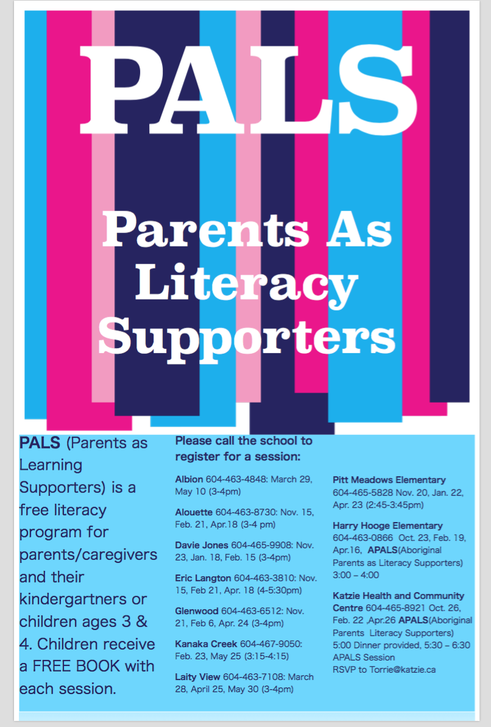

Reminders:

Nov 1 – Photo Retakes

Nov 7 – the amazing Ms Shelley Moore will be working with some of our teachers at Glenwood. I am attaching a link to one of her videos – she is amazing… Viewing optional: https://www.youtube.com/watch?v=or1C64P4XNc

Nov 8 – Gr 6 immunizations

Nov 8 – Hot lunch forms due

Nov 9 – Remembrance Day assemblies at approx. 10:45am; Ms Sylvia Russell visiting GW.

**Nov. 10** is a school-based professional development/growth plan day at GW.

Nov. 13 – Remembrance Day STAT

Nov 14 – PAC

Nov 14 – Volleyball game – girls – at GW

Nov 22 – Primary Play Day

Nov 24 – Hot lunch Panago

Nov 27 – Trustee walk through

Nov 30 – Poinsettia Delivery – to be picked up on Dec. 1

Nov 30 and Dec 1 – Student led – three way - conferences. Parents will need to sign up via the portal. It is imperative that you are registered on the portal as soon as possible, if you are not yet.

Nov 30 – Early dismissal at 11-30 am

Dec 1 – No classes – three way conferences.

Additional news:

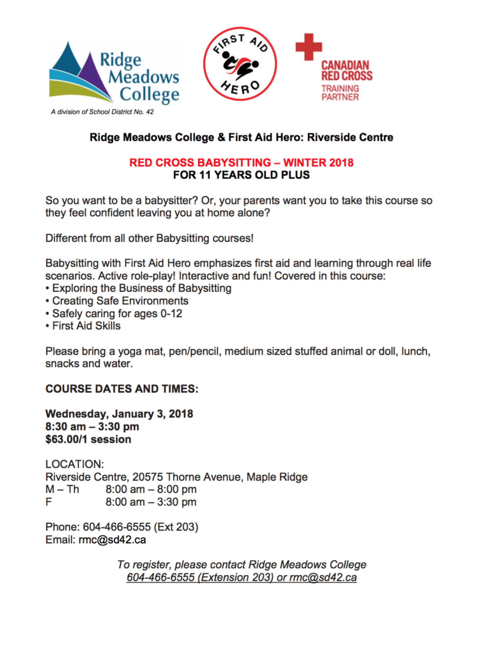

Glenwood is also a school. Please, be aware there are people on campus who are allergic to any kind of scent. Let’s keep our campus scent free. Thanks for your understanding.

Lastly – our Glenwood PAC is amazing.  For more information on PAC – here is the link to their website:   <https://www.facebook.com/GlenwoodPAC/>