***CORE COMPETENCIES:***

***What are they and why are they in the curriculum?***

The BC curriculum has been redesigned to meet the needs of 21st century students. The new curriculum maintains a focus on literacy and numeracy while supporting deeper learning through three core competency areas: **communication**, **personal and social**, and **thinking.**

Core competencies are sets of intellectual, personal, and social and emotional proficiencies that all students need to develop in order to engage in life-long learning. Core competencies are evident in every area of learning and in every grade, and come into play when students become actively engaged in their learning.

For more information about the new curriculum, visit <http://www.sd42.ca/new-curriculum>.

**Coming in November –** *The Communication Competency.*

The communication competency encompasses the set of abilities that students use to impart and exchange information, experiences and ideas, to explore the world around them, and to understand and effectively engage in the use of digital media.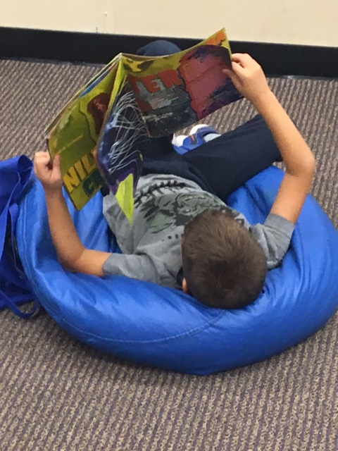 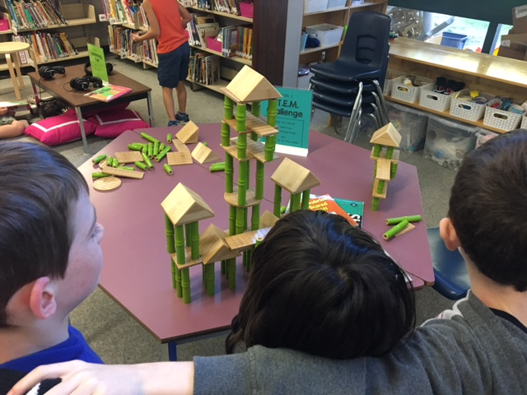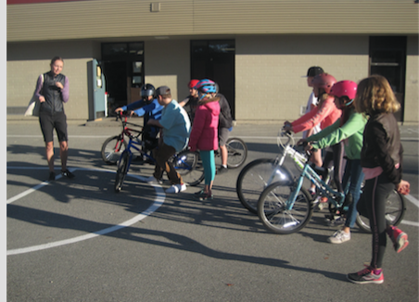

*We engage in reading about the world around us.*

*We exchange information, experiences and ideas, and can build structures together! We also celebrate our success with others!*

*We learn new skills, and improve on existing skills as we explore the world.*