HOW DO WE ASSESS AND CELEBRATE LEARNING?

H
ow Do We Assess and Celebrate Learning? Assessment and the curriculum are interconnected. Assessment is rigorous and based on learning standards, core competencies, literacy and numeracy. Students reflect and self-assess to build important higher-level thinking skills. Students set criteria, design inquiries, and participate in self and peer assessment, as well as setting goals for next steps. Teachers document student learning over time using collections of student work and demonstrations to create a profile of individual strengths, areas of growth, and areas for further development. Through multiple means and varied strategies, the student’s learning is made visible, and their successes celebrated.

For more information about the new curriculum, visit http://www.sd42.ca/new-curriculum.

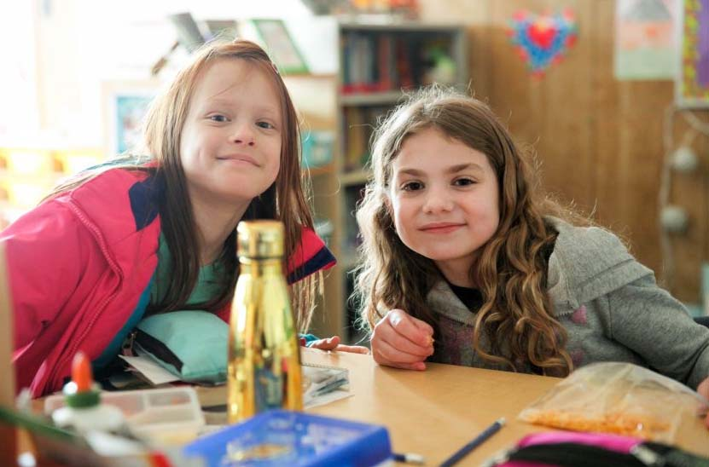

Caption here that explains how this photo illustrates the work done at school level in the
area of Assessing and Celebrating Learning.

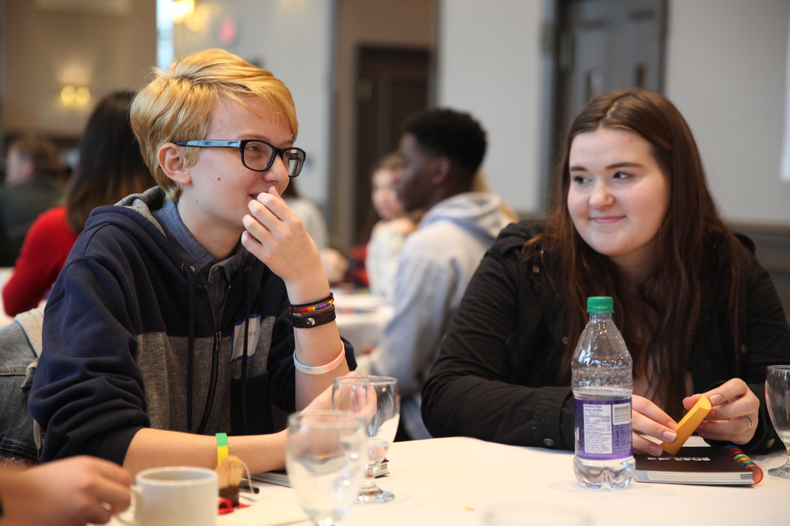

Caption here that explains how this photo illustrates the work done at school level in
the area of Assessing and Celebrating Learning.

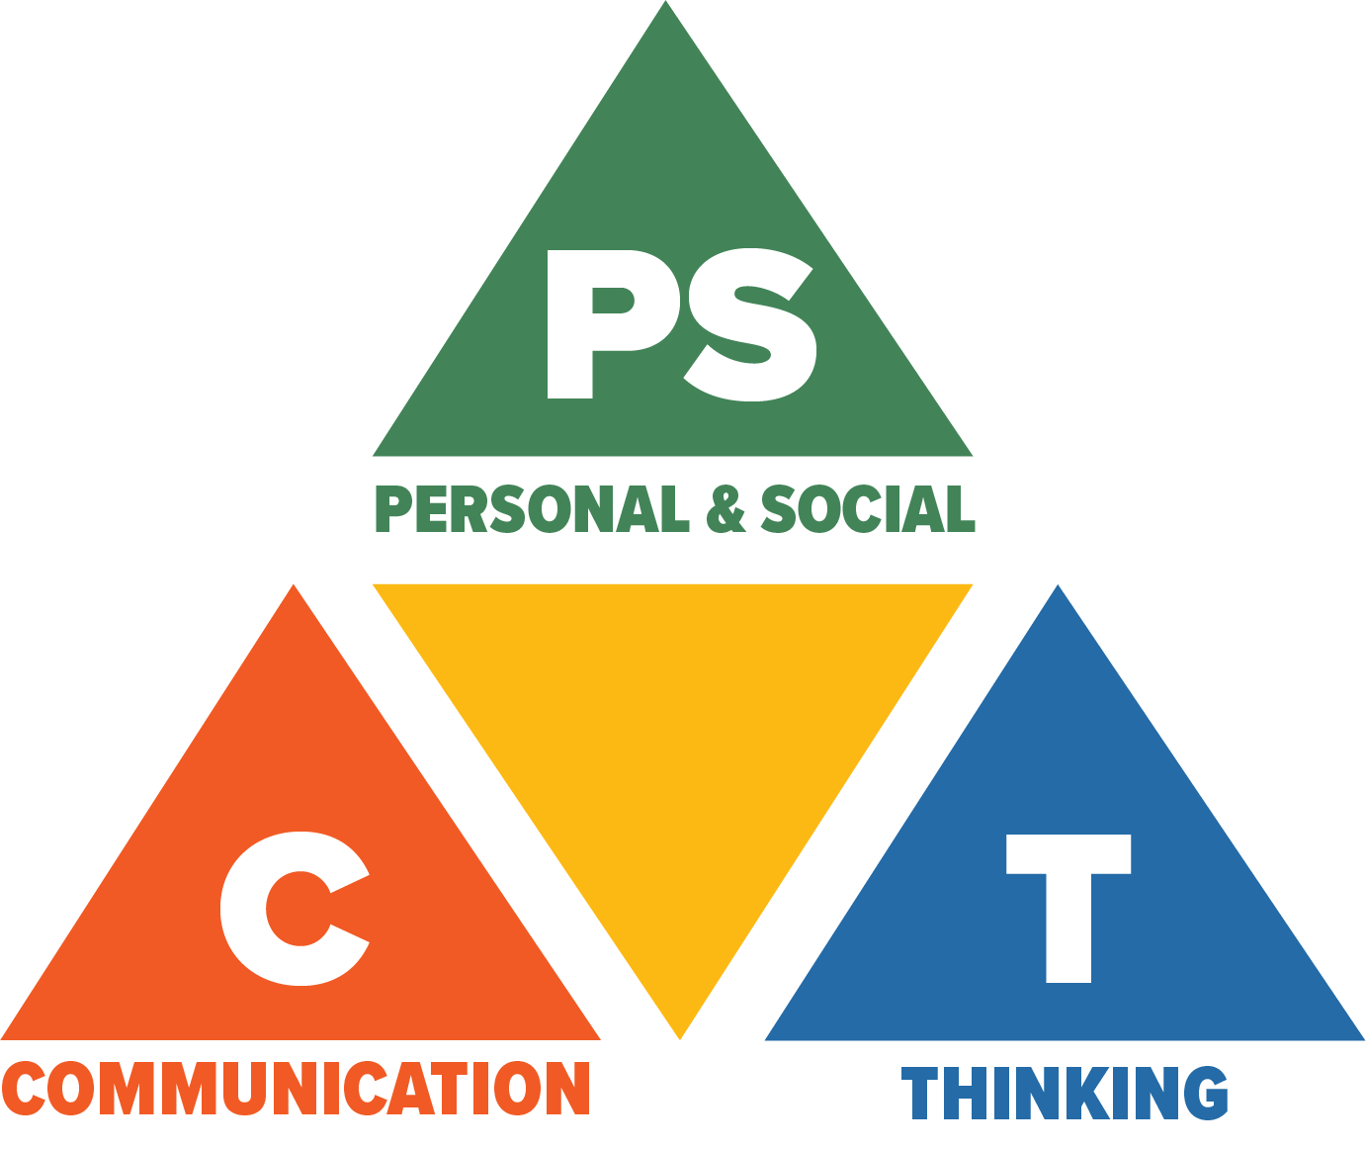
Core Competencies: What are they and why are they in the new curriculum?
The new curriculum centres around the following three core competency areas: communication, personal and social, thinking. They are sets of intellectual, personal, and social and emotional proficiencies that all students need to develop in order to engage in deep learning and life-long learning. Competencies are evident in every area of learning and in every grade and come into play when students become actively engaged in their learning. During the school year, students will have an opportunity to self-assess their proficiencies in these core competencies.

