PERSONAL & SOCIAL COMPETENCY
Positive personal and cultural identity, personal awareness and responsibility, and social responsibility are a set of competencies that relate to the development of an individual’s personal, social, and emotional capacities. Growth in these skills helps students thrive as individuals, understand and care about themselves and others, and find and achieve their purpose in the world. Learning in these areas is successful when schools, communities, and families value and support academic progress alongside the personal, social, and emotional development of their children.

For more information about the new curriculum, visit http://www.sd42.ca/new-curriculum.

Coming in February – Collaborative Learning.

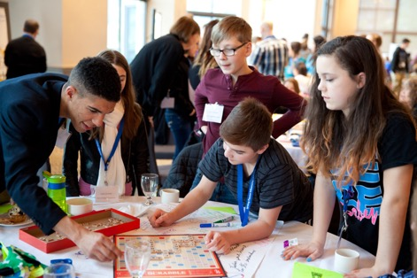

Caption here that explains how this photo illustrates the work done at school level in the
area of Personal & Social Competency.

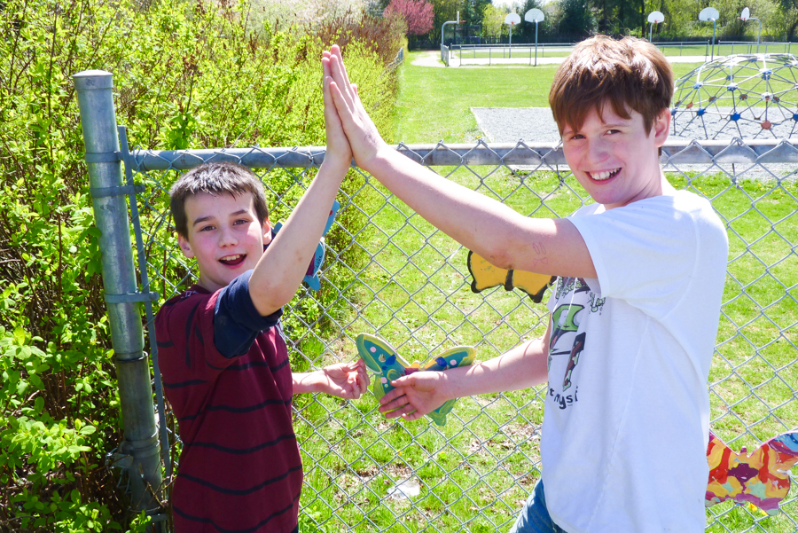

Caption here that explains how this photo illustrates the work done at school level in
the area of Personal & Social Competency.

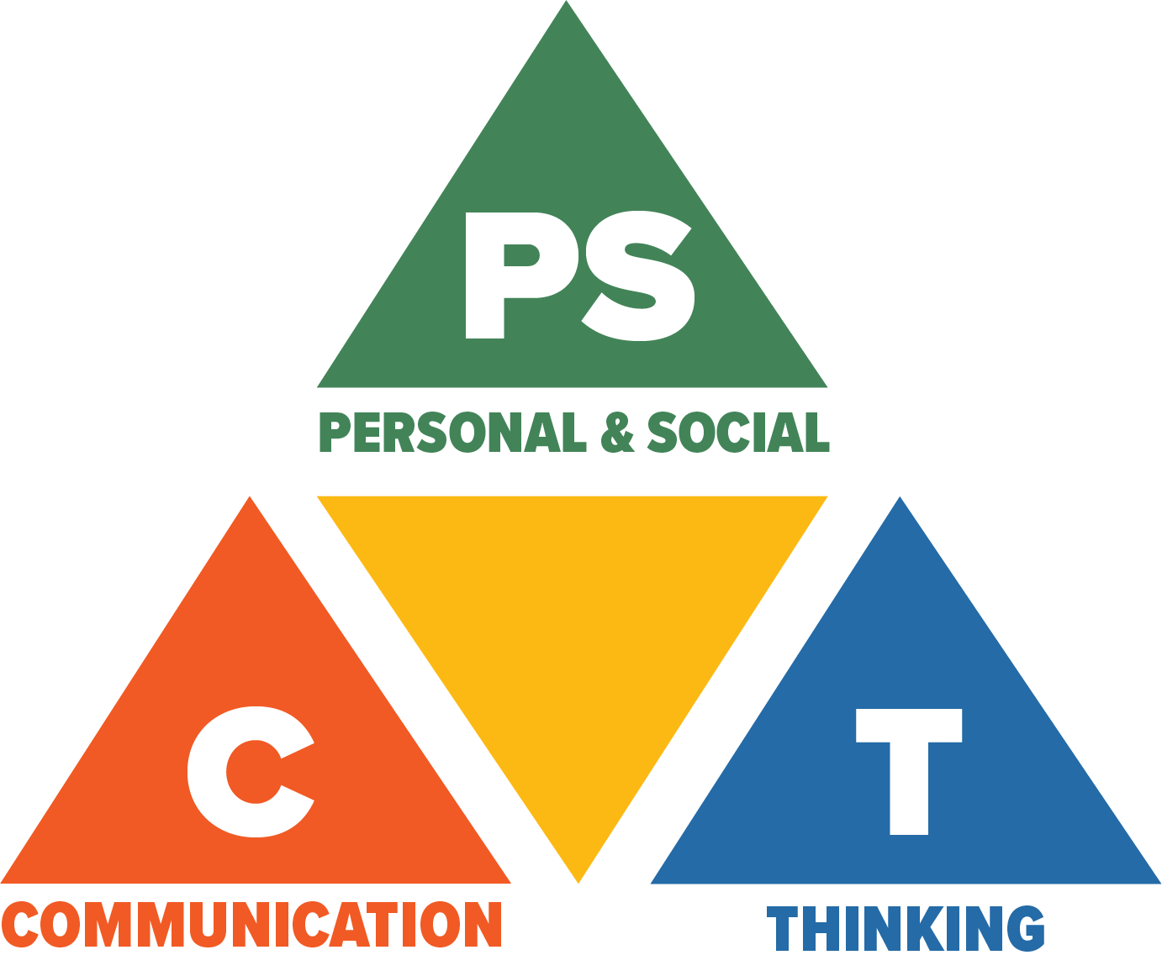
Core Competencies: What are they and why are they in the new curriculum?
The new curriculum centres around the following three core competency areas: communication, personal and social, thinking. They are sets of intellectual, personal, and social and emotional proficiencies that all students need to develop in order to engage in deep learning and life-long learning. Competencies are evident in every area of learning and in every grade, and come into play when students become actively engaged in their learning. During the school year, students will have an opportunity to self-assess their proficiencies in these core competencies.

