COLLABORATIVE LEARNING

C
ollaborative learning is an educational approach to teaching and learning that involves groups of students working together to solve a problem, complete a task, or create a product. This approach requires students to be highly engaged in their learning, with a focus on process rather than on the right answer.
Students are expected to come prepared to discuss and collaborate. Teachers build in accountability with group marks and individual student assessments. Students teach each other through working on challenging class problems with the teacher as facilitator or coach. The goal is to shift learning from teacher-centered to a student-centered model.

For more information about the new curriculum, visit http://www.sd42.ca/new-curriculum.

Coming in April – Place-Based Learning.

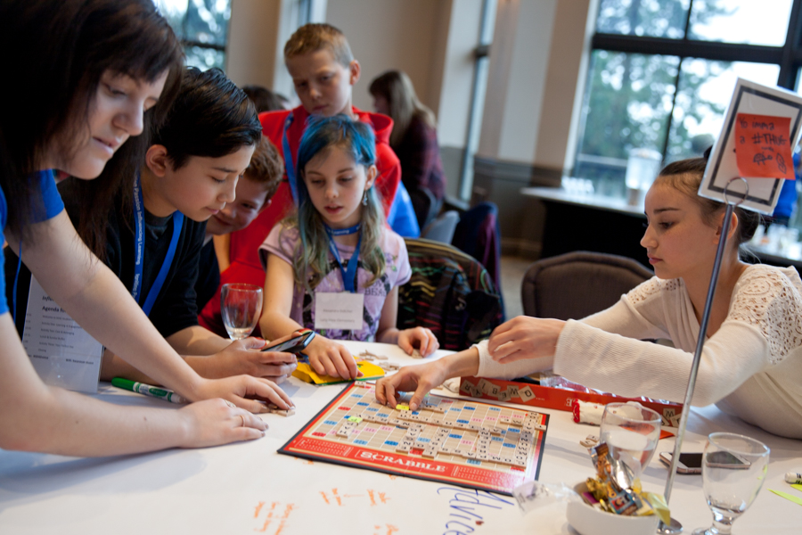

Caption here that explains how this photo illustrates the work done at school level in the
area of Collaborative Learning.

Caption here that explains how this photo illustrates the work done at school level in
the area of Collaborative Learning.

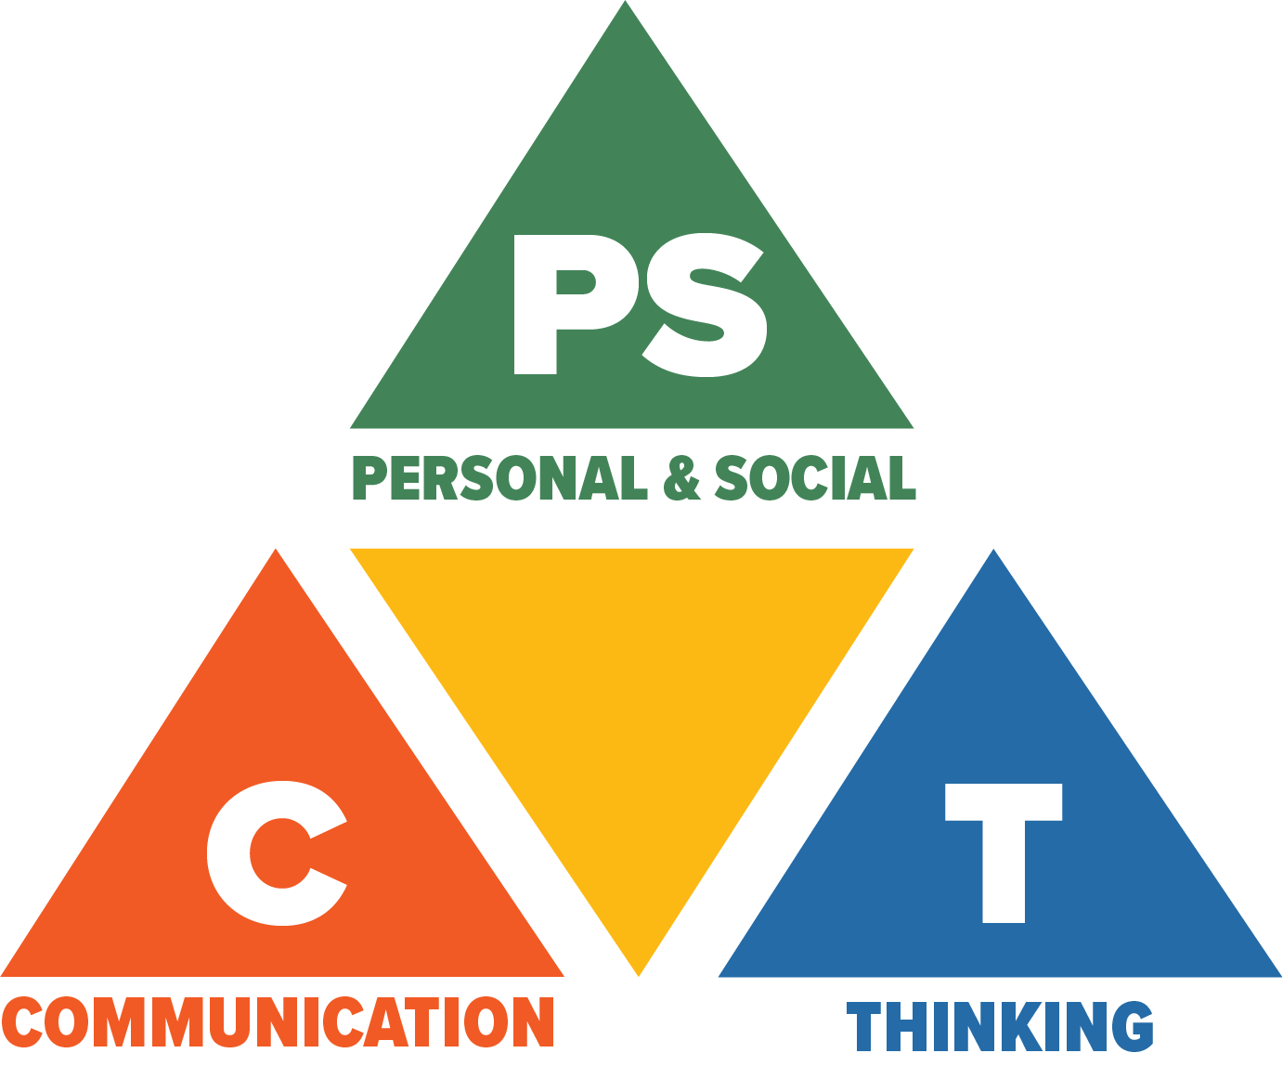
Core Competencies: What are they and why are they in the new curriculum?
The new curriculum centres around the following three core competency areas: communication, personal and social, thinking. They are sets of intellectual, personal, and social and emotional proficiencies that all students need to develop in order to engage in deep learning and life-long learning. Competencies are evident in every area of learning and in every grade, and come into play when students become actively engaged in their learning. During the school year, students will have an opportunity to self-assess their proficiencies in these core competencies.

