How has the curriculum been redesigned & how does this benefit student learning?

The BC curriculum has been redesigned to support the changing world students are entering. The redesigned curriculum is student-centered and flexible, maintains a focus on literacy and math skills, and includes Aboriginal perspectives.

So how and what will your child be learning? Each month in our school newsletter we will highlight a key feature of the redesigned curriculum and share stories about how this feature is being implemented in your child’s classroom. We will also tell you about why these skills and abilities will help your child succeed.

For more information about the new curriculum, visit http://www.sd42.ca/new-curriculum.

Coming in October - Competencies: Core vs. Curricular.

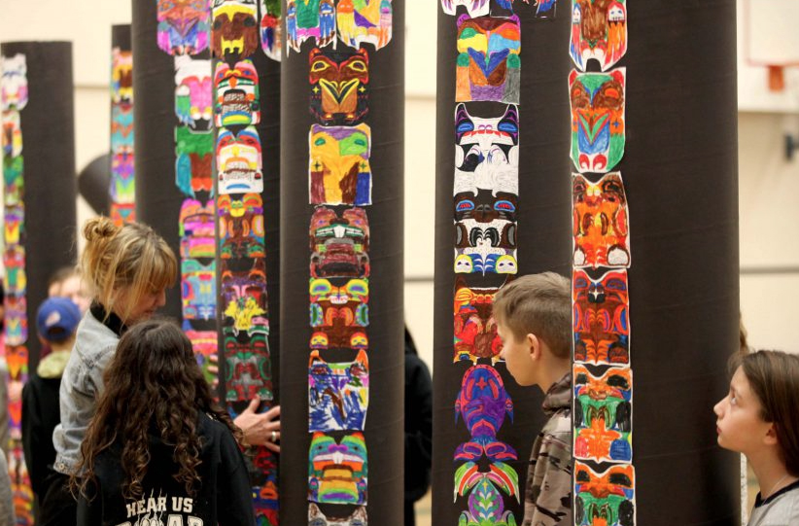

During the 2016/17 school year, students at Webster’s Corners collaborated to create hand-coloured totem poles and learn more about Aboriginal perspectives.

