April 2020 Newsletter

Blue Mountain Elementary

12153 248 Street, Maple Ridge, BC V4R 1J3
Principal: Mrs. Laureen Hickey laureen_hickey@sd42.ca
T: 604 463 6414 F: 604 463 4955
Website: elementary.sd42.ca/bluemountain

Message from the Principal:

During this time, I want to say how proud I am of our Blue Mountain Elementary community! Thank you for your continued support and patience during this unique time. We have been working hard to prepare meaningful and manageable learning opportunities for all of our students while ensuring the health and safety of our school community. For some of our staff, the shift to a virtual classroom will not be new; for many, however, the rapid change to a new format of instruction may be more challenging. Thankfully we have a school ethos of collaboration and support that is the very cornerstone of our values. Our instructional staff are forming teams, supporting each other, and investigating the power of remote instruction. At the same time, we recognize the uniqueness of each individual and will work to ensure that we provide diverse learning opportunities for students who may not be able to engage meaningfully in the virtual space. I know that our staff have thoroughly enjoyed reconnecting with your children. As restrictions are slowly being lifted, school at this point is continuing as it has for the past month with remote learning. I will be sure to relay any information to all parents if this changes. We continue to focus on care, compassion, community, communication, and connection. We are in this together! Take care and stay safe!

Sincerely, Mrs. L. Hickey,
Principal

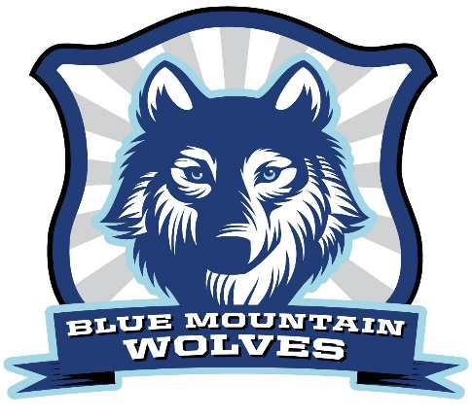

Upcoming Events

May 10
Happy Mother’s Day!
May 14
Dance Like A Chicken Day!
May 14
PAC meeting - Zoom
May 18
Victoria Day
May 19
Pro-D Day
May 28
Class Placement Parent Input Due
May 27-28th
Welcome to Kindergarten Package Pick Ups
June 30
Anonymous Student Learning
e-Survey access closes

Has Someone Moved Into The Neighbourhood:
If you know of any families who need to register to Blue Mountain (either this year or during the summer), tell them to call the office at 604-463-6414. Thank you.

Are you Moving:
If you know you will be moving or transferring from Blue Mt. (either this year or during the summer), please remember it is very important to let the office know ASAP. Staffing for next year is based on enrollmeent numbers estimated next month. The more accurate our numbers are the more efficient our staffing will be. Thank you.

COVID-19 Frequently Asked Questions SD42 has a collection of frequently asked questions on the school district website at https://www.sd42.ca/faq/. The district has already received many questions from students, parents/guardians and staff, and have been adding the answers to the growing list on this page. The search feature on this page allows you to sort through the existing questions/answers. You can also submit any question(s) not on the list and the district will post the answer(s) within 24-48 hours.

Good News Story

We hope you got a chance to view the video made by staff as a special message to BME Students, “ To Blue Mountain Elementary Students, We care for you and miss you! Keep happy and positive! You might have to be a lone wolf but soon we will be together in our Wolf Pack! Click the link to see more.
https://youtu.be/G1qw3TJGmP8

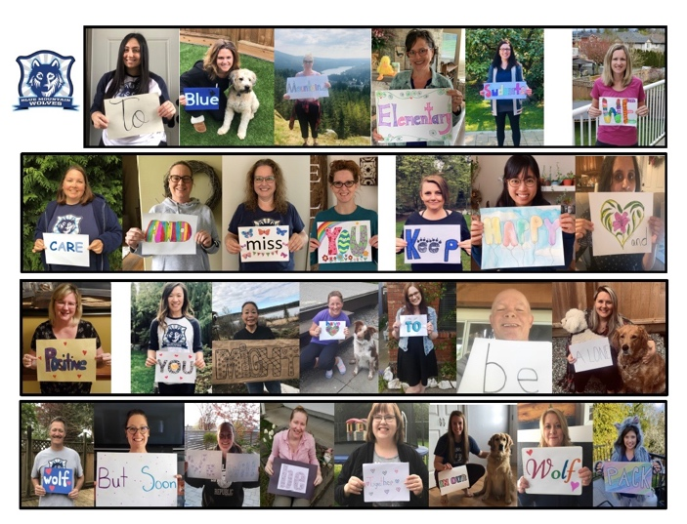

Wolf Paw Awards The staff and I would like to grant every student at BME a Wolf Paw Award to recognize all the unbelievable efforts made by the students (and their families) during this time. We appreciate how your efforts have been insurmountable at times.
In the words of one student ‘this virus might actually help the world, it already has caused pollution levels to decrease and animals to return to many areas. It has caused people to be less outgoing and reconnect with their families.’ Congratulations to you all. We will arrange for certificates when we are back.

Zoom Information; Technology best practices and etiquette (IT)

How wonderful it has been to get many students and classrooms connecting using video platforms such as Zoom. As we move forward with video conferencing and meetings, the school district has some guidelines for students and families to follow. Attached you will find technology best practices and etiquette documents for students and families. Please read through and review the student etiquette document with your child. Thank you.

‘Dance Like A Chicken Day’ May 14th
I didn't make this up. Go ahead and google it. This week, send us a video of your child (or even better, your family) dancing like a chicken - or performing the Chicken Dance and we'll feature them in next newsletter / memo. Don't worry, Mrs. Hickey will have a video up there too.

Class Placement 2020/21
Parent Input Regarding Student Placement for 2020-2021
We are beginning to create our classes for next year. Please be assured that staff devote considerable time, care and attention to this process. This very complex and lengthy responsibility occurs over several weeks and continues into September when class placements are finalized.
Throughout the year, there have been many opportunities for parents and teachers to discuss each child. Staff work together to consider the following criteria very carefully: social emotional skills and relationships, as well as learning styles, strengths, and needs. Our goal is to create safe and engaging inclusive classrooms that balance these factors, as equitably as possible.
If you feel there is further information to consider about your child, you may submit input to the principal in writing by letter or by email at Laureen_Hickey@sd42.ca by May 28, 2020. Please refrain from requesting specific teachers or peers by name. Thank you.
School Supplies for 2020-2021
Please watch for information regarding school supplies coming up on the portal in the next few days.
- Virtual Learning: The ACT Arts Centre is offering a dozen interactive arts classes for 3- to 15-year-olds. Per family rates rather than per child! For more information:
https://theactmapleridge.org/virtual-learning

- Safer Schools Together is offering free online courses for parents and high school students about digital safety.

FOR PARENTS:
"RAISING RESPONSIBLE DIGITAL LEARNERS"
Tues, May 26, 2020 9:00am-10:30am PST

FOR STUDENTS (Grades 8-12):

"SOCIAL MEDIA AWARENESS, DIGITAL FOOTPRINTS & CYBERBULLYING IN THE AGE OF COVID-19"
Tues, May 12, 2020 9:00am-10:00am PST

