Upcoming Events

January 25
NID no school for students
Red Cross Babysitting Course
Jiu-Jitsu – NO class today

January 29
Creative Arts – on Stage
Fruit and Vegetable Program

January 31
Bricks4Kidz – on Stage

February 1
Gr. 8 Registration Opens at 12 noon
Jiu-Jitsu – in Gym

February 5
Creative Arts – on Stage

February 7
Div 8 & 10 Field Trip Fire Safety
Hot Lunch: Swiss Chalet

February 8
Jiu-Jitsu – in Gym
Skating -Div. 2, 13

February 12
Creative Arts – on Stage

February 12 – April 4, 2019
Elementary student transfer opens

February 13
Mindful Movements Yoga – on Stage
Jump Rope For Heart – all day
PAC meeting 7 pm library

February 14
NID no school for students

February 15
Not is Session – school closed
Jiu-Jitsu – NO class today

February 18
Family Day – school closed

February 19
Div. 13 & 15 UBC Research Forest
Book Fair Feb.19-21st

February 20
Assembly 9 am
Div. 11 & 12 UBC Research Forest
Book Fair Feb.19-21st

February 21
Last Day of the Book Fair
Feb. 27 – Pink T-shirt Day

January 2019 Newsletter

Blue Mountain Elementary

12153 248 Street, Maple Ridge, BC V4R 1J3
Principal: Mrs. Hickey laureen_hickey@sd42.ca
T: 604 463 6414 F: 604 463 4955
Website: elementary.sd42.ca/bluemountain

Message from the Principal:

Welcome to a New Year at Blue Mountain! I have been thoroughly impressed with the focused learning that has been taking place now that our second term has started. We hope all Blue Mountain families had a great Christmas break and on behalf of the staff we would like to wish everyone a very happy and safe New Year! Many thanks go out to our staff for their hard work and effort within our school everyday. Staff members are continually giving of themselves by helping and supporting each other and your children. Blue Mountain is a truly wonderful community!

Just a few reminders; If you have students entering kindergarten or grade 8, please be sure to read the appropriate sections of the newsletter and make note of the important dates coming up. Further, if you are planning on moving this year and think you might need to change schools, please look at the information on the transfer process.
We are excited to get back and get started on term 2!! Although we’ve only a short time, our staff and students have jumped right back in to the learning. Whether it is learning “active reading” strategies, embarking on new novel studies, or practicing their creative arts skills with guitars, our students are learning new things each day. If you have any questions or concerns, please don’t hesitate to contact me.
Thank you,

Laureen Hickey
Laureen_hickey@sd42.ca

Just a reminder to parents that we offer the ability to report your child’s absence or late arrival through email OR on the parent portal.
To report an absence or late arrival, please email bm_reception@sd42.ca.
Please make sure you indicate your child’s teacher on the email and the reason for their absence. Thank you

Parent Portal Reminder

DON’T MISS OUT on another announcement, event, newsletter or field trip! In the fall, all forms and announcements will continue to be communicated from the school through the SD42 Forms and Parents Portal.
If you are not on the portal, please take a few minutes of your time to create an account at https://parents.sd42.ca/.
Parent make sure you have completed the policy/permission forms awaiting your approval on the portal!
District forms have been sent out through the portal. These forms are necessary to complete so your child can go on walking field trips, use iPads, etc.
Please complete them ASAP.
Remember to scroll down in each box as this indicates to the district that you have read the forms. If you have any issues, please come and see Mrs. Hickey.

KINDERGARTEN REGISTRATION DATES
Registration dates for the 2019/20 school year:
Sibling Registration – January 21 – Jan 25, 2019
Choice Registration – Feb. 1 – Feb. 4, 2019
General Registration – Feb.12—Feb.19, 2019
Late Registration – Feb. 27 – June 26, 2019
All registration open at 12 (noon)

Wolf Paw Awards

Div.4 – Brock H., Chad S., Maddy W.
Div.6 – Samuel E., Taylor G., Cody M.,
Nathan P., Chase V.
Div.7 – Rylee B., Bentley C., Madison H.
Div.8 – Chase B., Carter J., Ryder M.
Div.11 – Hunter V.
Div.13 – Christy M., Talon U.
Recognition for one of the
Six Pillars of Character.
GRADE 8 REGISTRATION DATES:
Registration opens at 12 noon on Tuesday, Feb. 5th. All Gr.8 registrations are done through the Parent Portal. It closes on Feb. 20 at 12 noon. If you do not register before deadline, you will need to complete a paper registration form at your child’s catchment high school. More information is on the district’s website.

More info: There are no Grade 7 Information Nights prior to registration. Each high school will host an
information session for incoming students once registration is complete. To provide an optimal
learning environment for all students, the Maple Ridge – Pitt Meadows School District must
manage enrolment across all schools, ensuring that enrolment numbers match building
capacity. Due to increasing enrolment in recent years, the majority of students are assigned to
their catchment school. All our high schools meet the needs of all learners.
The Grade 8 Information pamphlet has more details: http://www.sd42.ca/assets/media/Grade-
8-Registration-and-Transfer-Guidelines-2019_20-Dec-10.pdf
Important Registration Dates:
• Online registration opens Tues., February 5th at 12:00 noon (you must have a Parent
Portal account)
• Online registration closes Wed., February 20th at 12:00 noon (on the Parent Portal)
• Families will be notified of placement before Spring Break
• Upcoming Specialized Information Sessions:
January 17 at 7:00 pm – Gr. 7 Parent Evening sponsored by DPAC, Thomas Haney
January 29 at 7:00 pm – Student Support Services Information, Thomas Haney
Transfer Dates:
March 1 (approximately) – Families advised of high school placements
March 8 – Transfer request deadline; these will be considered by catchment, sibling, and other
circumstances (all by lottery)
March 11 – Transfer meeting
*see the district website for guidelines http://www.sd42.ca/studentregistration/
*the transfer form is completed at the assigned high school
Grade 7s Visit to the High Schools:
Wed., May 29 for most of the school day

Monday, February 18, 2019 All schools in the Province of B.C. will be closed for this special holiday. Please make note of this on your calendars at home and we hope you enjoy time spent with your family.

Student Transfer Guidelines: Elementary 2018/19
Transfer guidelines are on the district website, outlining dates and criteria for transfer.

Phase 1: Feb 12 to April 4, 2019
Phase 2: April 5 to June 12, 2019
Phase 3: June 13 to August 29 2019

For more info check out the district’s website:
http://www.sd42.ca/student-registration/

LOST & FOUND CLOTHING

It’s only a few weeks since winter break, and we already have many items in the lost and found.

We encourage everyone to take a moment and stop by to see if you are able to claim any items. Unclaimed items will be donated to charity.
December Wall of Fame
Div. 1 Lily B, Connor L., Dylan B.
Div. 4 Retish S., Brady H., Dahee K.
Div. 5 Ethan P., Cameron G., Harley W.
Div. 6 Rachel D.
Div. 7 Bentley C., Lynn S., Sephora U.,
Div. 8 Dorsa S., Marus H., Sadie U.,
Jasmine K.
Div. 9 Iola H., Avery T., Kai F.
Div. 10 Ava C., Elyse G., Daniel K.
Div. 12 Carver C., Liam H.,
Div. 13 Reece T., Zachary B., Madison B.
Div. 14 Mira H., Abby S.
Div. 15 Ben M., Emily A., Madison W.

CREATIVE ARTS (Gr. 1-7)
Miss Janet’s art activity classes are beginning this month! Starting January 15, these classes will run every Tuesday from 2:30-4:00pm on the stage. These classes run until March 5.

JIU-JITSU (Gr. 3-7)
Jiu-Jitsu based classes are being held starting January 11. These classes will run every Friday (excluding Jan.25 and Feb.15) and run from 2:30pm-4:00pm in the gym.
Please remember to bring appropriate gym attire!
Wild & Immersive Outdoor Nature Program (K to 7)
SD 42 has partnered with UBC to offer this engaging, nature-focused after school program. Activities will the place mostly outdoors, so please make sure your child is dressed appropriately for the weather. Starting Feb. 4.Class runs for 3 Mondays.

Jump Rope for Heart Feb. 13th, 2019
Our annual Jump Rope event is set for February 13th. Once again, all students at Blue Mountain be rotating through a variety of skipping activities. Prior to the skipping event, participants can secure pledges for the Heart and Stroke
Foundation. Students receive thank-you prizes based on the pledges they collect individually. This is optional, and we suggest pledges be secured from family and friends. For safety reasons, we do not suggest students go door to door. Any donation will be greatly appreciated; donations over $20.00 will receive a tax receipt. We request that cheques be made payable to the Heart and Stroke Foundation of B.C. and Yukon. Please print the information on the pledge sheet and have your child return the pledge envelope and donations to the school on or before February 22nd. You may also fundraise online at
www.jumpropeforheart.ca . Tax receipts are issued electronically for online donations of any amount. When you register online and raise the $5 minimum pledge, you receive an exclusive Jump Rope for Heart skipping rope as a thank you prize. If you have any questions or concerns, please contact the school for more information or visit
their web site. Please remember students should plan to bring water bottles for this event! Thank you in advance for your support and helping to make February a heart healthy month!

BME Basketball Teams 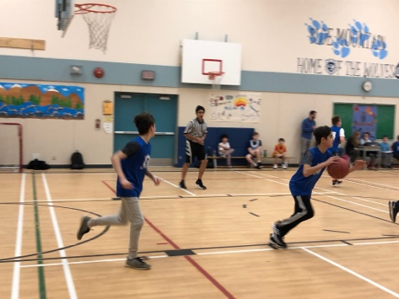
A huge thank you to our basketball coaches – Mr. Ferguson, Mr. Humphreys, and Ms. Wiebe
for coaching our boys’ and girls' basketball teams! We appreciate the extra time and effort they are volunteering to the Grade 6/7 students. We wish our four teams a successful and fun-filled season! Go Wolves!

Christmas Concerts
Thank you to students, staff and all who attended our Christmas concerts. Despite mother nature giving us a bit of a power issue on one of the dates, I thought the concert was excellent. There was such a variety of performances with singing, dance, instruments with a wonderful stage crew! Great work to all!

Pink T-Shirt Day is February 27th 2019

Registration Process
Registering your child for kindergarten is a big step, but it doesn't have to be a difficult one. With our easy online registration process, you can register your child from the comfort of your own home.
Review the registration steps below to ensure you are ready for the big day. Complete steps 1-4 before registration to save time.
STEP 1: OPEN A PARENT PORTAL ACCOUNT
You must open an SD42 Parent Portal account to access registration. If possible, complete this step well before registration day at http://parents.sd42.ca
STEP 2: FIND YOUR REGISTRATION DATE
Review our registration categories (SIBLING, CHOICE, GENERAL) to find your registration period.
STEP 3: REVIEW OUR REGISTRATION FORM
Review a copy of our online registration form before registration day at http://parents.sd42.ca.
STEP 4: REVIEW ACCEPTANCE CRITERIA
The order in which we place our new kindergarteners is determined by our Acceptance Criteria. Review these below .
STEP 5: REGISTER
Register your child at http://parents.sd42.ca
STEP 6: PROVIDE SUPPORTING DOCUMENTS
Once you receive email notification of your child’s tentative placement, you must bring supporting documents to that school. See Supporting Documents section below
Registration opens at noon on the first day of each registration period and closes at midnight of that registration period’s last day. You will be advised of your child’s tentative placement via email asking you to bring supporting documents to the school.
Acceptance Criteria –
- Siblings of students already attending desired elementary school currently in K-6;
- IN catchment (proof of residence required)
- IN catchment daycare (proof of daycare in catchment required)
- OUT of catchment without siblings
- OUT of district
Supporting Documents –
All students registering for kindergarten must be 5 years old on or before December 31, 2019. Parents must provide ONE of the following documents for verification: Birth Certificate, Passport, Immigration documents, Nexus Pass or BC Service Card.
Every parent registering a child must also show proof of BC residency with TWO of the following: BC Driver’s Licence, BC Identification, Municipal Tax or Utility bill, Mortgage or Rental Lease documents.
If you miss your deadline to provide supporting documentation, your child’s tentative school assignment will be cancelled and you will have to re-apply.

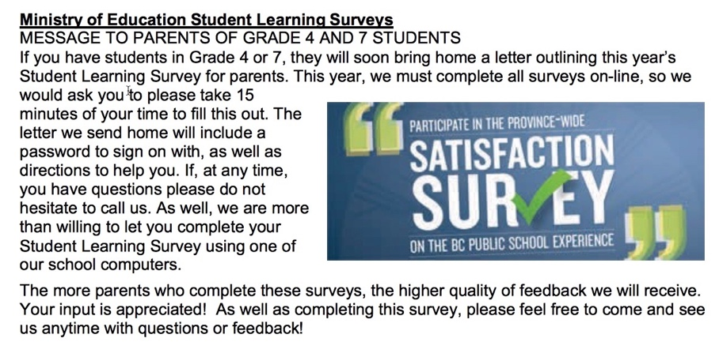

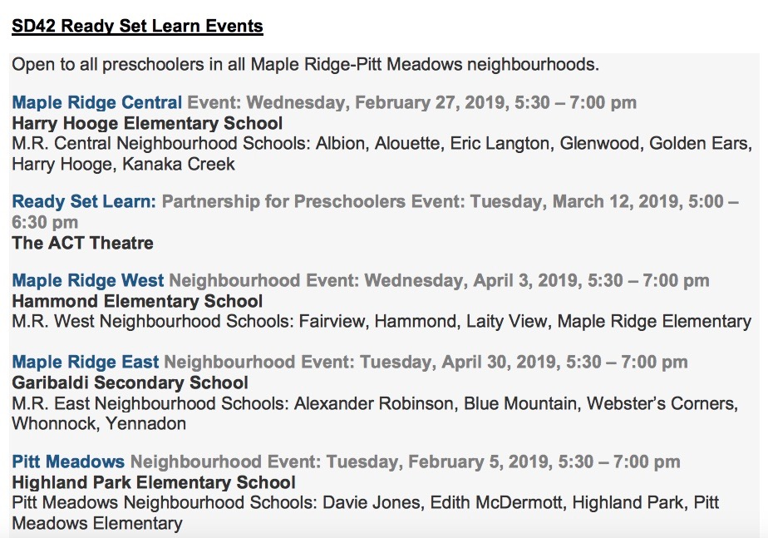

Important Memo on Parking Lot Safety and Routines
at Blue Mountain Elementary

Traffic issues surrounding BME Elementary have been a safety concern to all for the last few years, with the problem increasing as our population continues to grow. Our PAC, parents, and school neighbours have expressed safety concerns over driver behaviour and the amount of traffic in and around the school. Although we have repeatedly asked drivers to be aware of the restrictions, we continue to see double parking, unattended vehicles, and severe congestion, especially at pick up time. These circumstances are a considerable risk to our students and there have been too many ‘near misses’ as children weave through double-parked or unattended cars to get to their ride. These conditions aggravate drivers and pedestrians, which has led to discourtesy, conflict, and unsafe road conditions.

Safety is everyone’s responsibility and we need to ensure that we all do our part.

Common Traffic Problems at our Schools Include:
- Parking, stopping illegally, leaving vehicles unattended, blocking spaces intended for parents of children with disabilities
- Unsafe turns and U-turns
- Not stopping for children at crosswalks
- Arriving very close to bell times causing traffic congestion

Other Safety Problems:
- Children darting across the driveway or street through parked/waiting cars unaccompanied by an adult
- Crossing in between vehicles or mid-block instead of at the marked crosswalk
- Letting children out of the car on the driver side (traffic side) of the vehicle
- Double parking / reversing a vehicle out of the parking lot onto street

School Parking Lot Rules:
STAFF PARKING stalls – these spaces are reserved at ALL times for BME staff members.
HANDICAP SPOTS – for those displaying valid handicap permits.

City of Maple Ridge, Highway and Traffic Bylaw No. 6704-2009:
The City of Maple Ridge bylaw states in part; that no vehicle shall block a driveway or park within 3 meters of a driveway. Please be considerate of the neighbours. They need to be able to come and go safely too.
Note: The by-laws department will be issuing fines to anyone who is in violation of these by-laws;

Highway and Traffic Bylaw 12.1 –
(b) Driveway – in front of or within 3 metres of a public or private driveway;
(c) Intersection – in or within 6 metres of the approach or far side of an intersection, except as permitted by a sign
(d) Hydrant – within 5m of a fire hydrant measured from a point in the curb or edge of the roadway which is closest to the fire hydrant to the nearest wheel of the vehicle
(e) Crosswalk – on a crosswalk or within 6 metres of the approach side of a crosswalk

Suggestion to help keep the area safer:
- Consider parking away from the school and walking your child to school.
- Ensure all pedestrians use the designated crosswalk.
- Do not block the crosswalk with your vehicle.
- Do not let children out on the driver’s (traffic) side of the vehicle.

Important Memo on Parking Lot Safety and Routines
at Blue Mountain Elementary

Traffic issues surrounding BME Elementary have been a safety concern to all for the last few years, with the problem increasing as our population continues to grow. Our PAC, parents, and school neighbours have expressed safety concerns over driver behaviour and the amount of traffic in and around the school. Although we have repeatedly asked drivers to be aware of the restrictions, we continue to see double parking, unattended vehicles, and severe congestion, especially at pick up time. These circumstances are a considerable risk to our students and there have been too many ‘near misses’ as children weave through double-parked or unattended cars to get to their ride. These conditions aggravate drivers and pedestrians, which has led to discourtesy, conflict, and unsafe road conditions.

Safety is everyone’s responsibility and we need to ensure that we all do our part.

Common Traffic Problems at our Schools Include:
- Parking, stopping illegally, leaving vehicles unattended, blocking spaces intended for parents of children with disabilities
- Unsafe turns and U-turns
- Not stopping for children at crosswalks
- Arriving very close to bell times causing traffic congestion

Other Safety Problems:
- Children darting across the driveway or street through parked/waiting cars unaccompanied by an adult
- Crossing in between vehicles or mid-block instead of at the marked crosswalk
- Letting children out of the car on the driver side (traffic side) of the vehicle
- Double parking / reversing a vehicle out of the parking lot onto street

School Parking Lot Rules:
STAFF PARKING stalls – these spaces are reserved at ALL times for BME staff members.
HANDICAP SPOTS – for those displaying valid handicap permits.

City of Maple Ridge, Highway and Traffic Bylaw No. 6704-2009:
The City of Maple Ridge bylaw states in part; that no vehicle shall block a driveway or park within 3 meters of a driveway. Please be considerate of the neighbours. They need to be able to come and go safely too.
Note: The by-laws department will be issuing fines to anyone who is in violation of these by-laws;

Highway and Traffic Bylaw 12.1 –
(b) Driveway – in front of or within 3 metres of a public or private driveway;
(c) Intersection – in or within 6 metres of the approach or far side of an intersection, except as permitted by a sign
(d) Hydrant – within 5m of a fire hydrant measured from a point in the curb or edge of the roadway which is closest to the fire hydrant to the nearest wheel of the vehicle
(e) Crosswalk – on a crosswalk or within 6 metres of the approach side of a crosswalk

Suggestion to help keep the area safer:
- Consider parking away from the school and walking your child to school.
- Ensure all pedestrians use the designated crosswalk.
- Do not block the crosswalk with your vehicle.
- Do not let children out on the driver’s (traffic) side of the vehicle.

